PHARMACEUTICAL ANALYSIS – BP102T

UNIT : III PRECIPITATION TITRATION,COMPLEXOMETRIC TITRATION,GRAVIMETRY AND DIAZOTISATION TITRATION

CLASS:2
TOPIC: MODIFIED VOLHARDS AND FAJAN’S METHOD

Modified Volhard’s method:

Caldwell J.R and Mayer V.H modified this Volhard method by introducing wetting agent.

In this method Nitrobenzene is acting as a wetting agent and forms an insoluble protective layer over AgCl which minimizes the solubility of AgCl, hence we accurate end point.

Fajan’s method:

Titrant: AgNO3,
Analyte: Halides,
Indicator: Adsorption indicator, Fluorescein, Dichloro-fluorescein Eosin, Red Bengal

Principle:

It is based upon the Adsorption mechanism .
AgNO3 + NaCl →AgCl + NaNO3
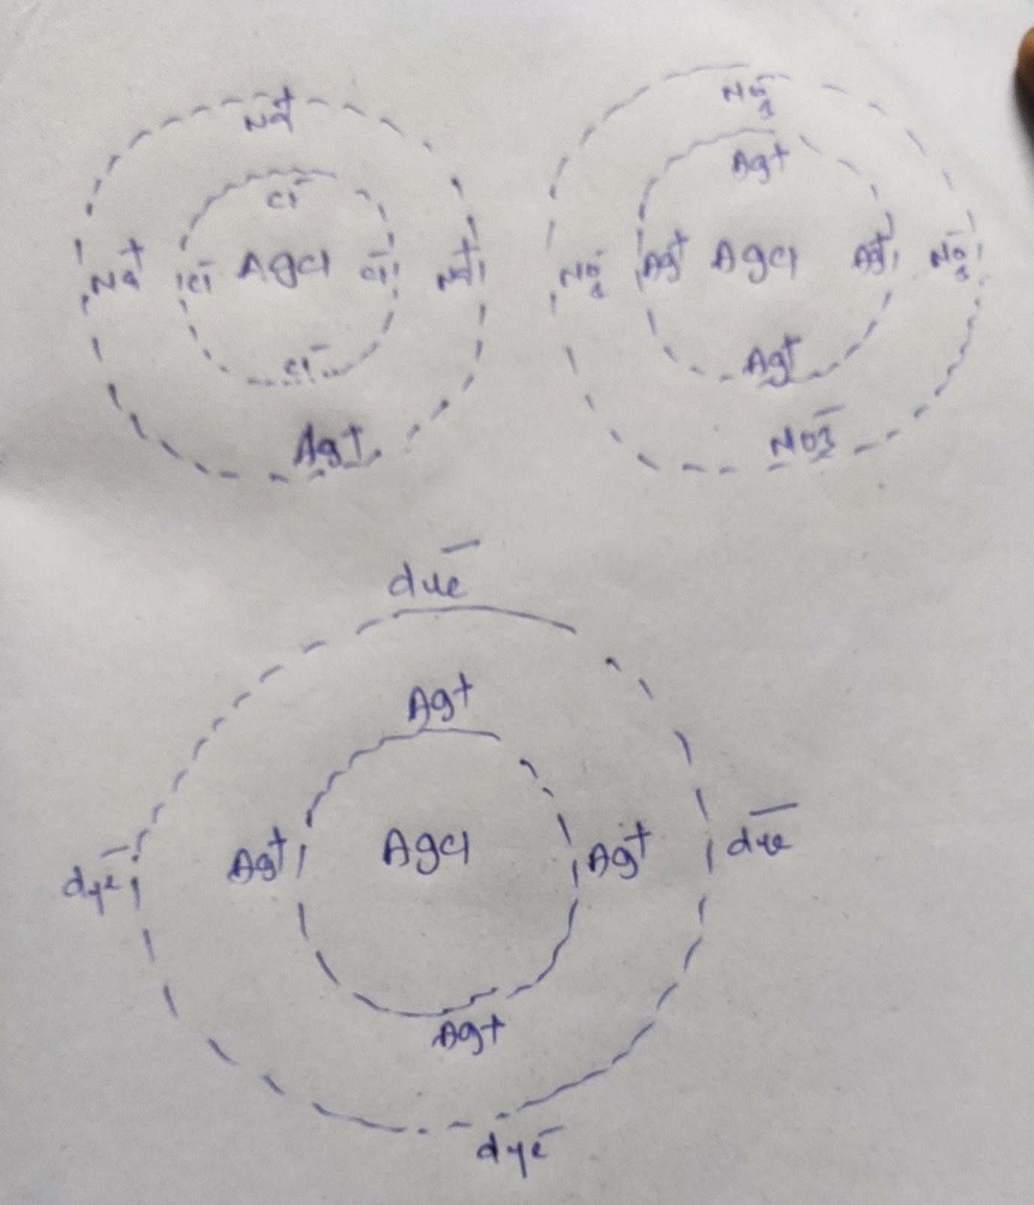

The indicator forms a layer over silver chloride precipitate and forms pink colour, indicates the completion of reaction

Adsorption indicators are acidic/basic dyes

Very Short Answer Questions:
1.write a short note on modified Volhard’s method.
2.What are dyes used in Fajans method.

Short Answer Questions:
1.Explain in detail about fajans method

