PHARMACEUTICAL ANALYSIS – BP102T

UNIT: V ELECTRO ANALYTICALS METHOD OF ANALYSIS

CLASS:10
TOPIC: CONDUCTOMETRY

Conductometry:
Determination of concentration of an electrolyte solution by conductometer is called conductometry. The ions bearing charges have mobility to concern electrodes.
Cations migrate towards cathode and anions migrate towards anode.
The conductance of ions is the basic principle for conductometric titrations.
In this type of titrations where there is no need of indicators or such type of titrations not required indicators.
Conductivity cell:
It is made up of fine glass quartz having two electrodes that is cathode and anode.it can available in three types
1.the conductivity cell having wide mouth with cork which is having holes for the passing of electrodes
2.the conductivity cell has a fixed lid with holes by which the burette and stirrer can be introduced 3.the conductivity cell consists of a wide glass bore at the tip of glass bore two platinum electrodes are present
the cell constant can be determined by using 0.02 KCl at 25°c or 0.01 KCl at 18° c determination of cell constant
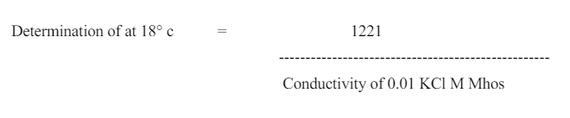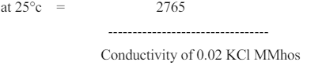
Conductometry is a measurement of electrolytic conductivity to monitor a progress of chemical reaction.
Principle:
Conductometric titration is a type of titration in which the electrolytic conductivity of the reaction mixture is continuously monitored as one reactant is added.
The equivalence point is the point at which the conductivity undergoes a sudden change.
Marked increase or decrease in conductance are associated with the changing concentrations of the two most highly conducting ions—the hydrogen and hydroxyl ions.
The method can be used for titrating-coloured solutions or homogeneous suspension (e.g.: wood pulp suspension ), which cannot be used with normal indicators.
Acid-base titrations and redox titrations are often performed in which common indicators are used to locate the end point e.g., methyl orange, phenolphthalein for acid base titrations and starch solutions for iodometric type redox process.
However, electrical conductance measurements can also be used as a tool to locate the end point.

