HUMAN ANATOMY AND PHYSIOLOGY-I, BP-101(T)

UNIT-II (Integumentary system)

CLASS:7

TOPIC – Physiology of muscle contraction, neuromuscular junction

5. | Muscle Contraction:
- The presence of calcium triggers a series of events leading to the contraction of the muscle fiber.
- The contraction involves the sliding of actin and myosin filaments, resulting in the shortening of sarcomeres and, consequently, muscle contraction.
It consists of three main components:

1. | Motor Neuron Terminal:
- Visualize a nerve cell ending in a terminal called the presynaptic terminal.
- This terminal has bulges filled with synaptic vesicles containing neurotransmitters (e.g., acetylcholine).
2.Synaptic Cleft:
- Picture a small gap, the synaptic cleft, separating the presynaptic terminal from the muscle fiber.
3.Muscle Fiber Receptor Site:
- On the other side of the synaptic cleft is the muscle fiber with a specialized region known as the postsynaptic membrane.
- The postsynaptic membrane has receptors that bind to the neurotransmitters released by the motor neuron.
- Flow of signals from the nerve cell to the muscle fiber:
- The action potential travels down the motor neuron and reaches the presynaptic terminal.
- Neurotransmitters (e.g., acetylcholine) are released into the synaptic cleft.
- Neurotransmitters bind to receptors on the postsynaptic membrane of the muscle fiber.
- This binding triggers an electrical signal in the muscle fiber, leading to the release of calcium ions from the sarcoplasmic reticulum.
- The presence of calcium ions initiates muscle contraction by allowing actin and myosin filaments to interact.
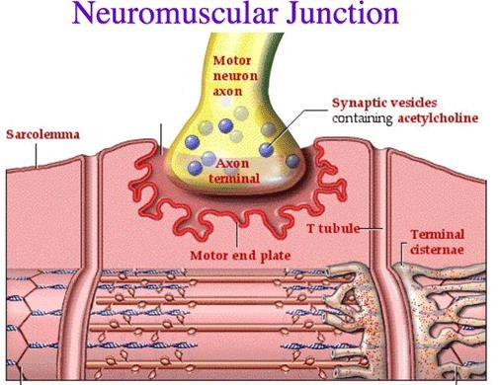

STRUCTURE OF A SKELETAL MUSCLE FIBER:

The structure of a skeletal muscle is highly organized and consists of various components that work together to
enable muscle contraction. Here's a brief overview:

Muscle Fiber (Muscle Cell):
  - The basic structural unit of a skeletal muscle is the muscle fiber, also known as a muscle cell.
  - Muscle fibers are elongated, multinucleated cells that run the length of the muscle.
2.Fascicles:
  - Muscle fibers are grouped into bundles called fascicles. Fascicles are surrounded by connective tissue called perimysium.
  - The entire muscle is formed by the grouping of fascicles. The bulk of the muscle that we typically see and feel is called the muscle belly.
4.Tendons:
3.Muscle Belly:
  - At each end of the muscle, collagenous fibers extend to form tendons.
  - Tendons attach muscles to bones, allowing for the transmission of forces generated during muscle contraction to produce movement.
5.Epimysium:
  - The entire muscle is surrounded by a layer of connective tissue called epimysium.
  - Epimysium helps protect and provide structural support to the entire muscle.
6.Perimysium:
  - Within the muscle, the fascicles are surrounded by another layer of connective tissue called perimysium.
  - Perimysium houses blood vessels and nerves that supply the muscle fibers within the fascicles.
7.Endomysium:
  - Each individual muscle fiber is enveloped by a delicate connective tissue layer known as endomysium.
  - Endomysium contains capillaries and nerves that supply and interact with individual muscle fibers.

8.Sarcolemma:

- The plasma membrane of a muscle fiber is called the sarcolemma.
- It surrounds the muscle fiber and contains receptors for neurotransmitters involved in muscle contraction.
9.Sarcoplasm:
- The cytoplasm of a muscle fiber is called sarcoplasm.
It contains the typical cellular components and also specialized structures like myofibrils. 10.
Myofibrils are thread-like structures within muscle fibers that contain the contractile proteins actin and myosin.
- These proteins are organized into repeating units called sarcomeres, which are the functional units of muscle contraction.
Myofibrils:
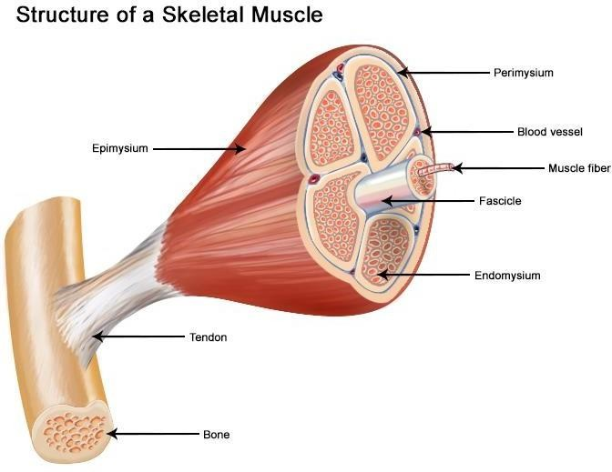
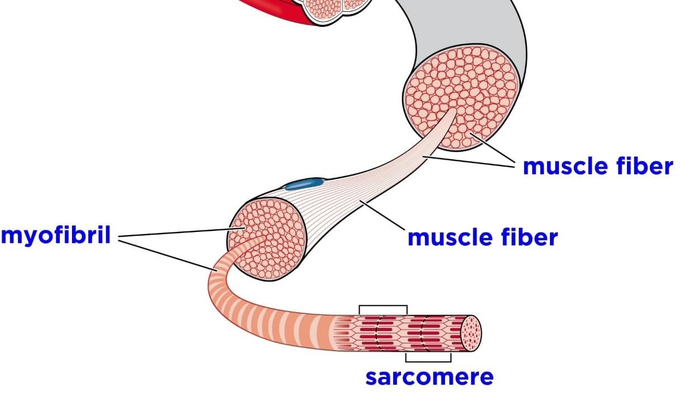

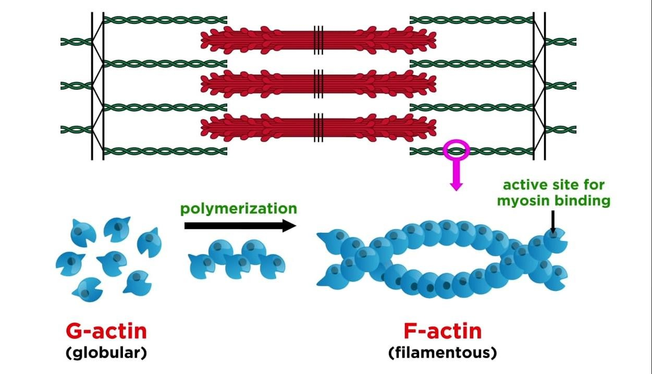
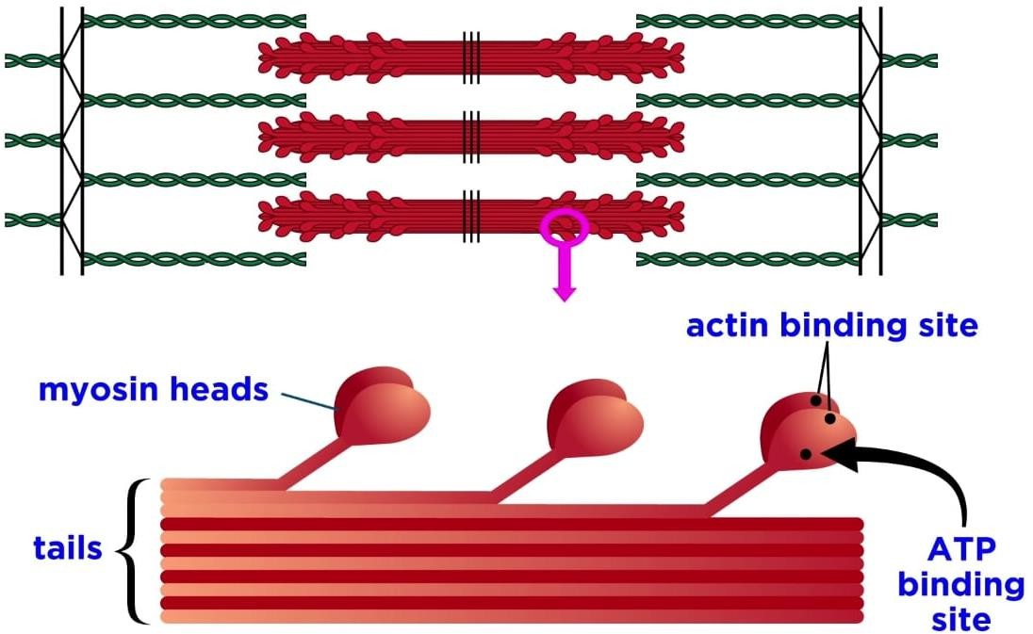

PHYSIOLOGY OF MUSCLE CONTRACTION:

Muscle contraction is a complex physiological process that involves the generation of force by muscle fibers. This
process is tightly regulated and involves various cellular and molecular events. Here is a simplified overview of the physiology of muscle contraction:

1. | Neuromuscular Signal:  - The process begins with a neural signal. Action potentials (nerve impulses) travel down motor neurons to reach theneuromuscular junction, where the motor neuron meets the muscle fiber.  - Release of Neurotransmitter:  - At the neuromuscular junction, the action potential triggers the release of neurotransmitters, usually acetylcholine(ACh), from synaptic vesicles in the motor neuron terminal.  - Activation of Muscle Fiber:  - Acetylcholine binds to receptors on the sarcolemma (muscle cell membrane), leading to the generation of an actionpotential in the muscle fiber.  - Propagation of Action Potential:  - The action potential travels along the sarcolemma and penetrates deep into the muscle fiber through structures calledtransverse tubules (T-tubules).  - Calcium Release:  - The action potential in the T-tubules signals the release of calcium ions (Ca2+) from the sarcoplasmic reticulum, aspecialized organelle within the muscle cell.  - Cross-Bridge Formation:  - Calcium ions bind to troponin, a regulatory protein on the actin filaments within the muscle fibers.  This binding causes a conformational change in troponin, exposing binding sites on actin for myosin.

7. | Sliding Filament Mechanism:
- Myosin heads bind to the exposed sites on actin, forming cross-bridges.
- ATP is hydrolyzed, providing energy for myosin heads to pull actin filaments toward the center of the sarcomere.
8.Muscle Contraction:
- The repeated formation and breakdown of cross-bridges result in the sliding of actin filaments over myosin filaments.
- This shortens the sarcomere, leading to muscle contraction.
9.ATP Replenishment:
- ATP is required for the detachment of myosin heads from actin.
- ATP is continuously hydrolyzed and regenerated to sustain muscle contraction.
10. Termination of Contraction:
- When the neural signal ceases, calcium ions are actively pumped back into the sarcoplasmic reticulum.
- With reduced calcium concentration, troponin returns to its original conformation, blocking the actin binding sites, and muscle contraction ceases.
PHYSIOLOGY OF MUSCLE CONTRACTION
