HUMAN ANATOMY & PHYSIOLOGY- BP101T

Unit IV 08 hours
- Peripheral nervous system:
Classification of peripheral nervous system: Structure and functions of
sympathetic and parasympathetic nervous system.
Origin and functions of spinal and cranial nerves.
- Special senses
Structure and functions of eye, ear, nose and tongue and their disorders.

TOPIC: PERIPHERAL NERVOUS SYSTEM
The peripheral nervous system (PNS) consists of all the nerves branching out of the brain and spinal cord (the central nervous system, CNS). If you imagine the CNS as the main highway, then the PNS forms all the connecting secondary roads. These allow electrical impulses to travel to and from the furthest regions, or periphery, of the human body.
The PNS is built almost entirely from nerves. There are two main types; spinal nerves and cranial nerves. Functionally, the PNS can be divided into the autonomic and somatic nervous systems. Both of these can be further subdivided; the former into sympathetic and parasympathetic arms and the latter into sensory and motor divisions.
Definition | A nervous system division composed of all the neural tissue found outside the cranial vault and vertebral canal.
Anatomical components | Peripheral nerves (spinal nerves, cranial nerves, autonomic nerves)  Ganglia
Functional components | Autonomic nervous system (ANS) - involuntary part in control of cardiac, smooth and glandular cells. It consists of sympathetic and parasympathetic divisions.  Somatic nervous system (SNS) - voluntary part in control of skeletal muscles and processing of somatic sensation.
Function | Transmits motor and sensory information between the central nervous system and peripheral body tissues.

Peripheral nerves
The workhorse of the peripheral nervous system are the peripheral nerves. Each nerve consists of a bundle of many nerve fibers (axons) and their connective tissue coverings. Each nerve fiber is an extension of a neuron whose cell body is held either within the grey matter of the CNS or within ganglia of the PNS. The comparable structure of the CNS is called a ‘tract’.
Peripheral nerves that carry information towards the CNS are called afferent or sensory neurons, while the ones transmitting impulses from the CNS are known as efferent or motor neurons.
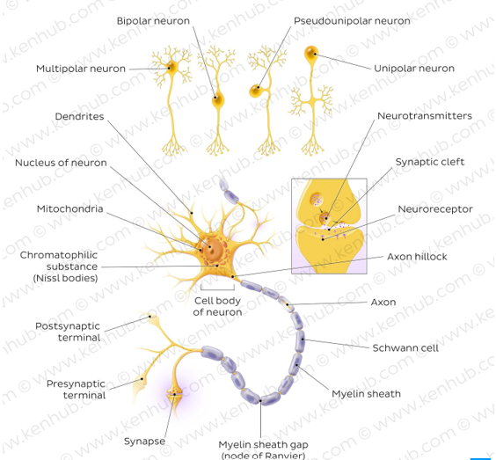
Afferent neurons transmit a variety of impulses from sensory receptors/sense organs. They carry general sensations like touch, pain, temperature and position in space (proprioception). Some also transmit more special, sensorial information like the special senses of smell, vision, hearing and balance. In contrast, efferent neurons bring general nervous information towards effector organs, like skeletal muscles, visceral organs and glands. They are responsible for initiating voluntary and involuntary motor functions, such as muscle contraction and gland secretion.
Nerves can also be classified as ‘cranial’ or ‘spinal’ according to where they exit the CNS. Cranial nerves emerge from the cranium (brain/brainstem) whilst spinal nerves leave the CNS via the spinal cord. There are 12 pairs of cranial nerves and 31 spinal nerve pairs, giving a total of 43 paired nerves forming the basis of the peripheral nervous system.

Cranial nerves :
Cranial nerves are peripheral nerves that mainly innervate anatomical structures of the head and neck. The exception to this is the vagus nerve, which also innervates various thoracic and abdominal organs. Cranial nerves originate from specific nuclei located in the brain. They leave the cranial cavity through foramina and project to their respective target structure. Cranial nerves are divided into three groups according to the type of information carried by their fibers:
Sensory
Motor
Mixed
