HUMAN ANATOMY & PHYSIOLOGY- BP101T

Unit IV 08 hours
- Peripheral nervous system:
Classification of peripheral nervous system: Structure and functions of
sympathetic and parasympathetic nervous system.
Origin and functions of spinal and cranial nerves.
- Special senses
Structure and functions of eye, ear, nose and tongue and their disorders.

TOPIC: PERIPHERAL NERVOUS SYSTEM
Nervous system: It is a network of interconnected cells, tissues, and organs that enables communication and response to environmental changes.
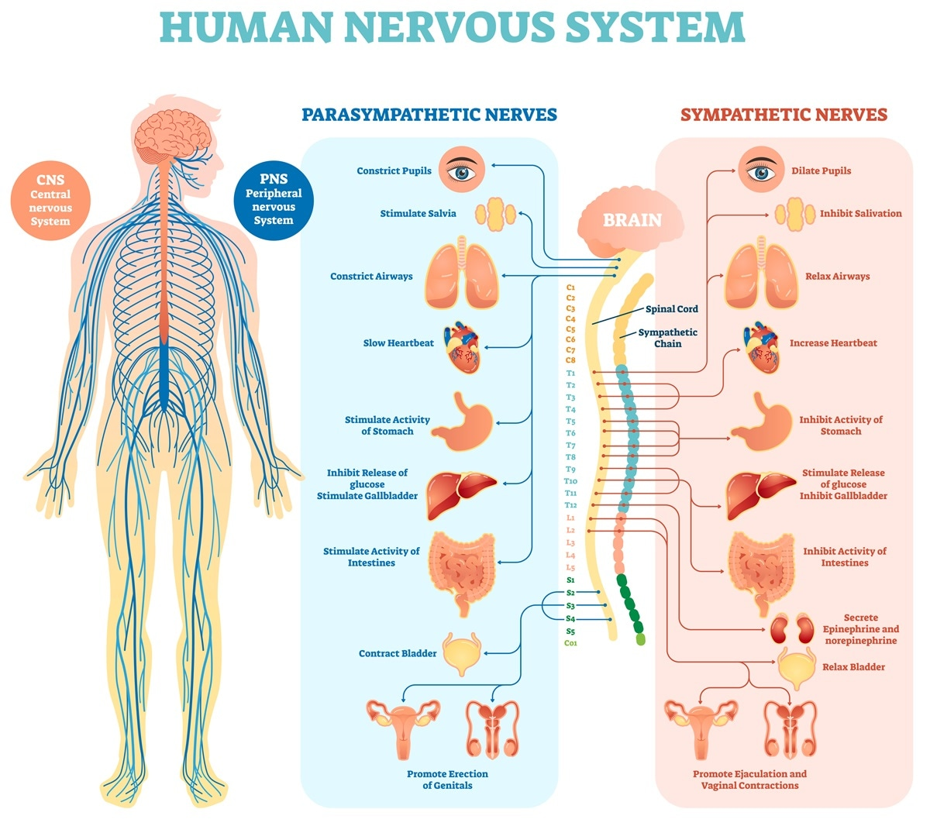
Functions of nervous system:
- Sensation: Receiving information about changes in the environment in response to stimuli (e.g. taste, smell, touch, sight, hearing).
- Integration: The process involves receiving stimuli, interpreting sensory input, and integrating this information for appropriate action..
- Motor output: It generates responses to stimuli, including voluntary (contraction of skeletal muscle) and involuntary (regulation of cardiac muscle and glands) responses.
- Mental activity
- Homeostasis
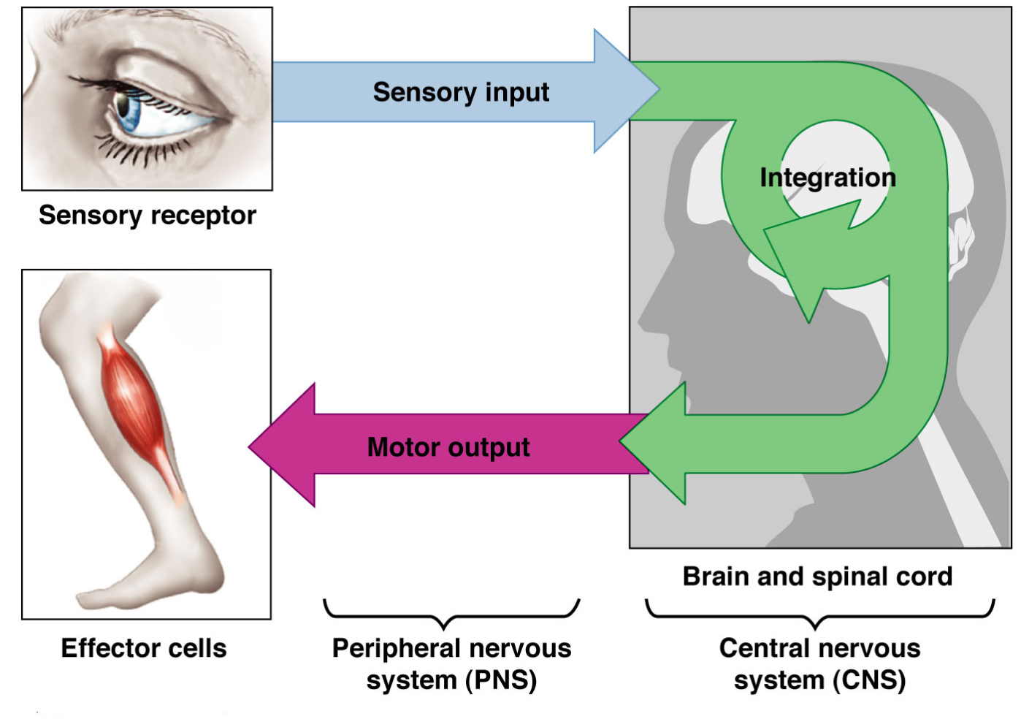

Classification of Nervous system
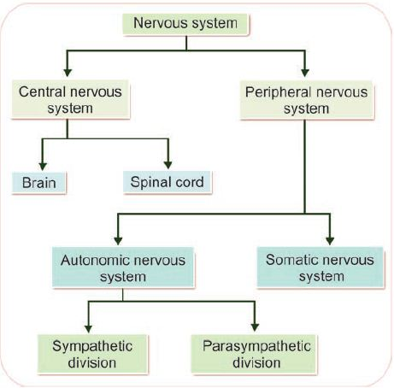

Composed of:
- Neuron: receive and transmit impulses
- Neuroglia: assist in the propagation of nerve impulse. They maintain homeostasis, form myelin, and provide protection for neurons.

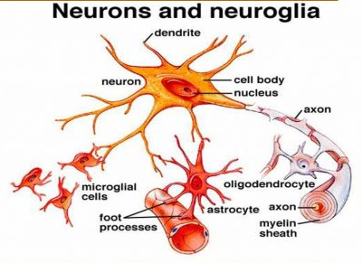
Neuroglial cell:
Type of neuroglial cell in CNS:
- Oligodendrocytes: form myelin sheath
- Astrocytes: recycle neuro transmitter and control chemical environment of neuron.
- Microglial cell: specialized macrophage and helps in phagocytosis.
- Ependymal cell: line the spinal cord and helps in secretion of CSF.
Type of neuroglial cell in PNS:
- Schwann cell: myelination and phagocytic activity.
- Satelite cell: regulate external chemical environment.
