HUMAN ANATOMY & PHYSIOLOGY- BP101T

Body fluids and blood
- Body fluids, composition and functions of blood, hemopoeisis, formation of
hemoglobin, anemia, mechanisms of coagulation, blood grouping, Rh factors,
transfusion, its significance and disorders of blood, Reticulo endothelial system.
- Lymphatic system
Lymphatic organs and tissues, lymphatic vessels, lymph circulation and functions of
lymphatic system
TOPIC: INTRODUCTION TO BODY FLUIDS AND BLOOD

Living cells require nutrients, oxygen, and other essential substances, while also needing to remove waste and harmful substances for healthy tissue function. Different groups of animals have developed various methods for transporting these substances. Simple organisms like sponges and coelenterates circulate water through their body cavities to facilitate substance exchange. More complex organisms use special fluids such as blood and lymph for this purpose. Blood is the primary body fluid for transportation in higher organisms like humans, while lymph also aids in transporting certain substances. This chapter covers the composition and properties of blood and lymph (tissue fluid), as well as the mechanism of blood circulation.

Composition of Body Fluids
The composition of the body fluids is explained below:
Body Fluids | Composition
Intracellular Body Fluids | 70% water, ions, and molecules
Extracellular Body Fluids | Cations and Anions
Transcellular Fluid | Electrolytes such as sodium, bicarbonate and chloride ions.

BLOOD: Blood is a special connective tissue consisting of a fluid matrix, plasma, and formed elements.
- PLASMA: Plasma is a straw coloured, viscous fluid constituting nearly 55 per cent of the blood. 90-92 per cent of plasma is water and proteins contribute 6-8 per cent of it. Fibrinogen, globulins and albumins are the major proteins. Fibrinogens are needed for clotting or coagulation of blood. Globulins primarly are involved in defense mechanisms of the body and the albumins help in osmotic balance. Plasma also contains small amounts of minerals like Na+ , Ca++, Mg++, HCO3 – , Cl– , etc. Glucose, amino acids, lipids, etc., are also present in the plasma as they are always in transit in the body. Factors for coagulation or clotting of blood are also present in the plasma in an inactive form. Plasma without the clotting factors is called serum.
- FORMED ELEMENTS: Erythrocytes, leucocytes and platelets are collectively called formed elements (Figure 18.1) and they constitute nearly 45 per cent of the blood.
Erythrocytes or red blood cells (RBC) are the most abundant of all the cells in blood. A healthy adult man has, on an average, 5 millions to 5.5 millions of RBCs mm–3 of blood. RBCs are formed in the red bone marrow in the adults. RBCs are devoid of nucleus in most of the mammals and are biconcave in shape. They have a red coloured, iron containing complex protein called haemoglobin, hence the colour and name of these cells. A healthy individual has 12-16 gms of haemoglobin in every 100 ml of blood. These molecules play a significant role in transport of respiratory gases. RBCs have an average life span of 120 days after which they are destroyed in the spleen (graveyard of RBCs).
Leucocytes are also known as white blood cells (WBC) as they are colourless due to the lack of haemoglobin. They are nucleated and are relatively lesser in number which averages 6000-8000 mm–3 of blood. Leucocytes are generally short lived. We have two main categories of WBCs – granulocytes and agranulocytes. Neutrophils, eosinophils and basophils are different types of granulocytes, while lymphocytes and monocytes are the agranulocytes. Neutrophils are the most abundant cells (60-65 per cent) of the total WBCs and basophils are the least (0.5-1 per cent) among them. Neutrophils and monocytes (6-8 per cent) are phagocytic cells which destroy foreign organisms entering the body. Basophils secrete histamine, serotonin, heparin, etc., and are involved in inflammatory reactions. Eosinophils (2-3 per cent) resist infections and are also
associated with allergic reactions. Lymphocytes (20-25 per cent) are of two major types – ‘B’ and ‘T’ forms. Both B and T lymphocytes are responsible for immune responses of the body. Platelets also called thrombocytes, are cell fragments produced from megakaryocytes (special cells in the bone marrow). Blood normally contains 1,500,00-3,500,00 platelets mm–3. Platelets can release a variety of substances most of which are involved in the coagulation or clotting of blood. A reduction in their number can lead to clotting disorders which will lead to excessive loss of blood from the body.

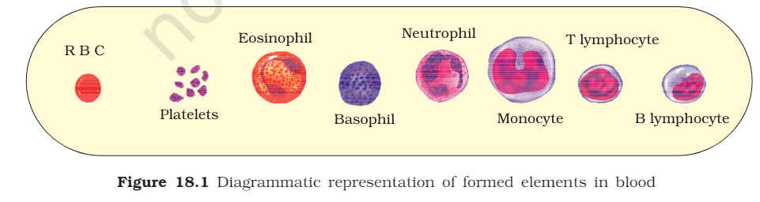

Functions of Body Fluids
The important functions of body fluids include:
- The body fluids facilitate the transportation of oxygen and nutrients throughout the body and remove waste from the body.
- They help in regulating body temperature.
- They maintain an efficient metabolism of the body.

