HUMAN ANATOMY AND PHYSIOLOGY-I, BP-101(T)

UNIT-II (Integumentary system)

CLASS:1

TOPIC – Introduction to Integumentary system, Structure of skin

The integumentary system is the largest organ of the body. It forms a physical barrier between the external environment and the internal environment and protect the body. The integumentary system includes:

- Skin (epidermis, dermis)
- Hypodermis
- Associated glands
- Hair
- Nails.

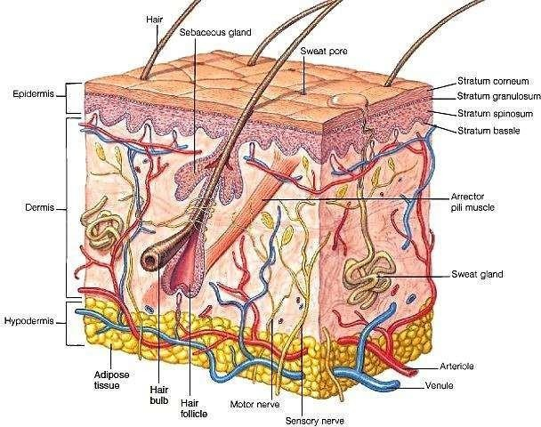

Skin occupy 16% of our total body weight

Skin is made up by two layers:

Epidermis:

  - It is a superficial layer of the skin
  - It contains four principal types of cells: keratinocytes, melanocytes,
  - Langerhans cells, and Merkel cells.
- About 90% of epidermal cells are keratinocytes which are arranged in four or five layers and produce the protein keratin, tough layer.
- About 8% of the epidermal cells are melanocytes which produce pigment melanin. Melanin is a yellow-red or brown-black pigment that contributes to skin color and absorbs damaging ultraviolet (UV) light.
- Langerhans cells develop from red bone marrow and migrate to the epidermis. They protect us from microbes.
- Merkel cells located in the deepest layer of the epidermis, it detect touch sensations.
- Layers of Epidermis: (from deep to superficial):
  - Stratum basale or germinatum – single row of cells attached to dermis; youngest cells
  - Stratum spinosum – Made up of bundles of protein resist tension
  - Stratum granulosum – layers of flattened keratinocytes producing keratin.
  - Stratum lucidum- (only found in thick skin – that is, the palms of the hands, the soles of the feet and the digits)

- Stratum corneum – horn cornified superficial layer
- It is a deep layer of skin made up by fibre and it having good tensile strength.
- It is divided in papillary and reticular region.

Dermis:

- The Papillary Dermis: The papillary dermis is the more superficial of the two, and lies just beneath the epidermal junction. It is relatively thin and is made up of loose connective tissue, which includes:

- Capillaries
  - Elastic fibers
  - Reticular fibers
  - Collagen
- The Reticular dermis:

The reticular dermis is the deeper and thicker layer of the dermis, which lies above the subcutaneous layer of the skin. It contains dense connective tissue, which includes:

  - Blood vessels
  - Elastic fibers (interlaced)
  - Collagen fibers (in parallel layers) or Fibroblasts
  - Mast cells
  - Nerve endings
  - Lymphatics

C.HYPODERMIS:

  - The hypodermis lies between the dermis and underlying organs.
  - It is also known as subcutaneous layer.
  - It is composed of loose areolar tissue and adipose tissue.
  - This layer provides additional cushion and insulation through its fat storage function and connects the skin to underlying structures such as muscle.

D.ASSOCIATED GLANDS:

Integumentary system has four types of exocrine glands, which secrete their product or substance outside the cells and body.

- Sudoriferous glands

  - Sweat glands excrete sweat via very small openings at the skin’s surface.
  - The purpose of sudoriferous glands is to emit perspiration to help cool the body off when the body temperature rises.
- Sebaceous glands:

- It is responsible for releasing oil into the hair follicle to help lubricate and protect the hair shaft, keeping it from becoming hard and brittle.

