HUMAN ANATOMY & PHYSIOLOGY- BP101T

Unit IV 08 hours
- Peripheral nervous system:
Classification of peripheral nervous system: Structure and functions of
sympathetic and parasympathetic nervous system.
Origin and functions of spinal and cranial nerves.
- Special senses
Structure and functions of eye, ear, nose and tongue and their disorders.

TOPIC: PERIPHERAL NERVOUS SYSTEM
Spinal nerves
The second set of peripheral nerves are spinal nerves, of which there are 31 pairs: eight cervical, twelve thoracic, five lumbar, five sacral, and one coccygeal. Their numbering relates to the vertebral column exit level; cervical spinal nerves are numbered according to the vertebra located below, while all the rest according to the vertebra situated above.
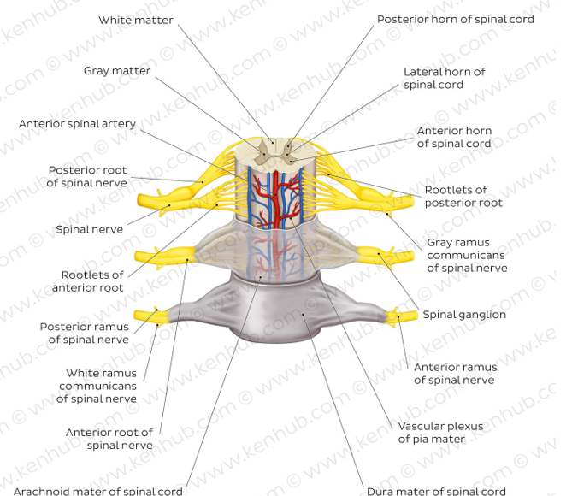
Spinal membranes and nerve roots
Each spinal nerve starts as several rootlets that unite to form two main roots. The anterior root carries motor fibers from neurons whose cell bodies are located in the anterior horn of the spinal cord. The posterior root transports sensory fibers from neurons which have their cell bodies in the dorsal root ganglion. In the thoracic and upper lumbar region, the anterior root also carries autonomic fibers from preganglionic sympathetic neurons whose cell bodies are located in the spinal cord’s lateral horn. The anterior and posterior roots subsequently join to form the spinal nerve proper that carries mixed (sensory, motor, autonomic) fibers.
Spinal nerves leave the vertebral column through the intervertebral foramina located between two successive, adjacent vertebrae. Each spinal nerve then divides into two branches called posterior/dorsal and anterior/ventral rami. Both rami carry mixed fibers. The posterior rami travel backward and divide into branches that supply post-vertebral structures. The anterior rami supply the skin and muscles of the limbs and anterior trunk.
Immediately after the division of the spinal nerve into the two rami, smaller communicating fibers branch out. These white and grey rami communicantes establish a connection between spinal nerves and the two sympathetic trunks of the autonomic nervous system that run along the length of the vertebral column. Note that grey rami communicantes exist at all levels of the spinal cord, whilst white rami are only found at T1-L2 levels.

Somatic nervous system
The somatic, voluntary, nervous system is responsible for providing sensory and motor innervation to skin, muscles and sensory organs. In other words, it carries sensations from the body (pain, touch, temperature, proprioception) and innervates skeletal muscles that are under conscious, or voluntary control. In addition, the somatic nervous system is involved in spinal reflexes, an example being the withdrawal reflex. This helps you to instantly pull away your hand when touching a hot object.
Both cranial and spinal nerves contribute to the somatic nervous system. Cranial nerves provide voluntary motor control and sensation to the head and face. Spinal nerves, as we mentioned previously, supply the trunk and limbs. The posterior rami travel backwards to supply the vertebral column, vertebral muscles and skin of the back whilst the anterior rami supply the limbs and anterior trunk. The majority of anterior rami combine to form nerve plexuses from which many major peripheral nerves stem. The exception to this is the anterior rami of the thoracic region which travel relatively independently from one another without forming plexuses, as the intercostal and subcostal nerves of the trunk.
Peripheral nerves of the nervous plexuses
Cervical plexus | Lesser occipital nerve  Great auricular nerve  Transverse cervical nerve  Supraclavicular nerves  Phrenic nerve  Ansa cervicalis  Other smaller branches, for instance the nerves to the rhomboids and serratus anterior muscles
Brachial plexus | Axillary nerve  Musculocutaneous nerve  Radial nerve  Median nerve  Ulnar nerve  Other smaller branches such as; dorsal scapular, long thoracic, suprascapular nerve, nerve to subclavius, lateral & medial pectoral, medial cutaneous of arm & forearm, superior & inferior subscapular, thoracodorsal
Lumbar plexus | Iliohypogastric nerve  Ilioinguinal nerve  Genitofemoral nerve  Lateral cutaneous nerve of the thigh  Femoral nerve  Obturator nerve
Sacral plexus | Superior gluteal nerve  Inferior gluteal nerve  Sciatic nerve (common fibular and tibial divisions)  Posterior cutaneous nerve of the thigh (perforating cutaneous)  Pudendal nerve  Other smaller branches such as; nerve to piriformis, nerve to quadratus femoris and inferior gemellus, nerve to obturator internus

