Contents of the Lecture:

Cell Communication Cell Signaling Process
Intracellular Signaling Pathways Cell Signaling Types

3

Cell Communication

External Signaling Molecules

Cellular Response

Internal Signaling Molecules
Cell communication is most important for the multicellular organism for the normal activity in a daily life
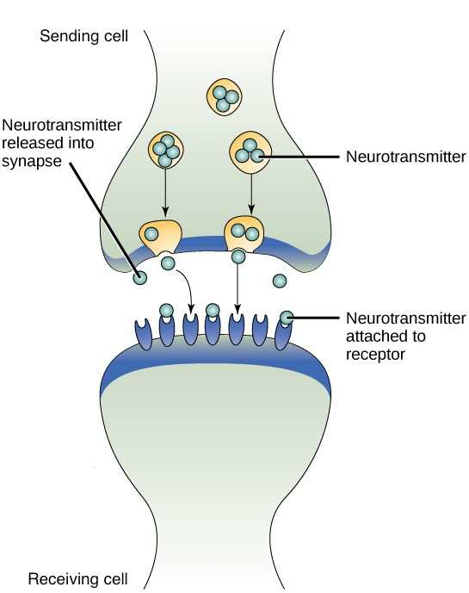


Cell communication occurs by electrochemical communications
All the communication system involve receiving, collecting, and responding to appropriate information according to the cell signaling molecules (internal or external communications)
Cellular Response depends upon the signaling molecules and cell type

4

Cell Communication


Internal communication mainly involves mainly the nervous and endocrine system; these are important for the homeostasis and regulation of the vital body function.
Signaling Molecules: Neurotransmitters and
Hormones

Hormone Signaling Molecules

Cellular Response

5

Cell Communication
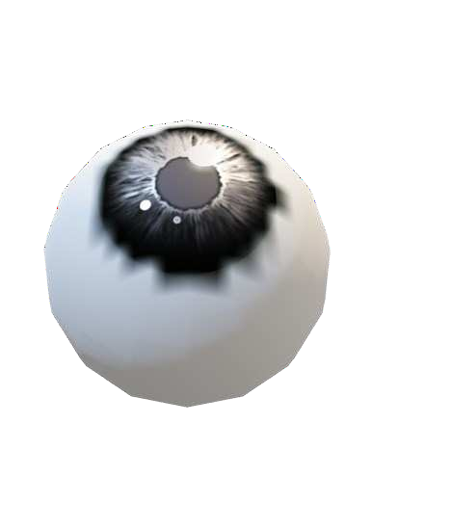
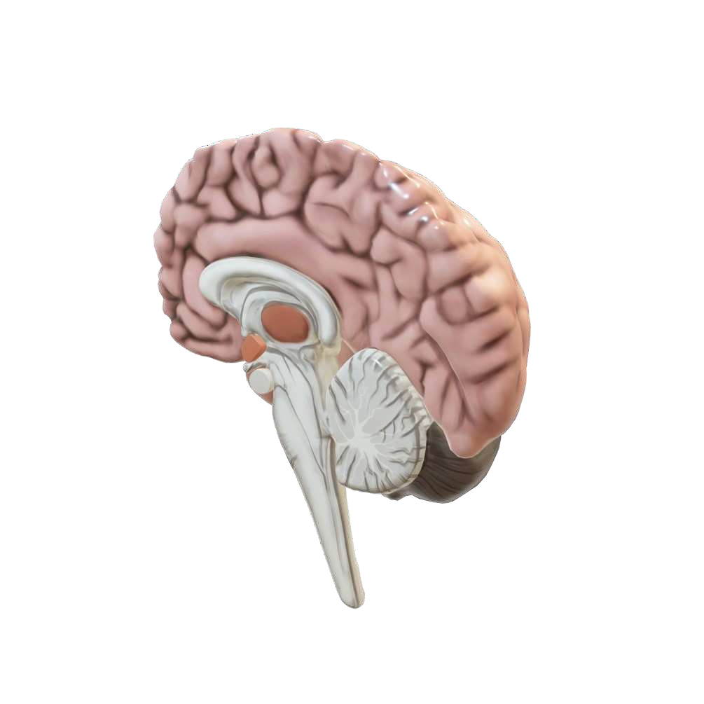
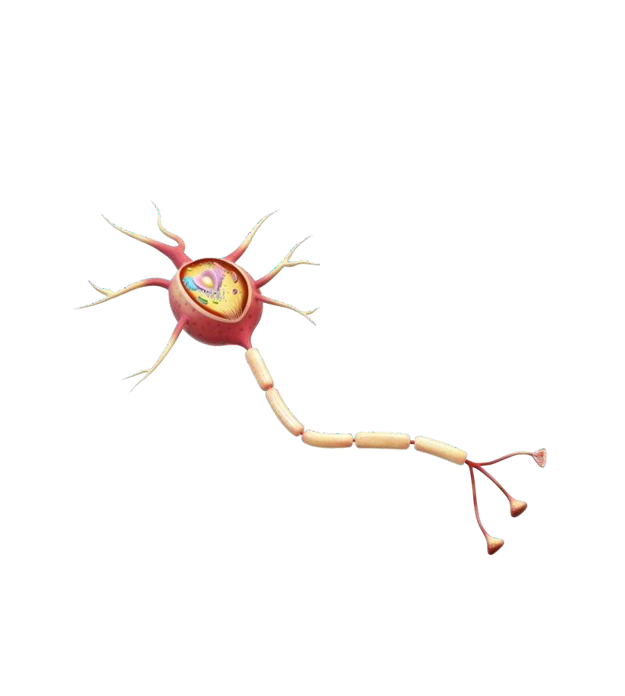
Communication with external environments involves the special senses (Vision, Hear, Taste), and these also depends on the nervous system.

6

Cell Signaling


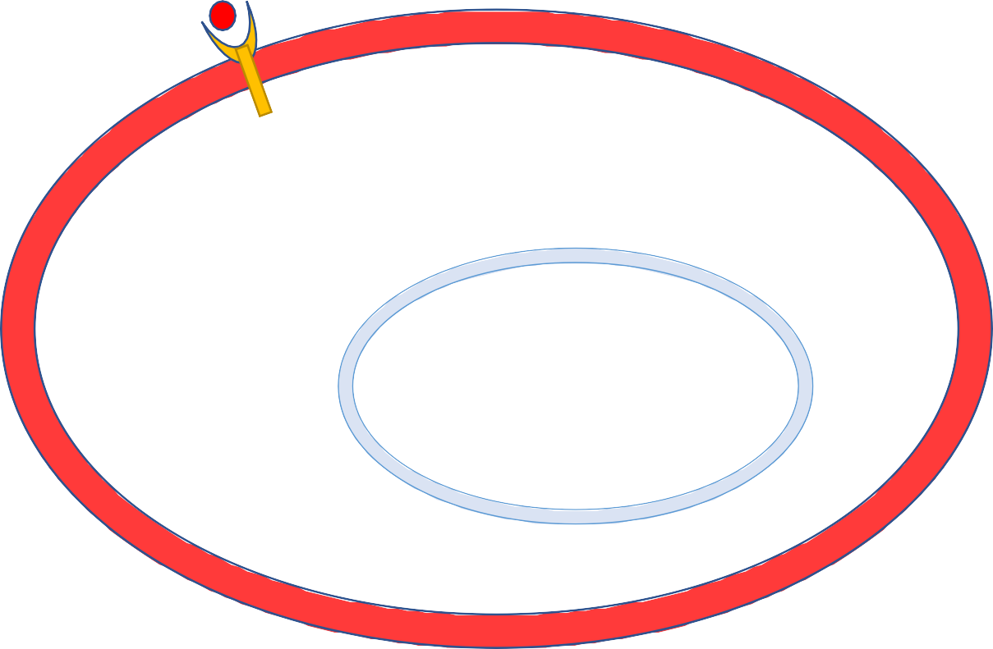
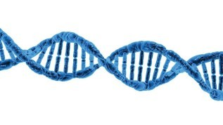

Cell Signaling are also known as signaling cascade, signal- transduction pathways, etc
Receptor
Cell Response
A signal-transduction pathway is a series of steps by which a signal on a cell’s surface or nucleus is converted into a specific cellular response within the cell

7

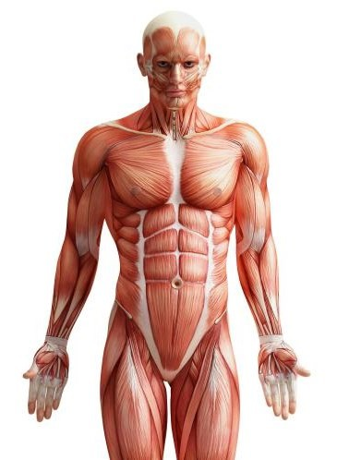




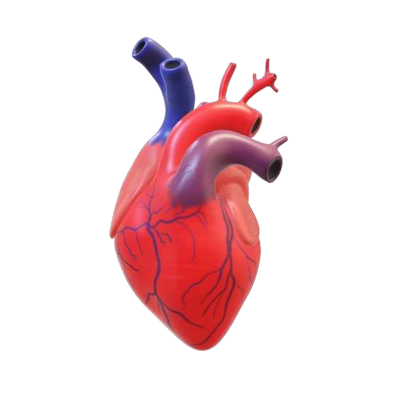
Cellular Responses: Depending upon signaling molecule, cell type and signaling pathways
Cardiac muscle
Myocardial Depression
Myocardial Activation
Contraction
Cell Signaling


Acetylcholine

Adrenaline



Acetylcholine
Skeletal Muscle ₈

Cell Signaling Process

Signaling molecules

Receptor
Cell Signaling occurs in three Stage ( As per Earl W. Sutherland)
- Reception
- Transduction
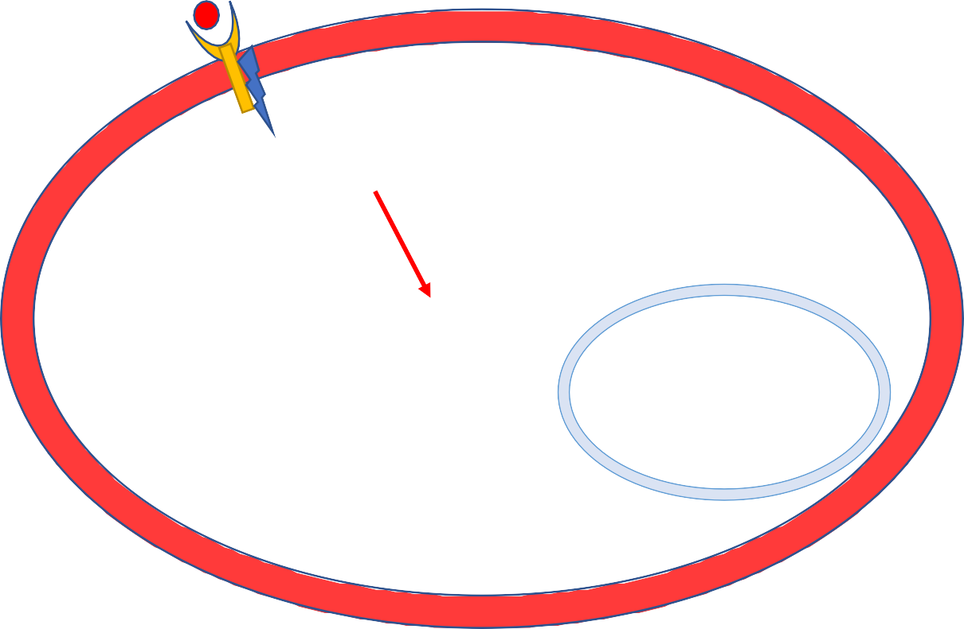
- Response
Signal-Transduction & Amplify
Cellular Response

9

Cell Signaling Receptors

LGIC

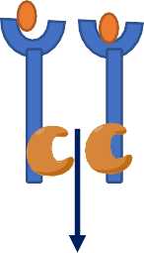
E
Cell Membrane
LR
NR
Ras/Raf/MAPK
Gene transcription

Ions



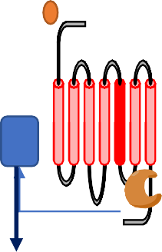
Ions

Cell Membrane

cAPM or IP3/DAG

GPCR

G-protein
- Receptors: proteins, which receive the signal from Biological active molecules
  - Ligand Gated Ion Channel (LGIC)- Fastest
  - G-Protein Coupled Receptor (GPCR)
  - Enzyme Linked Receptor
  - Nuclear Receptor- Slowest

10

Cell Signaling Pathways
- Signal Transduction Pathways cAMP/PKA signaling pathway IP3/Ca2+ Signaling Pathway DAG/PK-C Signaling Pathway NO/cGMP Signaling Pathway Ca2+ Signaling Pathway MAPK Signaling Pathway Ion conduction Pathway
Cell Signaling Pathways

11

Cell Signaling Pathways

Intracellular Signaling Pathways Activated by Extracellular Signaling Molecules:

Signaling Molecules | Target Proteins (Receptor/Enzyme) | Intracellular Signaling Pathways | Responses
Acetylcholine | LGIC  (Nm Receptor) | Na+ Conduction | Skeletal muscle contraction

Acetylcholine | GPCR  (M2-Receptor) | (-) cAMP/PK-A Pathway | Inhibition of Cardiac Activity
Adrenaline | GPCR  (Beta-1 Receptor) | (+) cAMP/PK-A Pathway | Increase the cardiac activity
Nor-Adrenaline | GPCR  (Alfa-1 Receptor) | (+) IP3/Ca2+ pathway (+) DAG/PK- Pathway | Vasoconstriction
Growth Factor | Tyrosine Kinase linked receptor | (+)Ras/Raf/MAPK | Protein synthesis for Growth
Nitric Oxide | Cytplasic Guanylyl cyclase enzyme | (+) cGMP Pathsway | Vasodilation

Cell Signaling Types

Cell Signaling is either local or long distance. Based on this signaling can divide in various forms:
- Contact Dependent
- Paracrine Signaling
C)Synaptic Signaling
- Endocrine Signaling
- Autocrine Signaling

13

Cell Signaling Types



Signaling Cell

Signaling Molecule

Receptor

Target Cell

Contact Dependent
cell signal occurs in between cells having physical contact with each other. This occurs at the cell membrane level.
One cell has a signal molecule, and the other has a
receptor moiety on their cell surfaces.
But both the cells are physically connected where the signaling occurs.
Important for development of immune cells

14

Cell Signaling types

Signaling Cell

Target Cell

Paracrine Signaling





This is a signal where one cell signals nearby neighboring cells. This is somewhat similar to the above type. But, the cells need not be directly connected.
Local Mediators
Target Cell
The signal molecules are released by one cell. These molecules reach nearby cells around and transmit the signal
Example: Response of Histamine, Serotonin,
Prostaglandins

15

Cell Signaling Types

Synaptic Signaling

Cellular Response
This signal occurs at Synaptic junction.
Important role in Neurotransmission within the nervous system

16

Cell Signaling Types



Endocrine Cell

Endocrine

Target Cell

Hormone

Endocrine Signaling
This is a signal which is given by one cell to another cell
located in a distant region.
The signal molecule (endocrine hormone) is released
into the bloodstream.
This is then carried away and distributed by the blood to other cells. These distant cells receive the signal.
Ex: Response of Endocrine hormones

17

Cell Signaling Types


Signaling & Target Cell

Autocrine Signaling
This is a type of cell signal where a cell gives a signal to itself.
A signal molecule is released out of the cell.
This molecule, in return, acts and gives a signal to the same
cell through surface receptors.
Examples: The monocytes produce cytokines that affect themselves.

18

