HUMAN ANATOMY AND PHYSIOLOGY-I, BP-101(T)

UNIT-I (Introduction to human body)

CLASS:2

TOPIC – Levels of Structural Organization, and body systems, basic life Processes

- The organization of the body often is discussed in terms of the distinct levels of increasing complexity, from the smallest chemical building blocks to a unique human organism.
- Life processes of the human body are maintained at several levels of structural organization. These include the chemical, cellular, tissue, organ, organ system, and the organism level. Higher levels of organization are built from lower levels.
- Therefore, molecules combine to form cells, cells combine to form tissues, tissues combine to form organs, organs combine to form organ systems, and organ systems combine to form organisms.

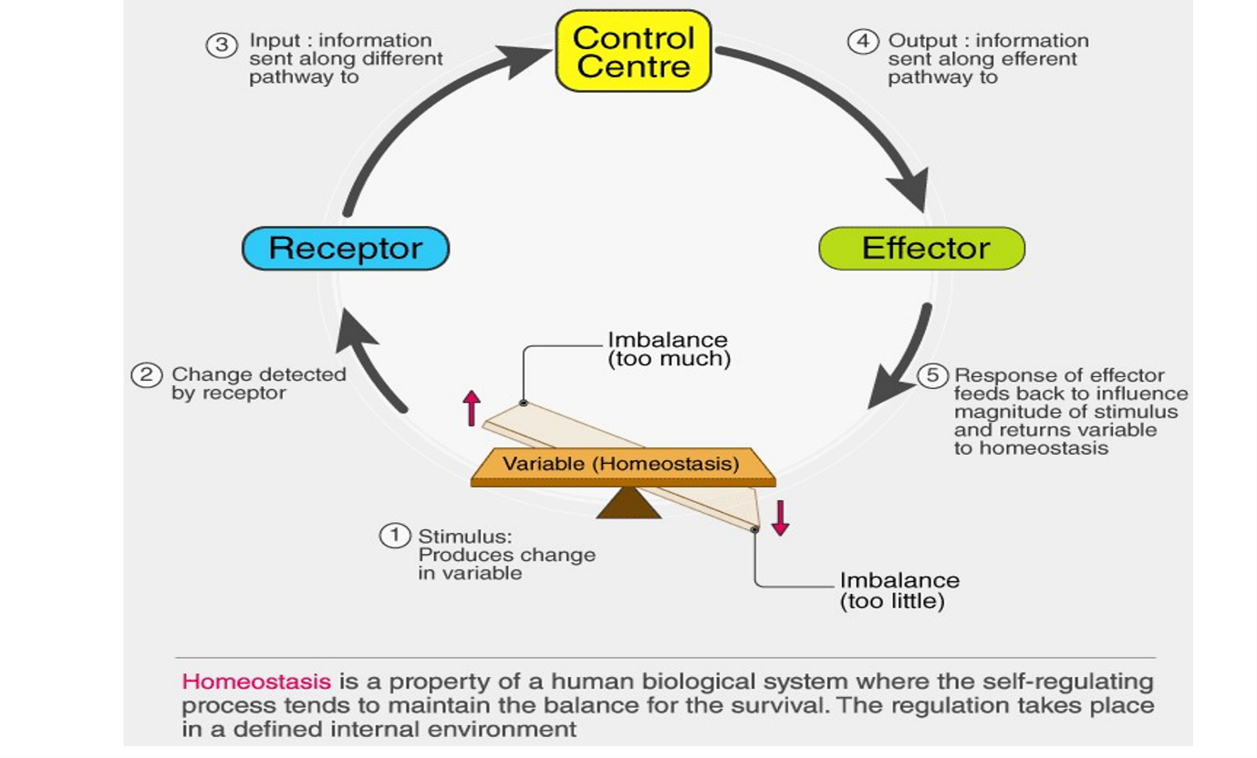

The Levels of Organization:
- A cell is the smallest independently functioning unit of a living organism. Single celled organisms, like bacteria, are extremely small, independently-living organisms with a cellular structure.
- Humans are multicellular organisms with independent cells working in concert together.
- All living structures of human anatomy contain cells, and almost all functions of human physiology are performed in cells or are initiated by cells.
- A human cell typically consists of flexible membranes that enclose cytoplasm, a water-based cellular fluid, with a variety of tiny functioning units called organelles.
- In humans, as in all organisms, cells perform all functions of life.
- A tissue is a group of many similar cells (though sometimes composed of a few related types) that work together to perform a specific function.
- An organ is an anatomically distinct structure of the body composed of two or more tissue types. Each organ performs one or more specific physiological functions.
- An organ system is a group of organs that work together to perform major functions or meet physiological needs of the body.
