HUMAN ANATOMY AND PHYSIOLOGY-I – BP101T

UNIT : V( CARDIOVASCULAR SYSTEM)
CLASS:7
TOPIC: DISORDERS OF HEART

Heart disease symptoms caused by diseased heart muscle (cardiomyopathy)
Early stages of cardiomyopathy may not cause noticeable symptoms. As the condition worsens, symptoms may include:
- Dizziness, lightheadedness and fainting
- Fatigue
- Feeling short of breath during activity or at rest
- Feeling short of breath at night when trying to sleep or waking up short of breath
- Irregular heartbeats that feel rapid, pounding or fluttering
- Swollen legs, ankles or feet

Heart disease symptoms caused by heart valve problems (valvular heart disease)
The heart has four valves — the aortic, mitral, pulmonary and tricuspid valves. They open and close to move blood through the heart. Many things can damage the heart valves. A heart valve may become narrowed (stenosis), leaky (regurgitation or insufficiency) or close improperly (prolapse).
Valvular heart disease is also called heart valve disease. Depending on which valve isn't working properly, heart valve disease symptoms generally include:
- Chest pain
- Fainting (syncope)
- Fatigue
- Irregular heartbeat
- Shortness of breath
- Swollen feet or ankles
Endocarditis is an infection that affects the heart valves and inner lining of the heart chambers and heart valves (endocardium). Endocarditis symptoms can include:
- Dry or persistent cough
- Fever
- Heartbeat changes
- Shortness of breath
- Skin rashes or unusual spots
- Swelling of the legs or belly area
- Weakness or fatigue

CAUSES
Heart disease causes depend on the specific type of heart disease. There are many different types of heart disease.

Causes of coronary artery disease
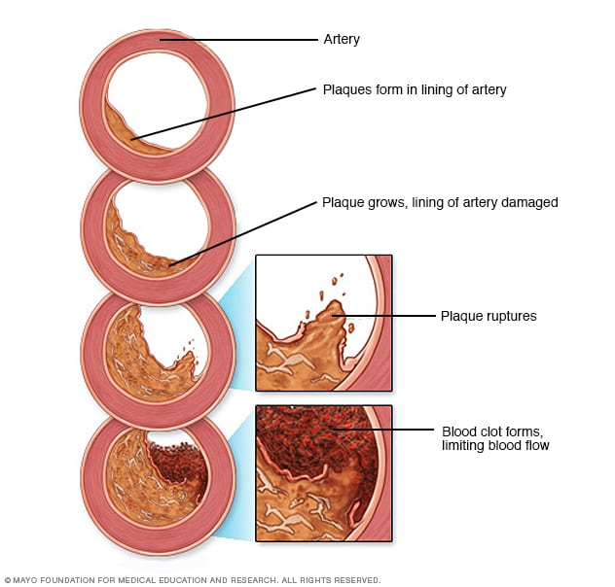
A buildup of fatty plaques in the arteries (atherosclerosis) is the most common cause of coronary artery disease. Risk factors include a poor diet, lack of exercise, obesity and smoking. Healthy lifestyle choices can help lower the risk of atherosclerosis.

Causes of irregular heartbeats (arrhythmias)
Common causes of arrhythmias or conditions that can lead to them include:
- Cardiomyopathy
- Coronary artery disease
- Diabetes
- Drug misuse
- Emotional stress
- Excessive use of alcohol or caffeine
- Heart problem present at birth (congenital heart defects)
- High blood pressure
- Smoking
- Heart valve disease
- Use of certain medications, including those bought without a prescription, and herbs and supplements

Causes of congenital heart defects
A congenital heart defect develops while a baby is growing in the womb. A congenital heart defect forms as the baby's heart develops, about a month after conception. Congenital heart defects change the flow of blood in the heart. Some medical conditions, medications and genes increase the risk of congenital heart defects.

Causes of a thickened or enlarged heart muscle (cardiomyopathy)
The cause of cardiomyopathy depends on the type:
- Dilated cardiomyopathy. The cause of this most common type of cardiomyopathy often is unknown. It may be passed down through families (inherited). Dilated cardiomyopathy typically starts in the heart's main pumping chamber (left ventricle). Many things can cause damage to the left ventricle, including heart attacks, infections, toxins and some drugs, including cancer medicines.
- Hypertrophic cardiomyopathy. This type is usually passed down through families (inherited).
- Restrictive cardiomyopathy. This is the least common type of cardiomyopathy. It can occur for no known reason. Sometimes it's caused by a buildup of protein called amyloid in the heart (cardiac amyloidosis) or connective tissue disorders.

Causes of heart infection
A heart infection, such as endocarditis, occurs when germs reach the heart or heart valves. The most common causes of heart infections are:
- Bacteria
- Viruses
- Parasites

Causes of heart valve disease
Many things can cause diseases of the heart valves. Some people are born with heart valve disease (congenital heart valve disease). Heart valve disease may also be caused by conditions such as:
- Rheumatic fever
- Infections (infectious endocarditis)
- Connective tissue disorders

RISK FACTORS
Risk factors for heart disease include:
- Age. Growing older increases the risk of damaged and narrowed arteries and a weakened or thickened heart muscle.
- Sex. Men are generally at greater risk of heart disease. The risk for women increases after menopause.
- Family history. A family history of heart disease increases the risk of coronary artery disease, especially if a parent developed it at an early age (before age 55 for a male relative, such as your brother or father, and 65 for a female relative, such as your mother or sister).
- Smoking. If you smoke, quit. Substances in tobacco smoke damage the arteries. Heart attacks are more common in smokers than in nonsmokers. If you need help quitting, talk to your health care provider about strategies that can help.
- Unhealthy diet. Diets high in fat, salt, sugar and cholesterol have been linked to heart disease.
- High blood pressure. Uncontrolled high blood pressure can cause the arteries to become hard and thick. These changes interrupt blood flow to the heart and body.
- High cholesterol. Having high cholesterol increases the risk of atherosclerosis. Atherosclerosis has been linked to heart attacks and strokes.
- Diabetes. Diabetes increases the risk of heart disease. Obesity and high blood pressure increase the risk of diabetes and heart disease.
- Obesity. Excess weight typically worsens other heart disease risk factors.
- Lack of exercises. Being inactive (sedentary lifestyle) is associated with many forms of heart disease and some of its risk factors, too.
- Stress. Unrelieved stress may damage the arteries and worsen other risk factors for heart disease.
- Poor dental health. It's important to brush and floss your teeth and gums often. Also get regular dental checkups. Unhealthy teeth and gums makes it easier for germs to enter the bloodstream and travel to the heart. This can cause endocarditis.

COMPLICATIONS
Complications of heart disease include:
- Heart failure. This is one of the most common complications of heart disease. Heart failure occurs when the heart can't pump enough blood to meet the body's needs.
- Heart attack. A heart attack may occur if a blood clot is stuck in a blood vessel that goes to the heart.
- Stroke. The risk factors that lead to heart disease can also lead to an ischemic stroke. This type of stroke happens when the arteries to the brain are narrowed or blocked. Too little blood reaches the brain. A stroke is a medical emergency — brain tissue begins to die within just a few minutes of a stroke.
- Aneurysm. An aneurysm is a bulge in the wall of an artery. If an aneurysm bursts, you may have life-threatening internal bleeding.
- Peripheral artery disease. In this condition, the arms or legs — usually the legs — don't get enough blood. This causes symptoms, most notably leg pain when walking (claudication). Atherosclerosis can lead to peripheral artery disease.
- Sudden cardiac arrest. Sudden cardiac arrest is the sudden loss of heart function, breathing and consciousness. It's usually due to a problem with the heart's electrical system. Sudden cardiac arrest is a medical emergency. If not treated immediately, it results in sudden cardiac death.

PREVENTION
The same lifestyle changes used to manage heart disease may also help prevent it. Try these heart-healthy tips:
- Don't smoke.
- Eat a diet that's low in salt and saturated fat.
- Exercise at least 30 minutes a day on most days of the week.
- Maintain a healthy weight.
- Reduce and manage stress.
- Control high blood pressure, high cholesterol and diabetes.
- Get good sleep. Adults should aim for 7 to 9 hours daily.

