HUMAN ANATOMY AND PHYSIOLOGY-I – BP101T

UNIT : V( CARDIOVASCULAR SYSTEM)
CLASS:5
TOPIC: CARDIOVASCULAR SYSTEM
Function of arteries:
Ascending aorta: It supply blood to heart itself.
Arch of aorta: It supplies blood to head, neck and upper limbs.
Descending aorta: It supplies blood to the body wall of chest and abdominal cavity and its viscera.
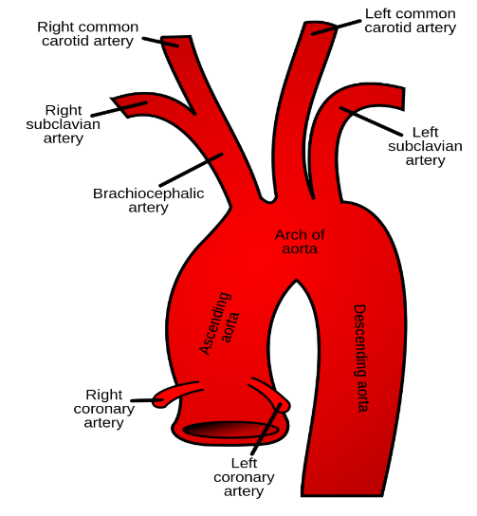
Function of veins:
- They are responsible for returning deoxygenated blood back to the heart after arteries carry blood out.
- The vena cava is the largest vein in the body.
- Veins have much thinner walls than arteries.
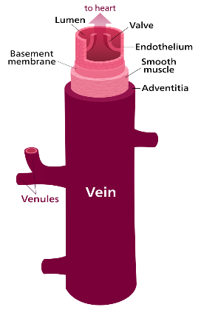

Blood circulation

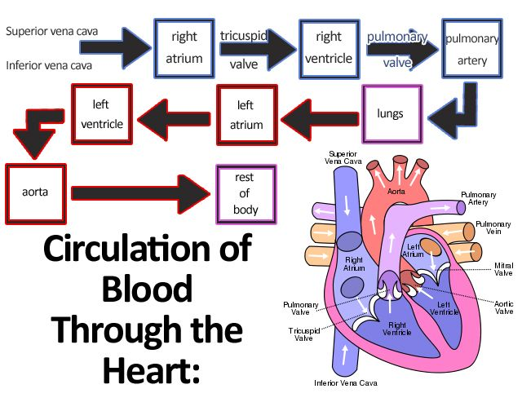
Function of Heart:
- The human heart is an organ that pumps blood throught the body via the circulatory system
- It supplying oxygen and nutrients to the tissues and removing carbon dioxide and other wastes
Electrocardiogram: An electrocardiogram (ECG or EKG) is a test that checks how your heart is functioning by measuring the electrical activity of the heart. With each heart beat, an electrical impulse (or wave) travels through your heart. This wave causes the muscle to squeeze and pump blood from the heart.
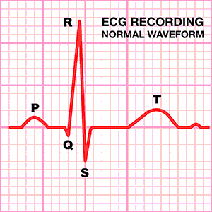

Cardiac cycle: The period of time that begins with contraction of the atria and ends with ventricular relaxation is known as the cardiac cycle. cardiac cycle occurs in two phases. They are:
- systole - a period of contraction
- Diastole- a period of relaxation
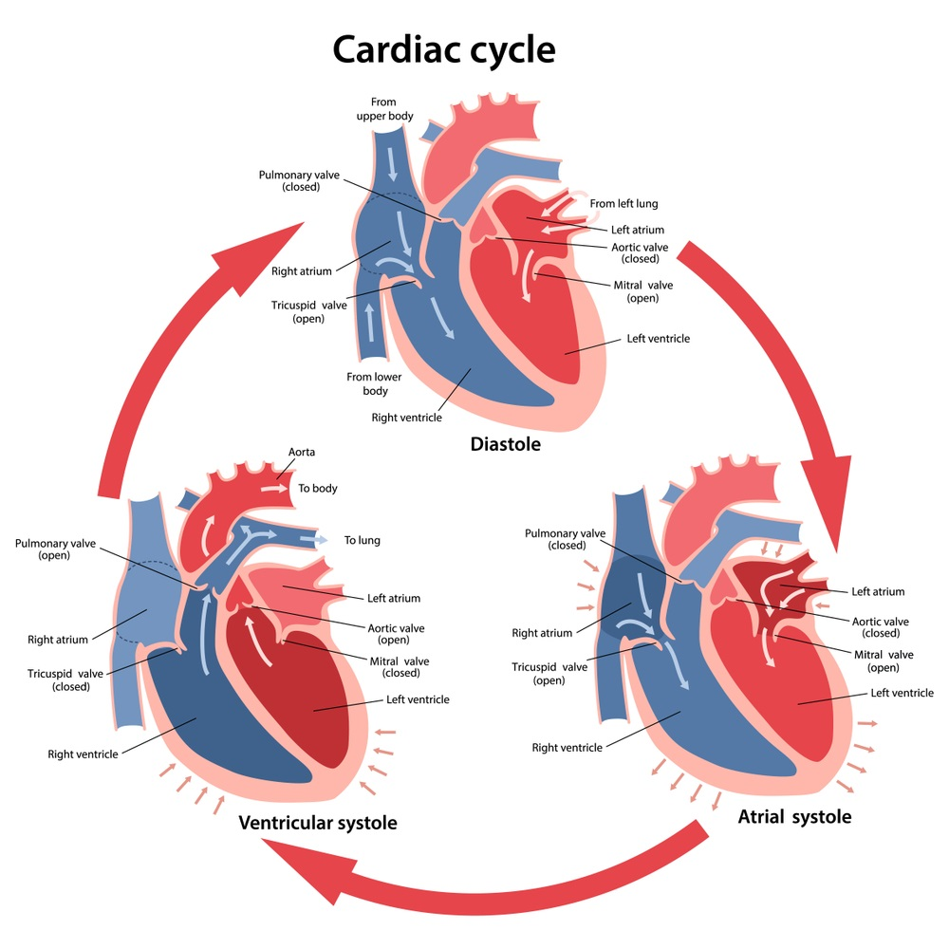
Cardiac output:
- It is defined as the quantity of blood pumped by the heart in one minute.
- Cardiac output (CO) is a measurement of the amount of blood pumped by each ventricle (stroke volume) in one minute. This is calculated by multiplying the stroke volume (SV) by the beats per minute of the heart rate (HR). So that:
CO = SV x HR.
