HUMAN ANATOMY AND PHYSIOLOGY-I – BP101T

UNIT : V( CARDIOVASCULAR SYSTEM)
CLASS:4
TOPIC: CARDIOVASCULAR SYSTEM
Arterial and venous system:
- The heart pumps blood into arteries and,
- The veins return blood to the heart.
So, arteries carry pure blood away from the heart. Veins carry impure blood to the heart.
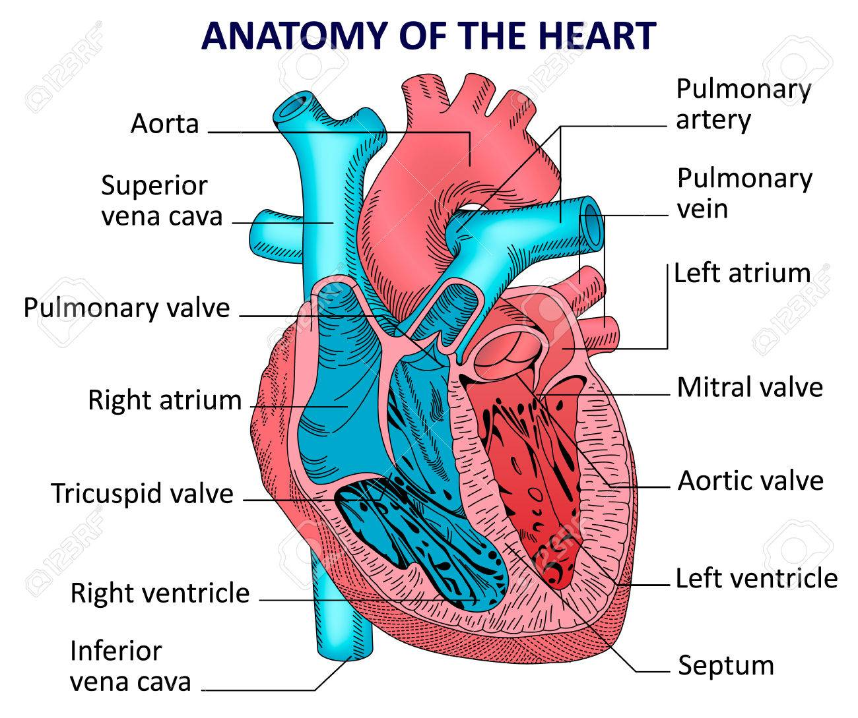

Structure of arteries & veins:
Arteries & veins are made of the 3 layer:
- Tunica adventitia-outer fibrous layer
- Tunica media-middle muscle layer
- Tunica intima-inner serous layer
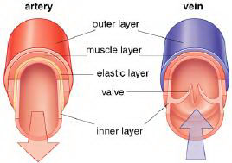
The Arteries:
Aorta is the main artery in the body. It arises from the left ventricle. Aorta consists of 3 parts:
- Ascending aorta
- Arch of aorta
- Descending aorta.
