HUMAN ANATOMY AND PHYSIOLOGY-I – BP101T

UNIT : V( CARDIOVASCULAR SYSTEM)
CLASS:2
TOPIC: CARDIOVASCULAR SYSTEM
Heart is made of four chambers.
The two chambers on the right side are known as-
- Right atrium
- Right ventricle
The chambers on the left side are known as-
- Left atrium
- Left ventricle
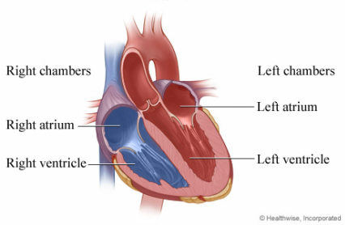
Upper chambers: The upper chambers are:
- The atria
-Right
-Left
- The right atrium: Receives deoxygenated blood from the body through the:
-Superior vena cava (head and upper
body)
-Inferior vena cava (legs and lower
torso)
- The left atrium: Receives oxygenated blood from the lungs through the:
-Pulmonary vein
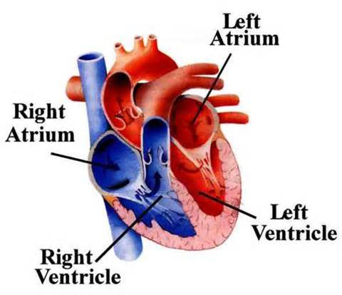
Lower chambers: The lower chambers are:
- The ventricle
-Right
-Left
- The right ventricle: Receives de-oxygenated blood as the right atrium contracts.
- The left ventricle: Receives oxygenated blood as the left atrium contracts.
Valves of the Heart: Valves are located within the chambers of the heart.
- The four valves are known as:
- The tricuspid valve.
- The pulmonic or pulmonary valve.
- The mitral valve.
- The aortic valve.
