HUMAN ANATOMY AND PHYSIOLOGY-I – BP101T

UNIT : V( CARDIOVASCULAR SYSTEM)
CLASS:1
TOPIC: CARDIOVASCULAR SYSTEM
- The cardiovascular system (cardio means- heart, vascular means – blood vessels).
- The cardiovascular system consists of heart and blood vessels.
- It is mainly a transport system.
- It transports respiratory gases, nutrients and excretory products to various parts of the body.
- Blood is the medium through which these substances are transported.
Anatomy of the Heart
- Anatomy of the Heart
- Heart is a conical, hollow, muscular organ.
- It lies in the thorax between the lungs and behind the sternum.
- It is about 10 cm long and weighs about 225 g in women and is heavier in men (about 310 g).
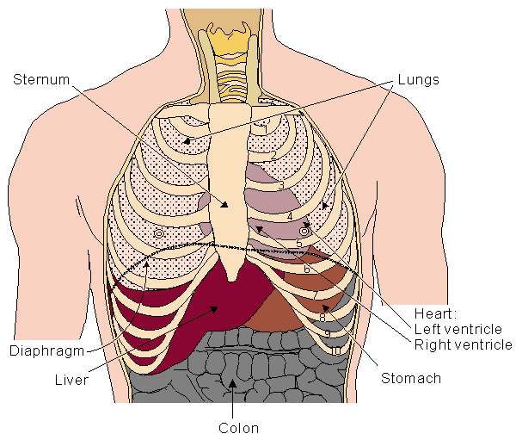
Blood is carried from the heart to the rest of the body through a complex network of arteries, arterioles and capillaries. Blood is returned to the heart through venules and veins.

Layers of the Heart
- Heart is surrounded by an outer covering called pericardium. It contains two layers called-
- visceral pericardium
- parietal pericardium
- The middle layer is made of heart muscle fibers. It is called as myocardium.
- The inner lining is called as endocardium.
