Wound Healing

Healing
- Healing - body response to injury
- An attempt to restore normal structure and function
- Involves 2 distinct processes:
- Regeneration - healing by proliferation of parenchymal cells ; results in complete restoration
- Repair - healing by proliferation of connective tissue elements resulting in fibrosis and scar

Regeneration
- Proliferation of parenchmal cells
- Complete restoration of original tissue
- Cells are under the constant regulatory control of their cell cycle
- Involves
  - Epidermal growth factor
  - fibroblast growth factor, platelet derived
  - growth factor, endothelial growth factor,
  - transforming growth factor-β

Cell cycle and its phases
- Period between two successive cell divisions
- M (mitosis) phase: Phase of mitosis.
- G1 (gap 1) phase: daughter cell enters G1 phase after mitosis
- S (synthesis) phase: the synthesis of nuclear DNA
- G2 (gap 2) phase
- G0 (gap 0) phase: resting phase of the cell after an M phase
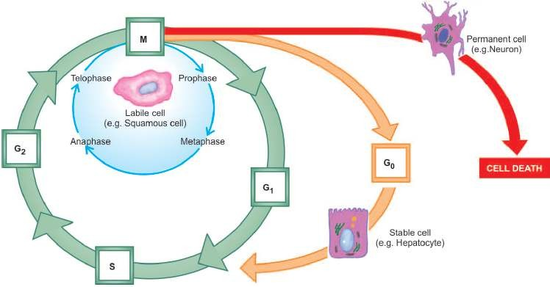

Phases of cell cycle

Type of cells involved in regeneration – depending on the speed of cell division
- Labile cells - continuously dividing
- Epidermis, mucosal epithelium, GI tract epithelium etc
- Stable cells - low level of replication
- Hepatocytes, renal tubular epithelium, pancreatic acini
- Permanent cells - never divide
- Nerve cells, cardiac myocytes, skeletal muscle

Repair
- Replacement of injured tissue by fibrous tissue Two processes are involved in repair:
- Granulation tissue formation
- Contraction of wounds
  - Involves mesenchymal cells
  - connective tissue cells
  - endothelial cells, macrophages & some parenchymal cells

Granulation tissue formation

Phase of inflammation
  - Acute inflammatory
  - Response with exudation of plasma, neutrophils
  - Monocytes within 24 hours

Phase of clearance
  - Proteolytic enzymes liberated from Neutrophils
  - Autolytic enzymes from dead tissues cells
  - Phagocytic activity of macrophages
  - Clear off the necrotic tissue, debris and RBCs

Phase of ingrowth of granulation tissue
- Angiogenesis
  - Proliferation of endothelial cells
  - Development of capillary sprout
  - Vascular endothelial growth factor (VEGF)
  - Platelet-derived growth factor (PDGF)

Fibrogenesis
- Fibroblasts originate from fibrocytes

- Collagen fibrils begin to appear by about 6th day
- Formation of inactive looking scar - cicatrisation

Contraction of wounds
- Wound starts contracting after 2-3 days
- Process is completed by the 14th day
- Reduced by approximately 80% of its original size
- Results in rapid healing
- Dehydration
- Contraction of collagen
- Appearance of Myofibroblasts

Healing of wound in skin
- Combination of Regeneration and repair Accomplished in one of the following two ways:
- Healing by first intention (primary union)
- Healing by second intention (secondary union)
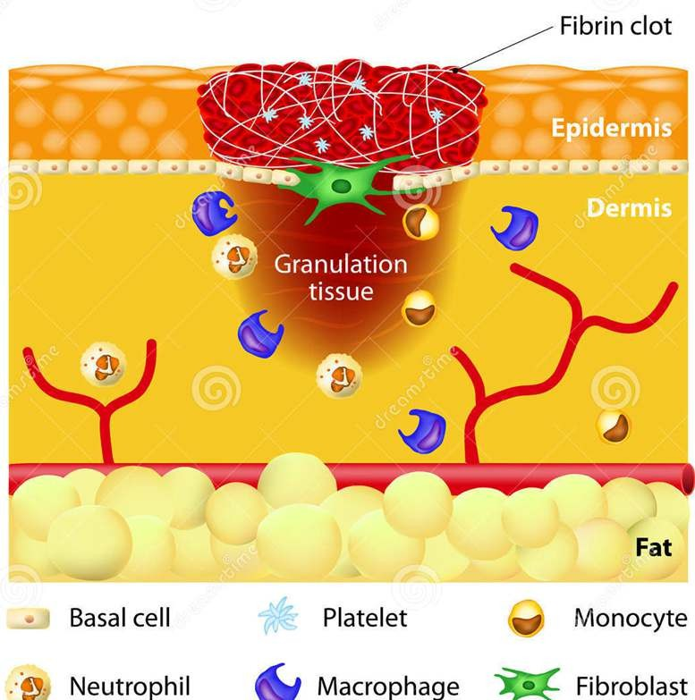
Healing by first intention (primary union)

Characteristics
- Clean and uninfected
- Surgically incised
- Without much loss of cells and tissue
- Edges of wound are approximated by surgical sutures

Sequence of events
- Initial haemorrhage
- Acute inflammatory response
- Epithelial changes
- Organisation
- Suture tracks
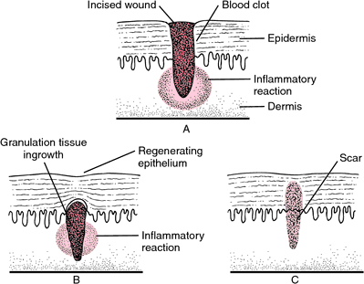

Healing by first intention
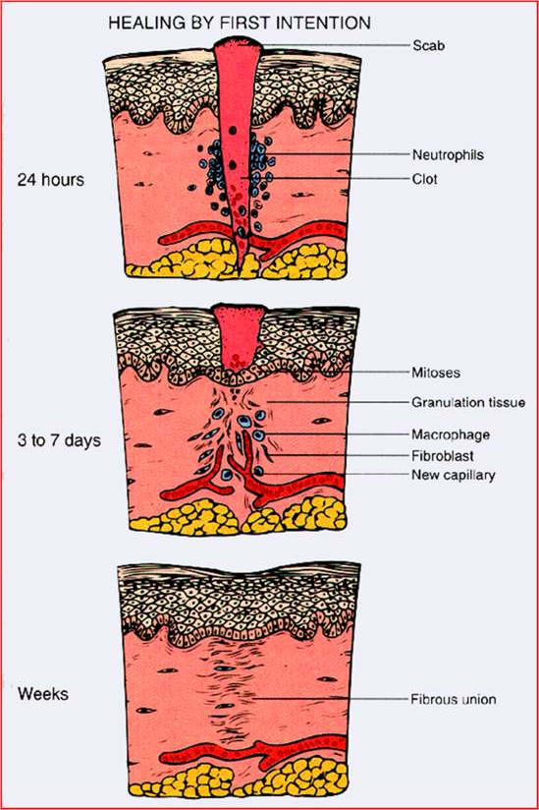

Healing by second intention (secondary union)

Characteristics
- Open with a large tissue defect, at times infected
- Having extensive loss of cells and tissues
- The wound is not approximated by surgical sutures but is left open

Sequence of events
- Initial haemorrhage followed by clotting
- Inflammatory phase – neutrophills & macrophages
- Epithelial changes – epidermal cell margination & proliferation
- Granulation tissue
- Wound contraction
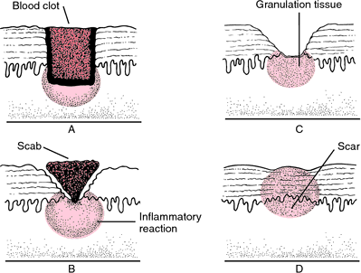
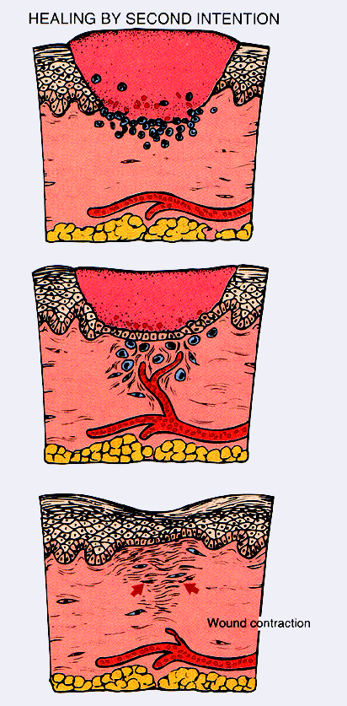

Factors affecting wound healing

Local factors
- Infection
- Blood supply to wound area
- Mechanical factors
- Foreign bodies
- Exposure to ionising radiation
- Size, Location & type of wound

Systemic factors
- Age
- Nutrition
- Systemic infection
- Uncontrolled diabetes
- Haemetological abnormalities

Summary
- Healing is a body response to injury it is an attempt to restore normal structure and function
- Healing occurs by two processes- regeneration and repair
- Contraction of wound involves dehydration, contraction of collagen, appearance of myofibroblasts
- Healing of wounds of skin occurs by first intention or second intention depending on the type of infection.

