PATHOPHYSIOLOGY
- Chronic inflammation of the synovial tissue lining the joint results in the proliferation of this tissue
- The inflamed, proliferating synovium is characteristic of rheumatoid arthritis is called pannus
- This pannus invades the cartilage and eventually the bone surface, producing erosions of bone and cartilage and leading to destruction of the joint
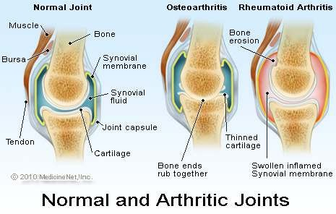

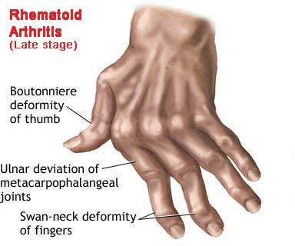
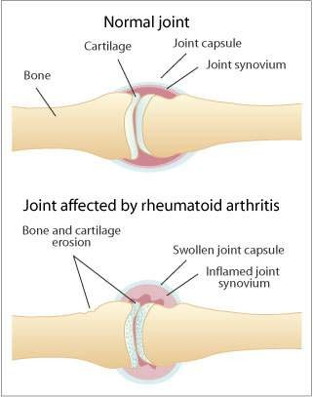

- Rheumatoid arthritis is considered to be an immune response to an unknown antigen and the antibody formed against rheumatoid arthritis is (rheumatoid factor), which is Immunoglobulin M (IgM).
- In rheumatoid arthritis immune system can no longer differentiate self from nonself tissues and attacks the synovial tissue and other connective tissues
- The immune system has both
  - humoral (B -Lymphocytes) and
  - cell-mediated (T-lymphocytes) functions.
- The humoral component is necessary for the formation of antibodies.
- Most patients with rheumatoid arthritis form antibodies called rheumatoid factors.
- Immunoglobulins (IgM) can activate the complement system
- The complement system encourages chemotaxis, phagocytosis, and the release of lymphokines by mononuclear cells, which are then presented to T lymphocytes.
- The processed antigen is recognized by MHC proteins on the lymphocyte, which activates it to stimulate the production of T and B cells.
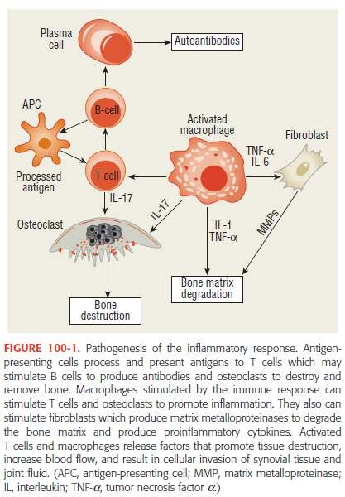

- The proinflammatory cytokines tumor necrosis factor (TNF), interleukin-1 (IL-1), and interleukin-6 (IL-6) are key substances in the initiation and continuance of rheumatoid inflammation
- Activated T cells produce cytotoxins, which are directly toxic to tissues, and cytokines, which stimulate further activation of inflammatory processes and attract cells to areas of inflammation

Rheumatoid arthritis progresses in 3 stages:-

- st Stage - Swelling of the synovial lining, causing, pain, warmth,stiffness, redness ,swelling around the joint

- nd Stage - Rapid division and growth of cells, or pannus, which causes the synovium to thicken

- rd Stage - The inflamed cells release enzymes that might damage, bone & cartilage, often causing the involved joint to loose its shape and alignment, causing more pain and loss of movement
- Vasoactive substances also play a role in the inflammatory process.
- Histamine, kinins, and prostaglandins are released at the site of inflammation.
- These substances increase both blood flow to the site of inflammation and the permeability of blood vessels.
- These substances cause the edema, warmth, erythema and pain
- Loss of cartilage may result in a loss of the joint space
- The formation of chronic granulation or scar tissue can lead to loss of joint motion or bony fusion (called
ankylosis)
- This results in a loss of support to the affected joint leading to chronic deformity
- CD8 + killer T cells have a regulatory effect on the immune process by suppressing activity of CD4 + cells through release of antiinflammatory cytokines and promoting apoptosis (cell death)
- Activated T cells produce cytotoxins, which are directly toxic to tissues, and cytokines, which stimulate further activation of inflammatory processes and attract cells to areas of inflammation
- Macrophages are stimulated to release prostaglandins and cytotoxins
- T-cell activation requires both stimulation by proinflammatory cytokines as well as interaction between cell surface receptors, called co-stimulation
- One of these costimulation interactions is between CD28 and CD80/86
- The binding of the CD80/86 receptor by abatacept has proved to be an effective treatment for RA but preventing costimulation interactions between T cells
- Although it has been suggested that T cells play a key role in the pathogenesis of RA, B cells clearly have an equally important role
- Evidence for this importance may be found in the effectiveness of B-cell depletion using rituximab in controlling rheumatoid inflammation
- Activated B cells produce plasma cells, which form antibodies
- These antibodies in combination with complement result in the accumulation of polymorphonuclear leukocytes, which release cytotoxins, oxygen free radicals, and hydroxyl radicals that promote cellular damage to synovium and bone

- The benefits of B-cell depletion occur even though antibody formation is not suppressed with rituximab therapy suggesting other mechanisms play a role in reducing RA activity
- B cells produce cytokines that may alter the function of other immune cells
- They also have the ability to process antigens and act as antigen presenting cells, which interact with T cells to activate the immune process
- In the synovial membrane, CD4 + T cells are abundant and communicate with macrophages, osteoclasts, fibroblasts and chondrocytes either through direct cell–cell interactions using cell surface receptors or through proinflammatory cytokines such as TNF-α, IL-1, and IL-6
- These cells produce metalloproteinases and other cytotoxic substances, which lead to the erosion of bone and cartilage
- They also release substances promoting growth of blood vessels and adhesion molecules, which assists in proinflammatory cell trafficking and attachment of fibroblasts to cartilage and eventual synovial invasion and destruction
- Vasoactive substances also play a role in the inflammatory process
- Histamine, kinins, and prostaglandins are released at the site of inflammation
- These substances increase both blood flow to the site of inflammation and the permeability of blood vessels
- These substances cause -granulocytes to pass from blood vessels to the site of inflammation
- The end results of the chronic inflammatory changes are variable. Loss of cartilage may result in a loss of the joint space
- The formation of chronic granulation or scar tissue can lead to loss of joint motion or bony fusion (called
ankylosis )
- Laxity of tendon structures can result in a loss of support to the affected joint, leading to instability or subluxation

Clinical Presentation SYMPTOMS
- Joint pain and stiffness of more than 6 weeks’ duration
- May also experience fatigue, weakness, low-grade fever, and loss of appetite
- Muscle pain and afternoon fatigue may also be present
- Joint deformity is generally seen late in the disease

SIGNS
- Tenderness with warmth and swelling over affected joints usually involving hands and feet
- Distribution of joint involvement is frequently symmetrical
- Rheumatoid nodules may also be present

LABORATORY TESTS
- Rheumatoid factor detectable in 60% to 70%.
- Elevated erythrocyte sedimentation rate (ESR)and
- C-reactive protein are markers for inflammation.
- Normocytic normochromic anemia is common, as is thrombocytosis.

OTHER DIAGNOSTIC TESTS
- Joint fluid aspiration may show increased white blood cell counts without infection, and crystals.
- Joint radiographs may show periarticular osteoporosis, joint space narrowing, or erosions.

- The symptoms of rheumatoid arthritis usually develop over the course of several weeks to months
- symptoms include fatigue, weakness, low-grade fever, loss of appetite, and joint pain
- Stiffness and muscle aches (myalgias) may precede the development of joint swelling (synovitis)
- Fatigue may be more of a problem in the afternoon
- During disease flares, the onset of fatigue begins earlier in the day and subsides as disease activity lessens

Joint Involvement
- Joint involvement tends to be symmetrical; however, early in the disease some patients present with an asymmetrical pattern involving one or a few joints that eventually develops into the more classic presentation
- About 20% of patients develop an abrupt onset of their illness with fevers, polyarthritis, and constitutional symptoms (e.g., depression, anxiety, fatigue, anorexia, and weight loss
- No single test or physical finding can be used to make the diagnosis of rheumatoid arthritis
- The joints affected most frequently by rheumatoid arthritis are the small joints of the hands, wrists, and feet
- In addition, elbows, shoulders, hips, knees, and ankles may be involved
- Patients usually experience joint stiffness that typically is worse in the morning
- Chronic inflammation with lack of adequate exercise program results in loss of range of motion, atrophy of muscles, weakness, and deformity
- On examination, the swelling of the joints may be visible or may be apparent only by palpation
- The swelling feels soft and spongy because it is caused by proliferation of soft tissues or fluid accumulation within the joint capsule
- The swollen joint may appear erythematous and feel warmer than nearby skin surfaces, especially early in the course of the disease
- Deformity of the hand may be seen with chronic inflammation
- These changes may alter the mechanics of hand function, reducing grip strength and making it difficult to perform usual daily activities

- Swelling at the elbow is most evident at the radiohumeral joint
- Shoulder pain may result from involvement of the joint itself or from tendon inflammation (tendinitis) or inflammation of the bursa (bursitis) near the deltoid muscle
- The knee also can be involved, with loss of cartilage, instability, and joint pain
- Foot and ankle involvement in rheumatoid arthritis is common
- The metatarsophalangeal joints are involved commonly in rheumatoid arthritis, making walking difficult
- Subluxation of the metatarsal heads leads to “cock-up” or hammer-toe deformities
- Involvement of the spine usually occurs in the cervical vertebrae; lumbar vertebral involvement is rare
- The temporomandibular joint (jaw) can be affected, resulting in difficulty in chewing food
- Inflammation of cartilage in the chest can lead to chest wall pain
- Hip pain may occur as a result of destructive changes in the hip joint, soft-tissue inflammation (e.g., bursitis), or referred pain from nerve entrapment at the lumbar vertebrae

EXTRA-ARTICULAR INVOLVEMENT
- RHEUMATOID NODULES (on extensor surfaces of elbows, forearms, and hands)
- VASCULITIS (Invasion of blood vessel walls by inflammatory cells)
- PULMONARY COMPLICATIONS (pleural effusion,fibrosis)
- OCULAR MANIFESTATIONS (keratoconjunctivitis, Sjogren’s syndrome)
- CARDIAC INVOLVEMENT (pericarditis)
- FELTY’S SYNDROME (splenomegaly and neutropenia)
- OTHER COMPLICATIONS (Lymphadenopathy)
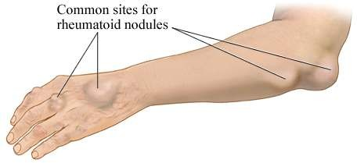

TREATMENT GOALS
- The ultimate goal is to achieve complete disease remission, although this goal is hardly ever achieved.
- Additional goals include
- controlling disease activity and joint pain,
- maintaining the ability to function in daily activities or work,
- improving the quality of life,
- slowing destructive joint changes.

TREATMENT
- Includes pharmacologic and nonpharmacologic therapies.

NONPHARMACOLOGIC THERAPY
- Rest (relieves stress on inflamed joints), occupational therapy (skills and exercises), physical therapy, use of assistive devices, weight reduction, and surgery are the most useful types of nonpharmacologic therapy.

