Electrophilic addition to symmetrical and unsymmetrical 𝝅 bonds

    - When the same substituents are at each end of the double or triple bond, it is called symmetrical.
    - Unsymmetrical means different substituents are at each end of the double or triple bond.
    - Electrophilic addition of unsymmetrical reagents (HX, H2O or ROH) to unsymmetrical double or triple bonds follows Markovnikov’s rule.

MARKOVNIKOV'S RULE
- In the ionic addition of an acid to the carbon-carbon double bond of an alkene, the hydrogen of the acid attaches itself to the carbon atom that already holds the greater number of hydrogen. This statement is generally known as Markovnikov's rule.
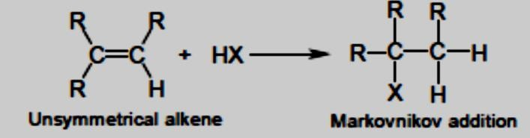

Modern Markovnikov rule states

- The modern Markovnikov rule states that, in the ionic addition of an unsymmetrical reagent to a double bond, the positive portion of the adding reagent adds to a carbon atom of the double bond to yield the more stable carbocation as an intermediate.

- For example, Alkenes are converted to alkyl halides by the addition of HX (HCl, HBr or HI). Addition of HX to unsymmetrical alkenes follows Markovnikov’s rule.

- addition of hydrogen bromide (HBr) to propene yields 2-bromopropane as the major product.
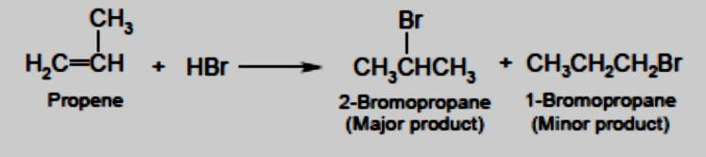

Mechanism. The double bond p electrons attack the electrophile. Protonation of the double bond yields a secondary carbocation inter mediate. The bromine nucleophile attacks the carbocation to form 2 - bromopropane.
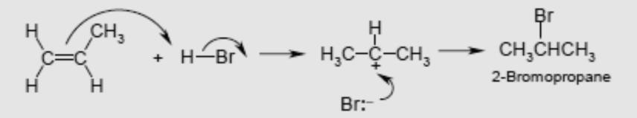
  - Addition of HBr to 1-butene yields a chiral molecule. The reaction is regioselective and a racemic mixture is formed.
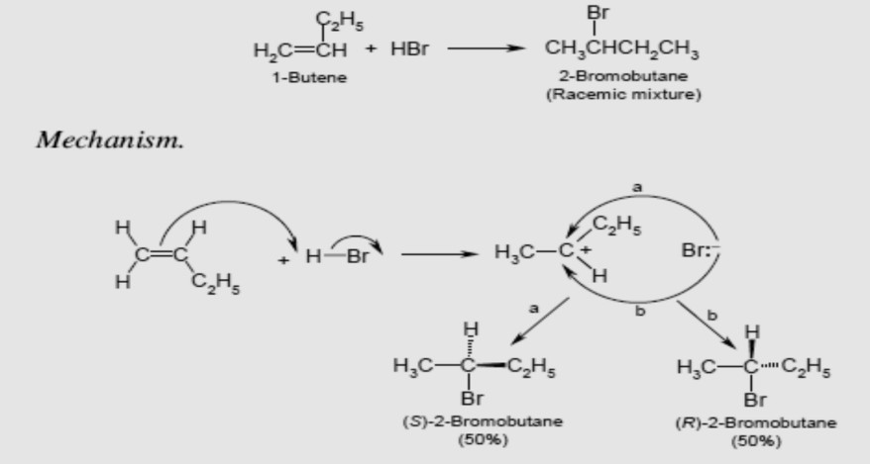

Peroxide Effect or Kharasch Effect or Anti-Markovnikov Rule (Free radical addition reaction)

- In the absence of peroxides, hydrogen bromide 'adds to alkenes in agreement with Markovnikov's rule; in the presence of peroxides, the direction of addition is exactly reversed.

- When HBr is added to alkenes in the presence of free radical initiators, e.g. hydrogen peroxide (HOOH) or alkyl peroxide (ROOR).
- For example, 2-methyl propene reacts with HBr in the presence of peroxide (ROOR) to form 1-bromo- 2-methyl propane, which is an anti-Markovnikov product.
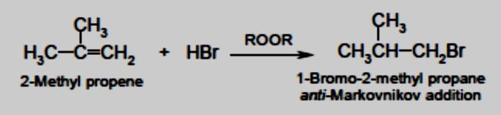
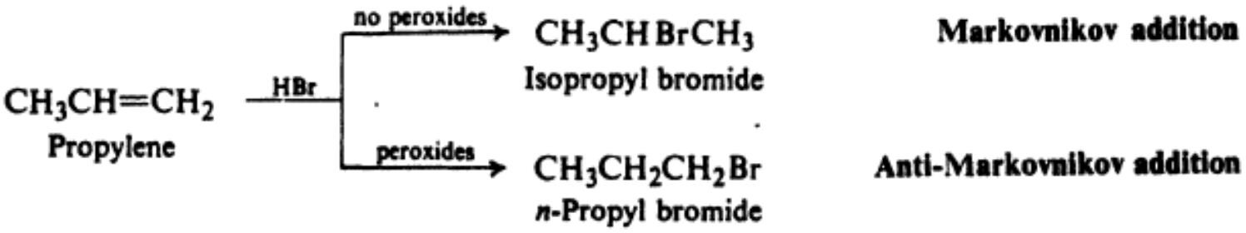
- Radical additions do not proceed with HCl or HI.

Mechanism: Free radicals reaction occurs in three steps

- Initiation The oxygen–oxygen bond is weak, and is easily homolytically cleaved to generate two alkoxy radicals, which in turn abstract hydrogen to generate bromine radicals.
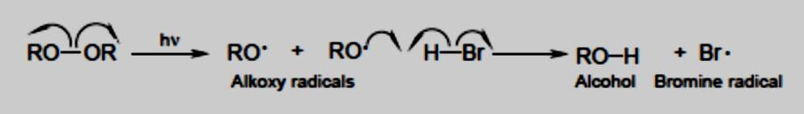

- Propagation The bromine radical is electron deficient and electrophilic.
  - The radical adds to the double bond, generating a carbon-centered radical. This radical abstracts hydrogen from HBr, giving the product and another bromine radical.
  - The orientation of this reaction is anti-Markovnikov. The reversal of regiochemistry through the use of peroxides is called the peroxide effect.
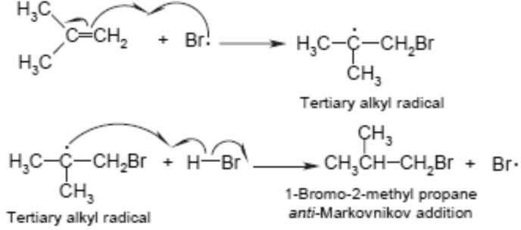

- Termination Any two radicals present in the reaction mixture can combine in a termination step, and end the radical chain reaction. Thus, radical reactions produce a mixture of products.
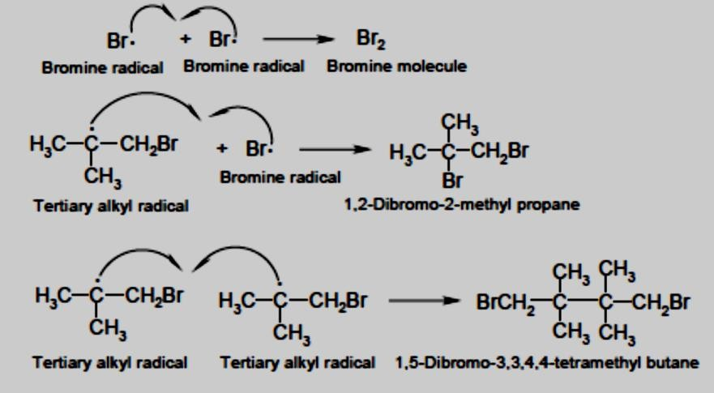

Ozonolysis

  - Ozone (O3) is the triatomic form of oxygen.
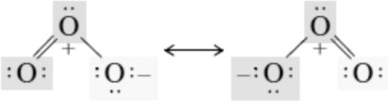
  - It is a neutral but polar molecule that can be represented as a hybrid of its two most stable Lewis structures.

·
  - Ozone is a powerful electrophile and undergoes a remarkable reaction with alkenes in which both the σ and π components of the carbon–carbon double bond are cleaved to give a product referred to as an ozonide.

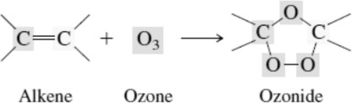

  - Ozonides undergo hydrolysis in water, giving carbonyl compounds.

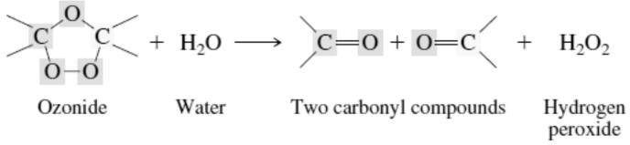

  - The two-stage reaction sequence is called ozonolysisand is represented by the general equation
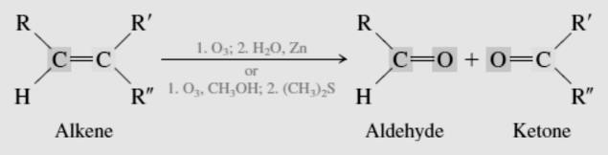
  - Each carbon of the double bond becomes the carbon of a carbonyl group.
Ozonolysis has both synthetic and analytical applications in organic chemistry. In synthesis, Ozonolysis of alkenes provides a method for the preparation of aldehydes and ketones

