Unit-2
cardiovascular diseases

Angina pectoris
- Discomfort due to transient myocardial ischemia
- Heart muscle does not receive enough blood (nutrient & O2) resulting in chest pain
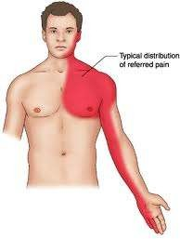

Etiology of Angina Pectoris
- Atherosclerosis of large coronary arteries
- Heart valve disease
- Thickening of heart muscles
- Coronary artery spasm
- Hypertension
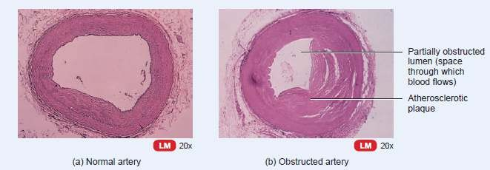

Symptoms of Angina Pectoris
- Gripping of central chest pain
- ↑ shortness of breath on exercise

- Sense of heaviness or numbness in the arm, shoulder, elbow or hand usually on the left side
- Constricting sensation in the throat
- Mild ache to severe pain
- Sweating and fear
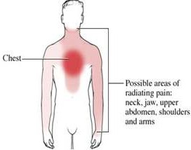
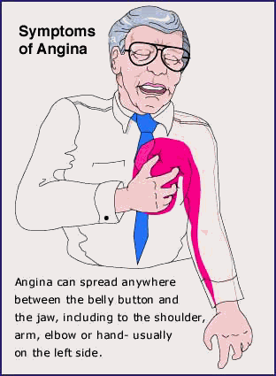

Pathogenesis and types of Angina
- Imbalance between myocardial oxygen demand and supply
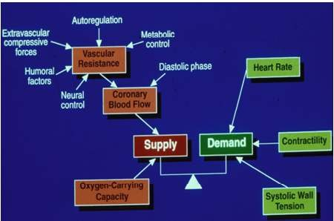

Stable/ Typical/ Exertional/ Classical Angina
- Provoked by physical exertion
- Heaviness, squeezing and sensation of constriction in the chest
- Pain subsides on resting
- Depression in ST segment of ECG
- No elevation in the blood enzyme level if no myocardial injury

Variant/ Prinzmetal Angina
- Pain at rest
- No relationship with physical activity
- Occur due to coronary artery spasm
- Spasm – due to release of vasoconstrictor by mast cells in coronary artery
- Attacks are painful, occur between midnight & daily morning
- ST segment elevation in ECG
- Patient respond well to vasodilator like nitroglycerine

Unstable/ Atypical/ Cresendo/ Preinfarction Angina or Acute coronary insufficiency
- Frequent onset of pain for longer duration
- Occurs often at rest
- Indication of myocardial infarction

Microvascular angina
- Chest pain , no apparent coronary artery damage
- Poor functioning of blood vessels of heart, arm or legs
- May occur during exercise or at rest
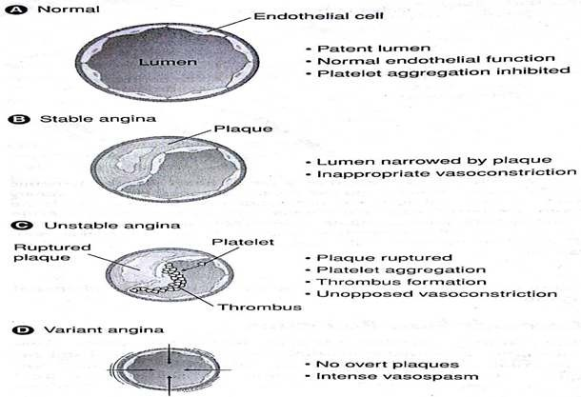

Myocardial infarction
- Myocardial infarction / Heart attack results from complete obstruction to blood flow in coronary artery
- Imbalance in supply and demand of O2 to myocardium
- Underlining cause – coronary artery disease
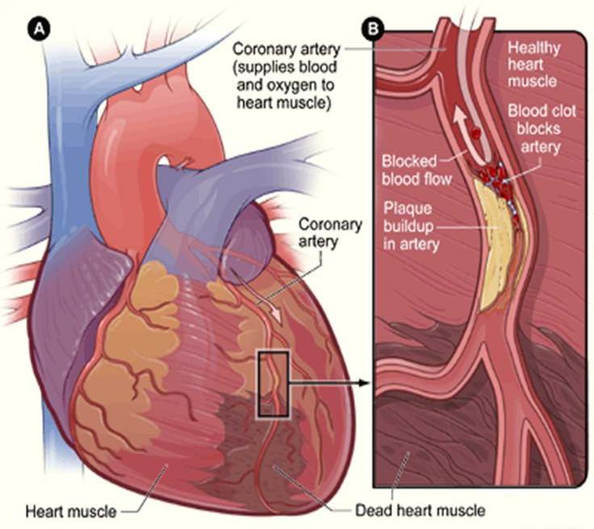

Symptoms of myocardial infarction
- Severe chest pain
- Sweating
- Chest pain radiating through jaw, shoulder, arms and back
- Epigastric discomfort with or without nausea/ vomiting
- Sproathy and blood stained sputum
- Dizziness, weakness, Anxiety
- Irregular heart beat
- Heart burn & indigestion

Etio-pathogenesis of MI

Atherosclerotic causes
- Accounts for 75% of cases
- Fatty streak deposits on the coronary artery
- Endothelium develop into an atherosclerotic plague depending on the presence of risk factors

- Risk factors – HT, DM, Smoking, Hyperlipidemia
- Plaque progression, proliferation and disruption of integrity of blood vessel
- Results in narrowing off coronary artery & MI

Non atherosclerotic causes
- Accounts for 10% of the causes of MI
- Coronary vasospasm
- Inflammation of arteries
- Coronary embolism
- Development of thrombosis
- Injury
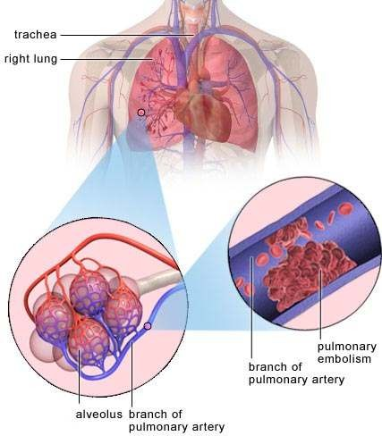

Complications of MI
- Cardiac arrhythmia
- Congestive heart failure
- Cardiogenic shock
- Rapture of heart
- Mural thrombosis
- Thromboembolism

Summary
- Angina is the discomfort due to transient myocardial ischemia where heart muscle does not receive enough blood (nutrient & O2) resulting in chest pain
- Myocardial infarction / Heart attack results from complete obstruction to blood flow in coronary artery
- Causes of angina and MI include Atherosclerosis of large coronary arteries, heart valve disease, thickening of heart muscles, coronary artery spasm, hypertension
- Occurs mainly due to the imbalance in supply and demand of O2 to myocardium

