HEPATITIS
- Results in damage to hepatocytes with subsequent cell death

Etiology
- Viral infections – Hepatitis A, B, C, D, E ; Epstein barr virus, yellow fever virus, cytomegalo virus & herpes virus
- Autoimmune chronic hepatitis
- Toxins , Alcohol
- Drugs used for the treatment of tuberculosis e.g. Isoniazid

Symptoms of hepatitis

Initial symptoms | Final symptoms
Hepatic symptoms are flu like | Jaundice
Mild fever, Chills | Dark urine
Headache | Pale faeces containing puss cells
Nausea, Vomiting, Diarrhoea | Pruritis
Anorexia, Fatigue | Enlargement of spleen
Slight abdominal pain | Urticaria
Aching of joints | Dizziness, Drausiness, circulation problem
Types of hepatic viruses

Name of virus | Content | Mode of spread
Hepatitis A virus (HAV) | RNA | Faeces
Hepatitis B virus (HBV) | DNA | Parenteral, Sexual contact, Blood transfusion, Babies born to HBV infected mothers
Hepatitis C virus (HCV) | RNA | Parenteral transmission, IV drug abuse, needle sharing
Hepatitis D virus (HDV) | RNA | Super infection

Hepatitis E virus (HEV) | RNA | Transmitted enterically
Hepatits G virus (HGV) | RNA | Parenterally transmitted hepatotropic virus

Structure of HBV
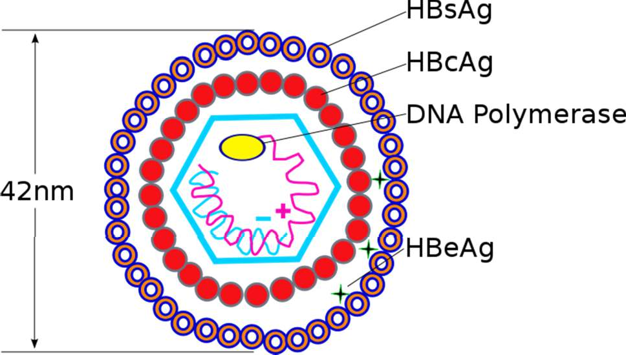
- Only DNA containing virus
- Belongs to group ‘hepadnaviridae’
- Diameter- 42 nm; incubation period is 6-8 weeks
- Comprises of core and a capsule
- Core consists of DNA & DNA polymerase
- Core is surrounded by markers
  - Hepatitis B core antigen (HBc Ag)
  - Hepatitis B envelope antigen (HBe Ag)
  - Hepatitis B surface antigen (HBs Ag)

Mode of transmission
- Present in all body secretion
- A close contact with an infected person spreads the disease
- By blood transfusion
- Not through fecal matter

Stages of hepatitis (Assessed by different markers)

Stage 1
- HBs Ag is identified in asymptomatic phase
- It appears even before the onset of a disease
- Reaches the peak level during disease stage
- The counts become less with in 3-6 months

Stage 2
- HBe Ag, HBV DNA, DNA polymerase appears
- HBe Ag – indicates the progression of infection
- Continues viral replication

Stage 3
- IgM and anti HBc is detected
- Ab is identified just before the onset of symptoms
- After several months of infections IgG and anti HBc

Phases of HBV infection

Proliferative phase
- Shows the presence of symptoms
- DNA of HBV has accessory replicative chromosomes and forms virions
- HBs antigen binds with MHC class molecule and activated CD8+ T-cells

Integrative phase
- Viral DNA gets incorporated into the host genome
- Damage of hepatocytes by activation of CD8+ T- cells

ATypes of Hepatitis

Acute hepatitis – comprises of 4 phases

- Incubation period –depends on type of virus
  - HAV – 12 weeks
  - HBV – 10 weeks
  - HCV – 7 weeks
  - HDV – 6 weeks
  - HEV – 2-8 weeks
Patient does not show any signs or symptoms in incubation period

Symptomatic pre – icteric phase
  - Non specific symptoms like fatigue, nausea, vomiting, weight loss, low fever, headache, muscle & joint aches, diarrhoea

Symptomatic icteric phase
  - Yellow coloration appears
  - Jaundice appears in 3rd stage

Phase of recovery
  - Takes place depending upon the severity of infection
Chronic hepatitis
  - Hepatic diseases remain for more than 6 months
  - Inflammation & necrosis takes place
  - Fatigue, Malaise, Lack of apetite, mild jaundice
  - Symptoms are highly variable & not predictive in nature

Summary
  - Hepatitis is inflammation of liver that results in damage to hepatocytes with subsequent cell death
  - It may occur due to viral , autoimmune chronic hepatitis, Toxins, Alcohol and drugs
  - HBV is main causative organism
  - Types of hepatitis include acute and chronic

Jaundice

Normal Range of Bilirubin
- 1～16μmol/l (0.1 ～1mg/dl)
4/5 are unconjugated bilirubin, others are conjugated bilirubin.
- <1mg/dl normal
- 1-2mg/dl occult Hyperbilirubinemia
- >2mg/ dl jaundice Hyperbilirubinemia

Hyperbilirubinemia

Hyperbilirubinemia: the concentration of blood bilirubin are more than 1mg/dl.
Occult: the concentration of blood bilirubin are increased, but have no clinic sympotom, normally 1-2mg/dl.
Jaundice: (also called icterus) refers to the yellow color of the skin and scleare caused by deposition of bilirubin, secondry to increased bilirubin levels in the blood.
Although not a disease itself, jaundice is usually a symptom of an underlying disorder.
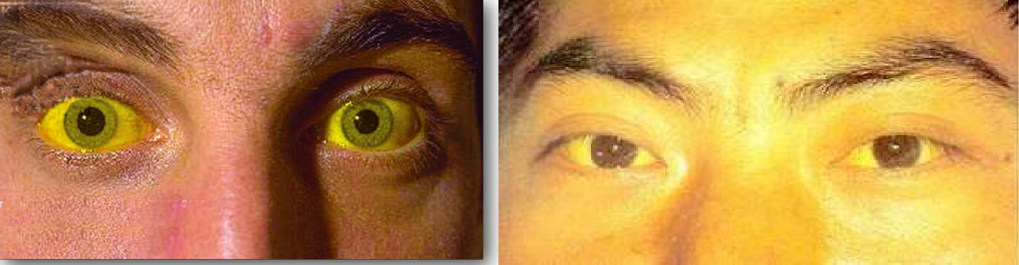
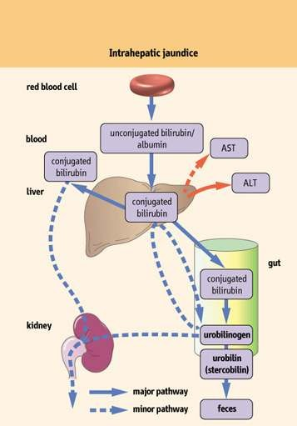

Mechanism of Jaundice

Based on pathophysiology, jaundice may result from one or more of the following mechanism:
- Increased bilirubin production (excessive red cell destruction)
- Decreased hepatic uptake (ligandin, drug, prolonged starvation, and sepsis) Decreased hepatic conjugation (enzyme,drugs, cirrhossis)
- Decreeased excretion of bilirubin into bile (gallstone, tumour)

Simple Classification of Jaundice
  - Accordingly, a simple classification of jaundice is to divided into 3 predominant type:
① Pre-hepatic (hemolytic jaundice)
② Hepatic jaundice
③ Post – hepatic cholestatic (obstructive jaundice)

Hemolytic Jaundice
massive lysis of red blood cells (for example, in patients with sickel cell anemia or malaria) may produce bilirubin faster than the liver can conjuagte it.

More bilirubin is excreted into the bile, the amount of the urobilinogen entering the enterohepatic circulation is increased, and urinary urobilinogen is increased.

Unconjugated bilirubin is elevated in blood.

Causes of Hemolytic Jaundice
- Malaria
- Side effects of certain drugs :antibiotic and anti-tuberculosis medicines, levodopa,
- Certain drugs in combination with a hereditary enzyme deficiency known as glucose-6-phosphate dehydrogenase (G6PD)
- Poisons Snake and spider venom, certain bacterial toxins, copper, and some organic industrial chemicals directly attack the membranes of red blood cells
- Artificial heart valves
- Hereditary RBC disorders sickle cell disease
- Enlargement of the spleen
- Diseases of the small blood vessels
- Immune reactions to RBCs cancer
- Transfusions
- Kidney failure and other serious diseases

Hepatocellular Jaundice
  - Damage to liver cells (for example in patient with cirrhosis or hepatitis) causes a decrease in both bilirubin uptake and production of conjuagted bilirubin.
  - Unconjugated bilirubin occur in the blood and increased urobilinogen in the urine.

- The urine is dark in color and stool are pale, clay color.
- Level of AST and ALT are elevated and the patient experience nausea and anorexia.
Obstructive Jaundice
- In this instance jaundice is results from obstruction of the bile duct.
- The presence of a hepatic tumor or bile stone may block the bile ducts, preventing passage of bilirubin into the intestine, patients with obstructive jaundice experience GI pain, nausea and produce stools that are a pale, clay color.
 | Sample | Indices | Normal | Obstructive Jaundice | Hemolytic Jaundice | Hepatic Jaundice
 | Serum | Total Bil | ＜1mg/dl | ＞1mg/dl | ＞1mg/dl | ＞1mg/dl
 |  | Direct Bil | 0～0.8mg/dl | ↑↑ |  | ↑
 |  | Indirect Bil | ＜1mg/dl |  | ↑↑
 | Urine | Color | Normal | deep | deeper | deep
 |  | Bilirubin | — | ＋＋ | — | ＋＋
 |  | Urobilinogen | a little | ↓ | ↑ | uncertain
 |  | Urobilin | a little | ↓ | ↑ | uncertain
 | Stool | Color | Normal | Argilous (complete obstruction) | deeper | lighter or normal
Diagnoses of Jaundice

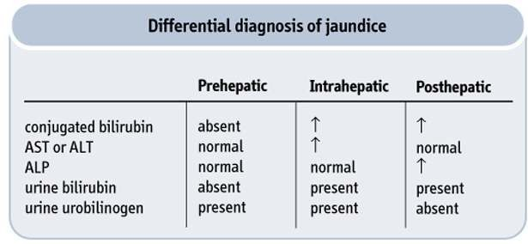

Summary
  - The main symptom of jaundice is a yellow discoloration of the white part of the eyes (sclera) and of the skin
  - Pre-hepatic jaundice is caused by anything which causes an increased rate of hemolysis
  - Hepatocellular (hepatic) jaundice can be caused by acute or chronic hepatitis, hepatotoxicity, cirrhosis, drug induced hepatitis and alcoholic liver disease
  - Complications of jaundice include sepsis especially cholangitis, biliary cirrhosis, pancreatitis, coagulopathy, renal and liver failure.

