Atherosclerosis

- Patchy focal disease of arterial wall
- Patchy thickening of the intimal layer of arterial wall
- Due to lipid deposition or fibrosis tissue formation
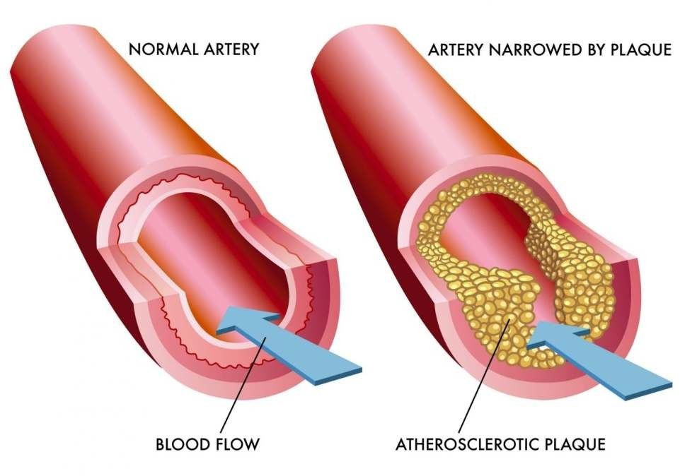

Major risk factors
- Age
- Family history & genetics
- Racial risk – whites are at greater risk than blacks
- Excess lipid deposition
- Hypertension
- Smoking
- Diabetes mellitus

Minor risk factors
- Obesity
- Lack of exercise
- Sedentary life style
- Use of oral contraceptives
- Alcohol consumption
- Stressful life
- Dietary factors
- Viral infection

Symptoms
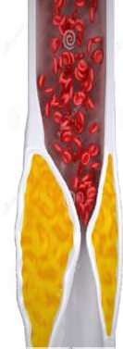
Symptoms vary depending on the organ involved

Heart

- Restricted blood supply to heart
- Angina & Myocardial infarction
- Shortness of breath
- Sweat
- Nausea
- Dizziness
- Palpitation

Brain

- Narrowing of arteries supplying brain
- Causes ischemic attacks
- Head ache
- Paralysis of one side of the body
- Numbness in various parts
- Visual disturbance
- Stroke

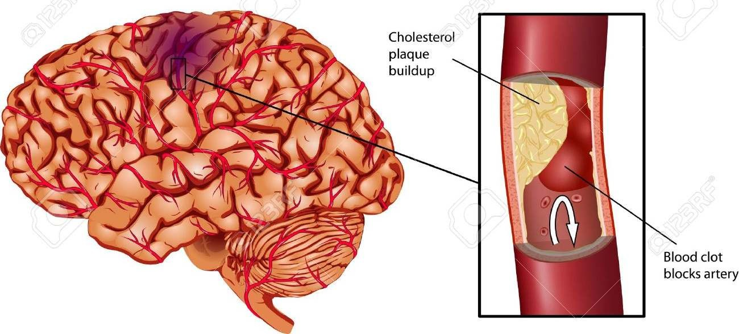

Abdomen

- Dull pain is felt in the abdomen
- Due to blockage of arteries supplying intestine
- Vomiting
- Diarrhoea
- Constipation

Leg

- Narrowing of artery supplying leg
- Pain in the leg
- Hair loss in leg

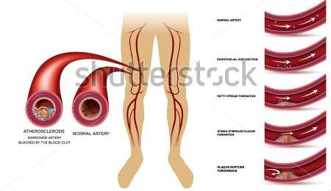

Pathogenesis

Endothelial injury
  - Atherosclerosis is initiated by injury of endothelium
  - In large & medium size arteries
  - Causes include smoking
  - Hypertension
  - Chronic hyperlipidemia
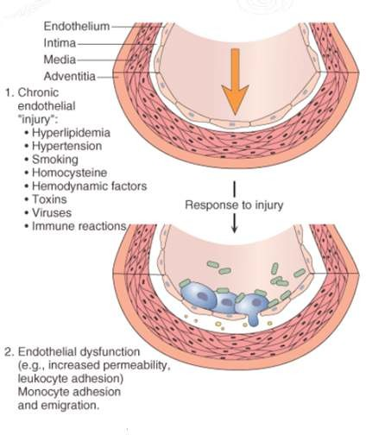

Internal smooth muscle cell proliferation
  - Subsequent to endothelial injury
  - Following disruption of endothelial layer
  - Smooth muscle cell of blood vessels
  - Cells of endothelium
  - Proliferate under influence of – PGDF, EDGF, TGF β
  - More synthesis of matrix protein
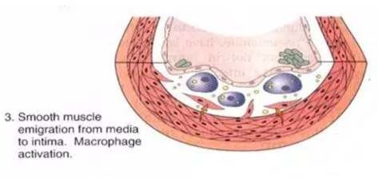

Lipoprotein entry into intima
  - LDL from blood enters intima & get oxidized
  - Oxidized LDL attracts monocytes
  - Activates monocytes to macrophages
  - Combination of oxidized LDL & macrophages - Lipid laden foam cells
  - Major factor contributing to plaque formation
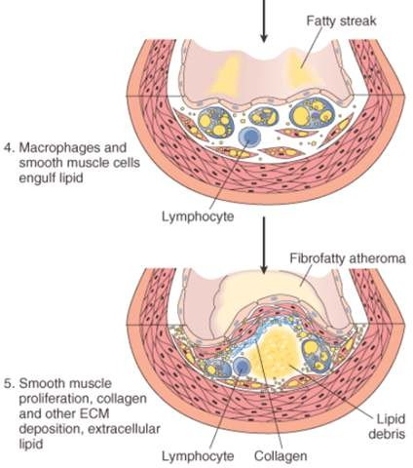

Mechanism involved in the formation of Foam cells

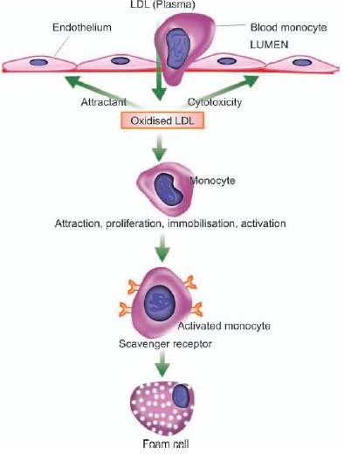

Summary
  - Atherosclerosis or atheroma is a patchy focal disease of arterial wall
  - Patchy thickening of the intimal layer of arterial wall due to lipid deposition or fibrosis tissue formation
  - The main mechanism involved in the development of atheroma is endothelial injury
Endothelial injury is followed by proliferation

