Thyroid disease

Thyroid gland
- The thyroid gland in an adult weighs 15-40 gm and is composed of two lateral lobes connected in the midline by a broad isthmus which may have a pyramidal lobe extending upwards
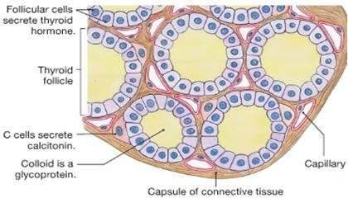
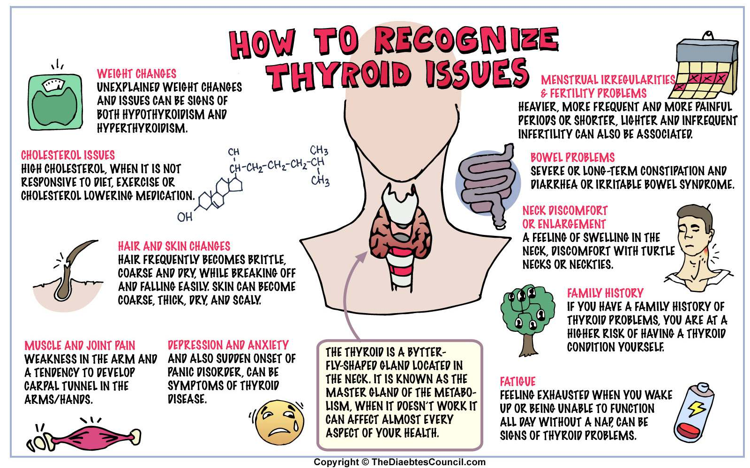

HYPERTHYROIDISM (THYROTOXICOSIS)
- Hyperthyroidism, also called thyrotoxicosis, is a hypermetabolic clinical and biochemical state caused by excess production of thyroid hormones

ETIOPATHOGENESIS
- 3 most common causes are:
- Graves’ disease (diffuse toxic goitre),
- toxic multinodular goitre
- toxic adenoma

Other causes
- hypersecretion of pituitary TSH by a pituitary tumour
- hypersecretion of TRH
- Thyroiditis
- metastatic tumours of the thyroid
- struma ovarii
- congenital hyperthyroidism in the newborn of mother with Graves’ disease
- hCG-secreting tumours due to mild thyrotropic effects of hCG (e.g. hydatidiform mole, choriocarcinoma and testicular tumours),
- Excessive doses of thyroid hormones or iodine called jodbasedow disease

CLINICAL FEATURES
- Fatigue
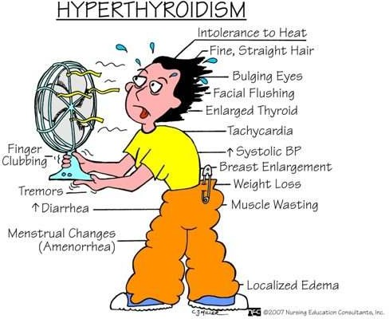
- heat intolerance
- sweating
- weight loss despite good appetite
- shakiness
- inappropriate anxiety
- palpitations of the heart
- shortness of breath,
- tetchiness and agitation,
- poor sleep
- thirst
- nausea
- increased frequency of defecation

Hypothyroidism
- It is a hypometabolic clinical state resulting from inadequate production of thyroid hormones for prolonged periods, or rarely, from resistance of the peripheral tissues to the effects of thyroid hormones
- Cretinism or congenital hypothyroidism -infancy and childhood.
- Myxoedema - adulthood

Cretinism
  - Hypothyroidism present at birth or developing within first two years of postnatal life.
ETIOPATHOGENESIS. The causes of congenital hypothyroidism are as follows:
Developmental anomalies

Foetal exposure to iodides and antithyroid drugs.

Genetic defect in thyroid hormone synthesis

Endemic cretinism

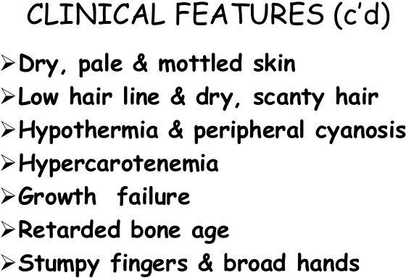

Myxoedema
  - The adult-onset severe hypothyroidism causes myxoedema

ETIOPATHOGENESIS
- Ablation of the thyroid by surgery or radiation.
- Autoimmune (lymphocytic) thyroiditis (termed primary idiopathic myxoedema).
- Endemic or sporadic goitre.
- Hypothalamic-pituitary lesions.
- Thyroid cancer.
- Prolonged administration of anti-thyroid drugs.
- Mild developmental anomalies and dyshormonogenesis

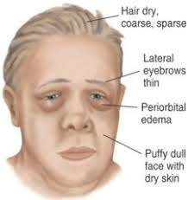
CLINICAL FEATURES
  - cold intolerance
  - mental and physical lethargy
  - constipation
  - slowing of speech and intellectual function
  - puffiness of face
  - loss of hair and altered texture of the skin

THYROIDITIS
  - Inflammation of the thyroid- Due to non-infectious causes

Classification

Acute thyroiditis:
  - Bacterial infection e.g. Staphylococcus, Streptococcus.
  - Fungal infection e.g. Aspergillus, Histoplasma, Pneumocystis.
  - Radiation injury

Subacute thyroiditis:
  - Subacute granulomatous thyroiditis (de Quervain’s thyroiditis, giant cell thyroiditis, viral thyroiditis)
  - Subacute lymphocytic (postpartum, silent) thyroiditis
  - Tuberculous thyroiditis

Chronic thyroiditis:
  - Autoimmune thyroiditis (Hashimoto’s thyroiditis or chronic lymphocytic thyroiditis)
  - Riedel’s thyroiditis (or invasive fibrous thyroiditis)

HASHIMOTO’S (AUTOIMMUNE, CHRONIC LYMPHOCYTIC) THYROIDITIS
    - Hashimoto’s thyroiditis, also called diffuse lymphocytic thyroiditis, struma lymphomatosa or goitrous autoimmune thyroiditis

ETIOPATHOGENESIS
- autoimmune disease association
- Immune destruction of thyroid cells
- Detection of autoantibodies
- Inhibitory TSH-receptor antibodies
- Genetic basis

GRAVES’ DISEASE (DIFFUSE TOXIC GOITRE)
    - Graves’ disease, also known as Basedow’s disease, primary hyperplasia, exophthalmic goitre, and diffuse toxic goitre
    - Characterised by a triad of features:
- Hyperthyroidism (thyrotoxicosis)
- Diffuse thyroid enlargement
- Ophthalmopathy

ETIOPATHOGENESIS
  - 1. Genetic factor association: HLA-DR3 (Hashimoto’s thyroiditis has both HLA-DR3 and HLA-DR5 association)
CTLA-4 and PTPN22 (a T-cell regulatory gene).
  - 2. Autoimmune disease association: Other factors. Besides these two factors, Graves’ disease has higher prevalence in women (7 to 10 times), and association with emotional stress and smoking

3. Other factors
  - 4. Autoantibodies: TSI, TGI, TBII

GOITRE
  - Thyroid enlargement caused by compensatory hyperplasia and hypertrophy of the follicular epithelium -thyroid hormone deficiency

Pathogenesis of Goitre
  - Nodular goitre is generally regarded as the end-stage of long-standing simple goitre
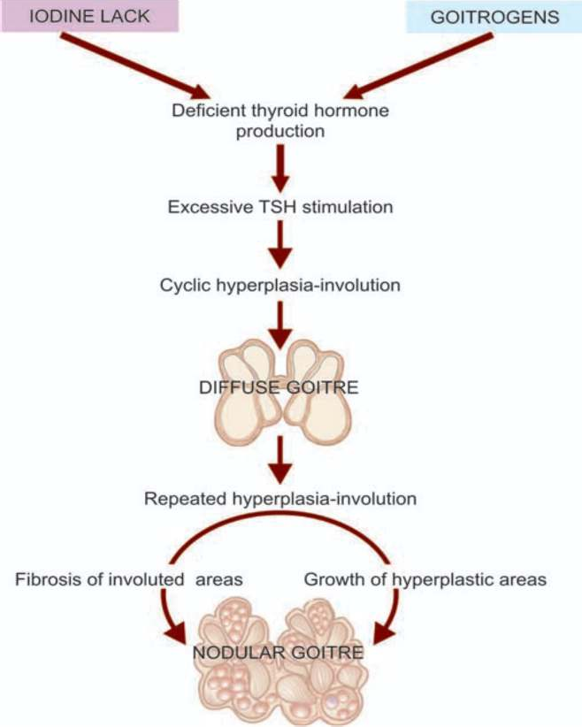

ETIOLOGY
  - Goitre occurs in 2 forms: endemic, and non-endemic or sporadic

Endemic goitre:
Mountainous regions-iodine content of drinking water and food
_ Genetic factors, Goitrogens

Sporadic (non-endemic) goitre:
_ Suboptimal iodine intake in conditions of increased demand as in puberty and pregnancy.
_ Genetic factors.
_ Dietary goitrogenes.
_ Hereditary defect in thyroid hormone synthesis and transport
_ Inborn errors of iodine metabolism

Nodular Goitre (Multinodular Goitre, Adenomatous Goitre)
  - It is the end-stage of long-standing simple goitre. It is characterised by most extreme degree of tumour-like enlargement of the thyroid gland and characteristic nodularity
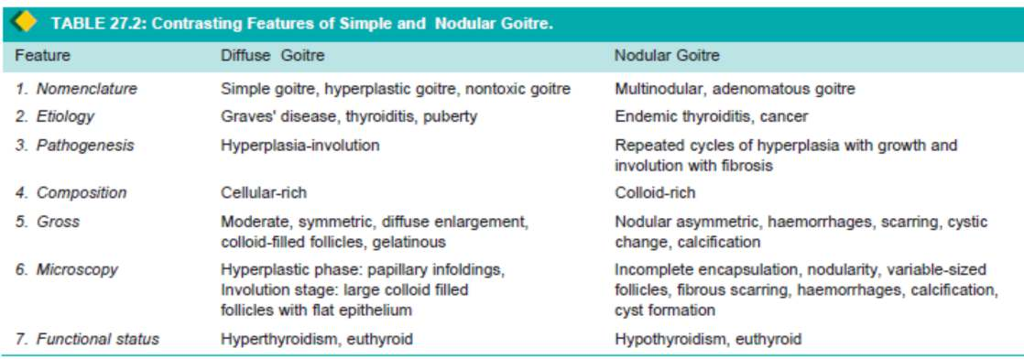

THYROID TUMOURS
  - Tumours of the thyroid are of follicular epithelial origin; a few arise from parafollicular C-cells
  - thyroid carcinoma is the most common type

FOLLICULAR ADENOMA
  - In adult women
  - an adenoma is small (up to 3 cm in diameter) and spherical.

THYROID CANCER
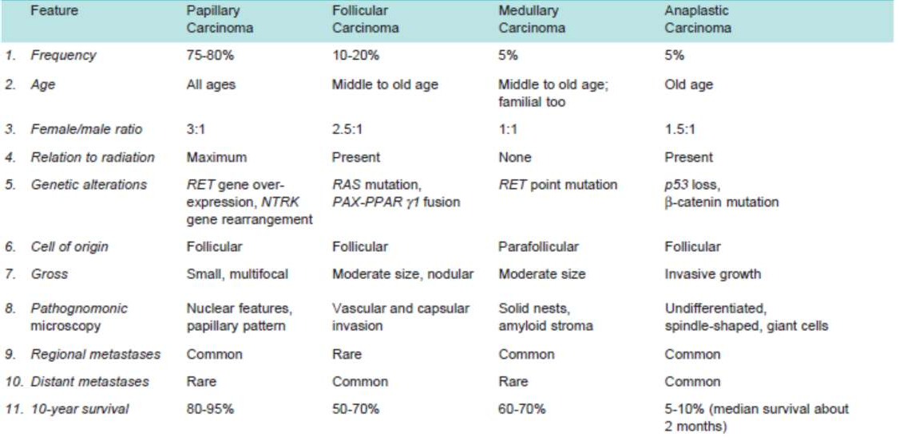

Summary
  - Hyperthyroidism, also called thyrotoxicosis, is a hypermetabolic clinical and biochemical state caused by excess production of thyroid hormones
  - Hypothyroidism is a hypometabolic clinical state resulting from inadequate production of thyroid hormones for prolonged period
  - Thyroiditis -Inflammation of the thyroid- Due to non-infectious causes
  - Goitre-Thyroid enlargement caused by compensatory hyperplasia and hypertrophy of the follicular epithelium - thyroid hormone deficiency
  - Tumours of the thyroid are of follicular epithelial origin; a few arise from parafollicular C-cells

