Thalassemia
- Thalassemia are a heterogenous group of genetic disorders of Hb synthesis characterized by a lack or decreased synthesis of globin chains
- Two major types of thalassemia:
  - Alpha (α) - Caused by defect in rate of synthesis of alpha chains.
  - Beta (β) - Caused by defect in rate of synthesis in beta chains.
- Alpha thalassemia usually caused by gene deletion; Beta thalassemia usually caused by mutation.
- Results in microcytic, hypochromic anemias of varying severity

BASICS - 3 Types of Hb

- Hb A - 2α and 2β chains forming a tetramer
  - 97% adult Hb
  - Postnatal life Hb A replaces Hb F by 6 months
- Fetal Hb – 2α and 2γ chains
  - 1% of adult Hb
  - 70-90% at term. Falls to 25% by 1st month and progressively
- Hb A2 – Consists of 2 α and 2 δ chains
  - 1.5 – 3.0% of adult Hb

INHERITANCE
  - Autosomal recessive
  - Beta thal - point mutations on chromosome 11
  - Alpha thal - gene deletions on chromosome 16

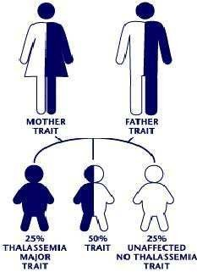

Classification
  - If synthesis of α chain is suppressed – level of all 3 normal Hb A (2α ,2β),A2 (2α,2δ), F(2α ,2γ) reduced

– alpha thalassemia
  - If β chain is suppressed- adult Hb is suppressed - beta thalassemia α-thalassemia
Hb H (β4)
Hb-Bart’s (4)

β-thalassemia
- β⁺ thal : reduced synthesis of β globin chain, heterozygous
- β ⁰ thal : absent synthesis of β globin chain, homozygous Hb A - absent
Hb F (α2 2) Hb A2 (α2 δ2)
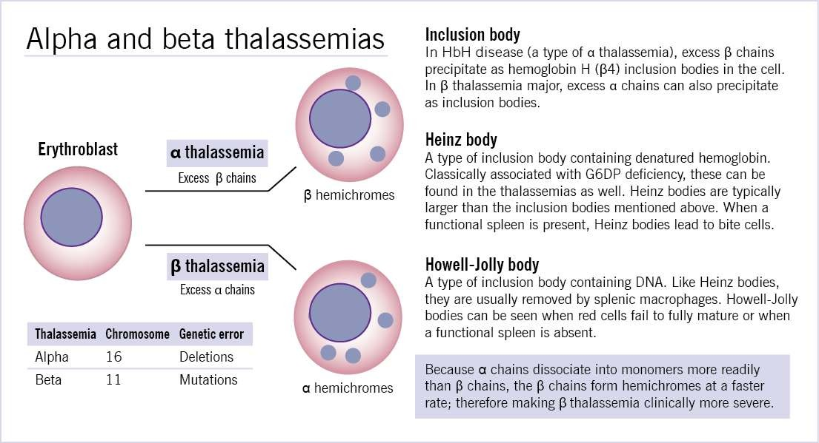

Classification of β Thalassemia

CLASSIFICATION | GENOTYPE | CLINICAL SEVERITY
β thal minor/trait | β/β+, β/β0 | Silent
β thal intermedia | β+ /β+, β+/β0 | Moderate
β thal major | β0/ β0 | Severe

Classification OF α-Thalassemia

No. Of genes present | Genotype | Clinical classification
4 genes | αα/αα | Normal
3 genes | αα/- α | Silent carrier
2 genes | - α/- α or αα/- - | α thalassemia trait
1 gene | -α/- - | Hb H Ds
0 genes | - -/- - | Hb Barts / Hydrops fetalis

α-Thalassaemia Molecular Pathogenesis
- Defective synthesis of α-globin chains: HbA, HbA2 and HbF
- Four α-gene deletion: Hb Bart’s hydrops foetalis
- Three α-gene deletion: HbH disease
- Two α-gene deletion: α-thalassaemia trait
- One α-gene deletion: α-thalassaemia trait (carrier)
  - β-thalassaemias are caused by decreased rate of β-chain synthesis resulting in reduced formation of HbA in the red cells.
- Transcription defect
- Translation defect
- mRNA splicing defect

3 Types of β-Thalassaemia

- Homozygous form
- β-Thalassaemia intermedia
- Heterozygous form

Pathophysiology
- Since ẞ chain synthesis reduced -
- 1. Gamma and delta δ2 chain combines with normally produced α chains ( Hb F (α22) , Hb A2 (α2 δ2) - Increased production of Hb F and Hb A2
- 2. Relative excess of α chains → α tetramers forms aggregates →precipitate in red cells → inclusion bodies
→ premature destruction of maturing erythroblasts within the marrow (Ineffective erythropoiesis) or in the periphery (Hemolysis)→ destroyed in spleen
Anemia result from lack of adequate Hb A
→ tissue hypoxia→↑EPO production →
↑ erythropoiesis in the marrow and sometimes extramedullary → expansion of medullary cavity of various bones

Liver spleen enlarge → extramedullay hematopoiesis

Clinical Features (Thal Major)

INFANTS:
- Age of presentation: 6-9 mo (Hb F replaced by Hb A)
- Progressive pallor and jaundice
- Cardiac failure
- Failure to thrive, gross motor delay
- Feeding problems
- Bouts of fever and diarrhea
- Hepatosplenomegaly

BY CHILDHOOD:
- Growth retardation
- Severe anemia-cardiac dilatation
- Transfusion dependant
- Icterus
- Changes in skeletal system

Clinical Features (Thal Intermedia)
- Moderate pallor, usually maintains Hb >6gm%
- Anemia worsens with pregnancy and infections (erythroid stress)
- Less transfusion dependant
- Skeletal changes present, progressive splenomegaly
- Growth retardation
- Longer survival than Thal major

Clinical Features (Thal Minor)
- Usually ASYMPTOMATIC
- Mild pallor, no jaundice
- No growth retardation, no skeletal abnormalities, no splenomegaly
- MAY PRESENT AS IRON DEFICIENCY ANEMIA (Hypochromic microcytic anemia)
- Unresponsive/ refractory to Fe therapy
- Normal life expectancy

Prevention of Thalassaemia
- antenatal diagnosis
- amniocentesis and foetal DNA studied by PCR amplification technique for presence of genetic mutations of thalassaemias
- Treatment- blood transfusions (4-6 weekly), chelation therapy, folic acid supplement, Bone marrow transplantation
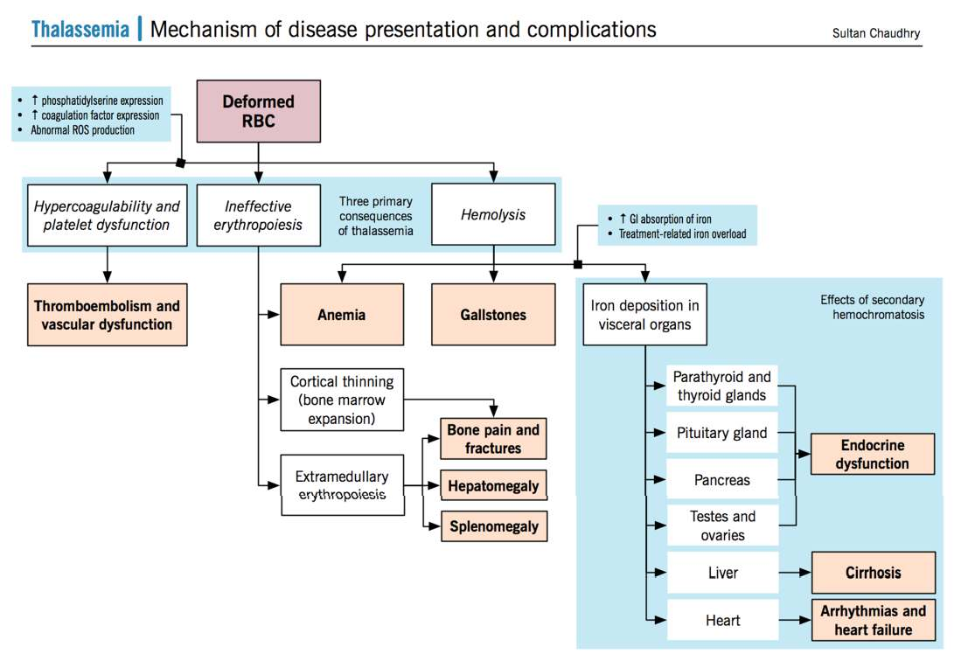

Summary
- Thalassemia are a heterogenous group of genetic disorders of Hb synthesis characterized by a lack or decreased synthesis of globin chains
  - Alpha (α) - Caused by defect in rate of synthesis of alpha chains.
  - Beta (β) - Caused by defect in rate of synthesis in beta chains.

