Renal Failure
- Cessation of glomerular filtration as kidney fails to function normally
- Leads to accumulation of Urea, creatinine Two type of Renal failure

Acute renal failure
- Chronic renal failure

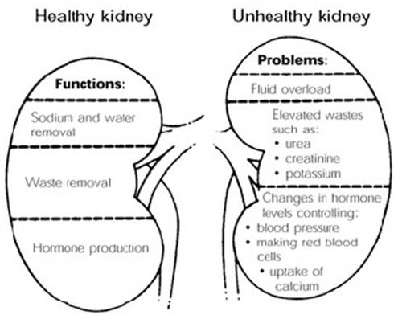

Acute renal Failure
- Kidney stops functioning all of a sudden Categorized by
- Oliguria
- Anuria
- Accumulation of metabolites

Etiology of acute renal Failure

Pre renal cause
- Causes above the level of kidney
- Reduction in blood volume
- Renal ischemia Intra renal causes
- Glomerular disease
- Disease of renal tubules
- Pyelonephritis Post renal causes
- Obstruction of urine flow Other causes – kidney stones drugs

Manifestations of acute renal failure
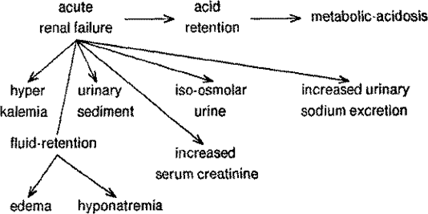
Chronic renal failure
- Progressive & irreversible damage in GFR
- Slow destruction of renal tubule
- Leads to death

Etiology
- Chronic glemerulo nephritis
- Diabetic nephropathy
- Polycystic kidney disease
- Exprosure to nephrotxins

Clinical Manifestations Renal manifestation
- Metabolic acidosis
- Hyperkalaemia

- Sodium & water retention
- Azotemia

Extra renal manifestation
- Anaemia
- Ureamic frost
- Pulmonary congestion
- Azotemia
- Osteomalacia
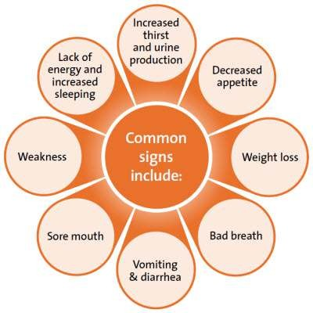

Pathogenesis

Mild CRF
- Decreased renal reserve
- GFR 50% of normal filtration
- Renal parenchyma is marginally lost
- Patient asymptomatic

Moderate CRF (Renal insufficiency)
- 75% of renal parenchyma gets destroyed
- GFR 25% of normal value

Severe chronic renal failure
- 90% renal parenchyma damage
- GFR 10% of normal values
- Tubular cells non functional
- Imbalance in sodium & water retention

Final stage of kidney
- Renal parenchyma completed destroyed
- GFR 5% of normal value
- Complete accumualtion of waste products
- Require dialysis therapy

Summary
- Renal failure is the cessation of glomerular filtration as kidney fails to function normally
- It Leads to accumulation of Urea, creatinine
- Renal failure is of two kinds - Acute and chronic renal failure
- In ARF, kidney stops functioning all of a sudden and is categorized by oliguria, anuria, accumulation of metabolites
- CRF is characterized by Progressive & irreversible damage in GFR , slow destruction of renal tubule, leading to death

