Meningitis
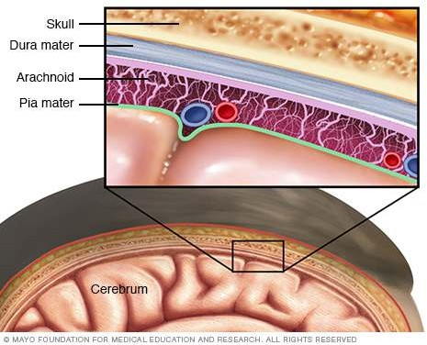
It is inflammatory involvement of the meninges.
- Meningitis may involve the dura called pachymeningitis,
- leptomeninges (pia-arachnoid) termed leptomeningitis
- Pachymeningitis: inflammation from chronic suppurative otitis media or from fracture of the skull.
- Extradural abscess may form by suppuration between the bone and dura- penetrate the dura and form a subdural abscess.
Leptomeningitis, commonly called meningitis- infection
- Infectious meningitis is broadly classified into 3 types:
- acute pyogenic,
- acute lymphocytic (viral, aseptic)
- chronic (bacterial or fungal)
Acute Pyogenic Meningitis
  - Acute pyogenic or acute purulent meningitis is acute infection of the pia-arachnoid and of the CSF enclosed in the subarachnoid space.
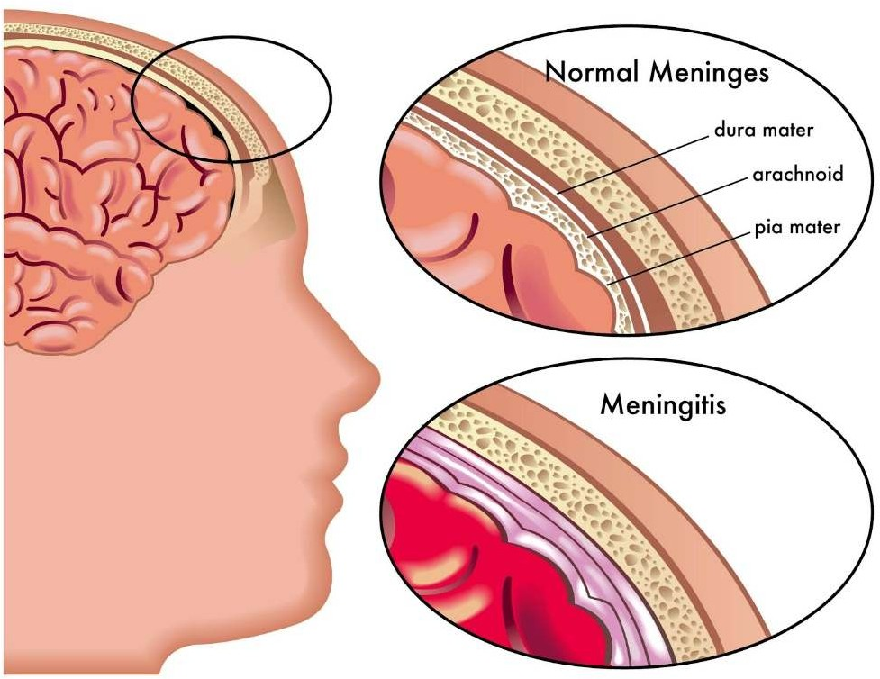

ETIOPATHOGENESIS-Acute Pyogenic Meningitis

Causative organisms vary with age of the patient
- Escherichia coli

- Haemophilus influenzae
- Neisseria meningitidis
- Streptococcus pneumoniae
  - routes of infection as follows:
- Most commonly by the blood stream.
- From an adjacent focus of infection.
- By iatrogenic infection such as introduction of microorganisms at operation or during lumbar puncture.
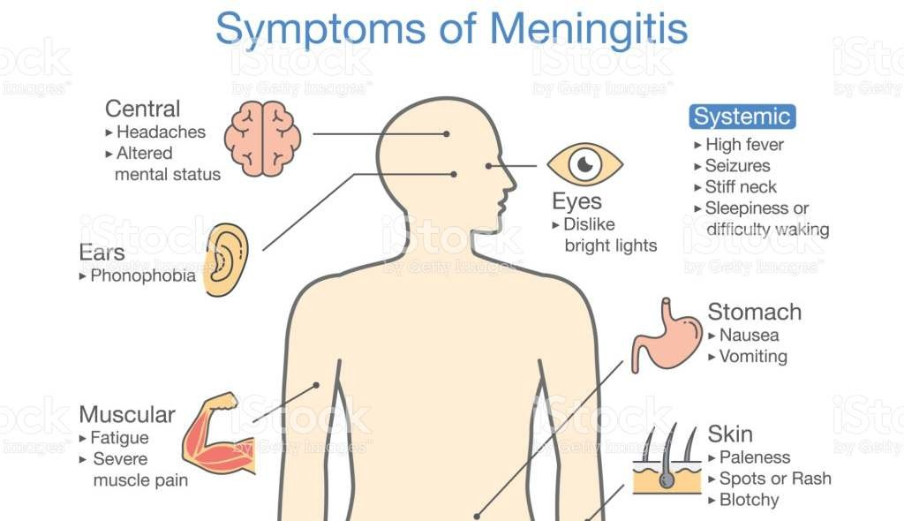
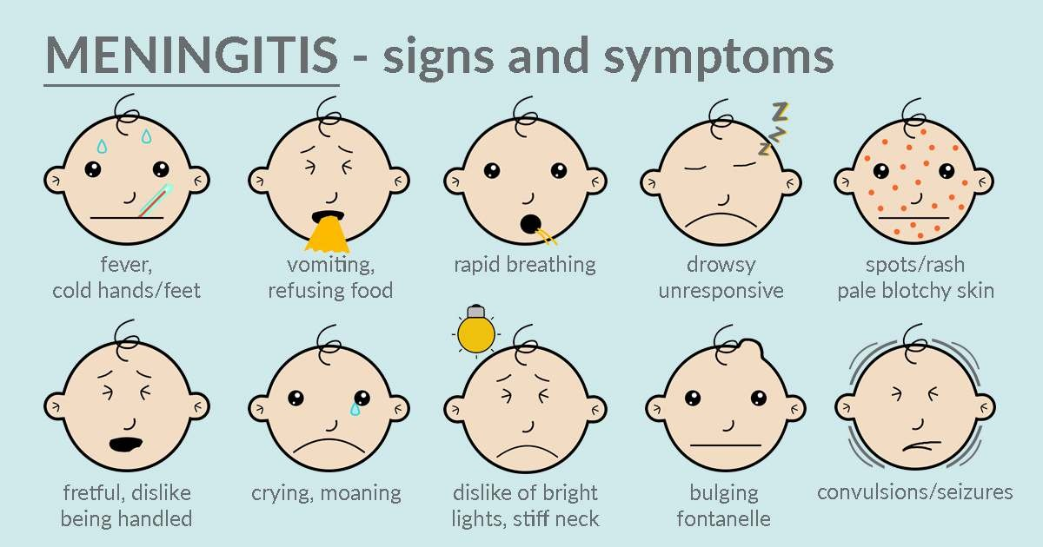

Acute bacterial meningitis is a medical emergency.
  - The immediate clinical manifestations are fever, severe headache, vomiting, drowsiness, stupor, coma, and occasionally, convulsions
  - The diagnosis is confirmed by examining CSF
- Naked eye appearance of cloudy or frankly purulent CSF.
- Elevated CSF pressure (above 180 mm water).
- Polymorphonuclear neutrophilic leucocytosis in CSF(between 10-10,000/μl).
- Raised CSF protein level (higher than 50 mg/dl).
- Decreased CSF sugar concentration (lower than 40 mg/dl)
- Bacteriologic examination by Gram’s stain

Acute Lymphocytic (Viral, Aseptic) Meningitis
  - Acute lymphocytic meningitis is a viral or aseptic meningitis, especially common in children and young adults.
  - Etiologic agents are numerous viruses such as enteroviruses, mumps, ECHO viruses, coxsackie virus, Epstein-Barr virus, herpes simplex virus-2, arthropode-borne viruses and HIV
  - viral meningitis has a benign and self-limiting clinical course of short duration and is invariably followed by complete recovery

Chronic (Tuberculous and Cryptococcal) Meningitis
  - There are two principal types of chronic meningitis—bacterial (tuberculous meningitis) and fungal (cryptococcal meningitis)
  - Tuberculous meningitis occurs in children and adults through haematogenous spread of infection from tuberculosis
  - Cryptococcal meningitis develops particularly in debilitated or immunocompromised persons, usually as a result of haematogenous dissemination from a pulmonary lesion

  - Tuberculous meningitis manifests clinically as headache, confusion, malaise and vomiting
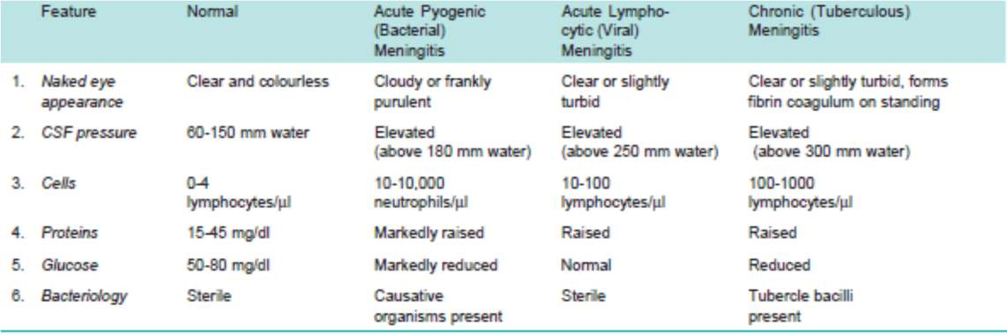

Summary
  - Meningitis is inflammatory involvement of the meninges
  - Acute pyogenic or acute purulent meningitis is acute infection of the pia-arachnoid and of the CSF enclosed in the subarachnoid space
  - Acute lymphocytic meningitis is a viral or aseptic meningitis, especially common in children and young adults.
  - There are two principal types of chronic meningitis—bacterial (tuberculous meningitis) and fungal (cryptococcal meningitis)

Typhoid Fever
(Enteric Fevers)

Typhoid fevers are prevalent in many regions in the World
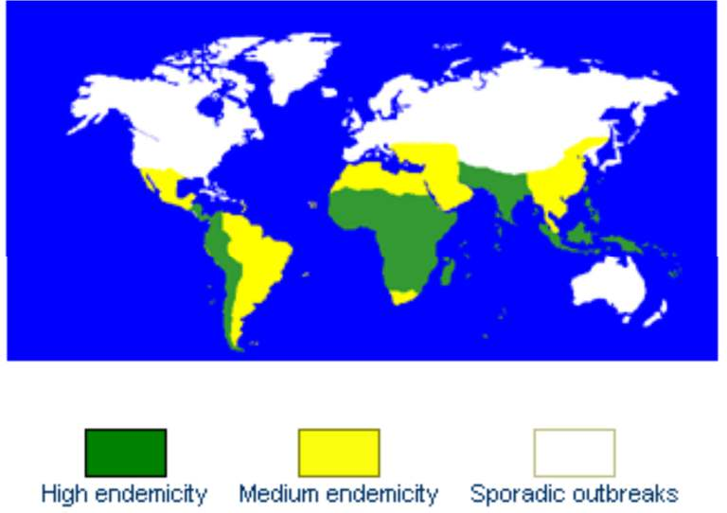
In 1906, Irish immigrant Mary Mallon worked as a cook in the Oyster Bay summer home of New York banker Charles Henry Warren and his family. By the end of the summer, six members of the household had contracted typhoid fever. The Warrens hired sanitary engineer, George Soper, to determine the source of the disease. Soper concluded that Mallon, while immune herself to the disease, was its carrier. For three years, she was isolated on North Brother Island, near Rikers Island, earning the nickname "Typhoid Mary." Instructed not to cook for others upon her release, she nevertheless changed her name and became a cook at a maternity hospital in Manhattan. At least 25 staff members contracted typhoid. "Typhoid Mary" returned to North Brother Island, where she lived alone for 23 years, until her death in 1938. She is shown here on the island in an undated photo. She died of a stroke after 23 years in quarantine.

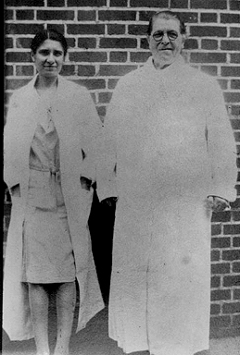
Mary Mallon (wearing glasses) photographed with bacteriologist Emma Sherman on North Brother Island in 1931 or 1932, over 15 years after she had been quarantined there permanently.

Etiology of Typhoid fever
- Typhoid fever is a bacterial disease, caused by Salmonella typhi.
- It is transmitted through the ingestion of food or drink contaminated by the faeces or urine of infected people.
- Para typhoid fevers are produced by other species named
- Paratyphi A, B, C

How a Typhoid fever spreads
- Salmonella Typhi lives only in humans.
- Persons with typhoid fever carry the bacteria in their bloodstream and intestinal tract. In addition, a small number of persons, called carriers, recover from typhoid fever but continue to carry the bacteria.
- Both ill persons and carriers shed S. Typhi in their feces (stool).

Epidemology
- World largest outbreak of typhoid in SANGLI on December 1975 to February 1976. This disease is endemic in India

• | 1992 : | 3,52,980 cases with 735 deaths
• | 1993 : | 3,57,452 cases and 888 deaths
• | 1994 : | 2,78,451 cases and 304 deaths
- Case fatality rate due to typhoid has been varying between 1.1% to 2.5 % in last few years.
Manifestations
- Relative bradycardia
- Hepatomegaly
- Splenomegaly

Causes

Age group: Typhoid fever may occur at any age but it is considered to be a disease mainly of children and young adults. In endemic areas, the highest attack rate occurs in children aged 8-13 years. In a recent study from slums of Delhi, it was found that contrary to popular belief, the disease affects even children aged 1-5 years
Gender and race: Typhoid fever cases are more commonly seen in males than in females. On the contrary, females have a special predilection to become chronic carriers.
Occupation: Certain categories of persons handling the infective material and live cultures of S. typhi are at increased risk of acquiring infection.
Socio-economic factors: It is a disease of poverty as it is often associated with inadequate sanitation facilities and unsafe water supplies.
Environmental factors: Though the cases are observed throughout the year, the peak incidence of typhoid fever is reported during July - September. This period coincides with the rainy season and a substantial increase in fly population.
Social factors: pollution of drinking water supplies, open air defecation, and urination, low standards of food and personal hygiene, and health ignorance.

Pathogenesis

Caused by
- S. typhi
- S.paratyphi
- The organisms penetrate ileal mucosa reach mesenteric lymph nodes via Lymphatics , Multiply,
- Invade Blood stream via thoracic duct
- In 7 – 10 days through blood stream infect
- Liver, Gall Bladder,, spleen, Kidney, Bone marrow.
- After multiplication bacilli pass into blood causing secondary and heavier bactermia

Management of typhoid fever:

General: Supportive care includes
- Maintenance of adequate hydration.
- Antipyretics.
- Appropriate nutrition.
Specific: Antimicrobial therapy is the mainstay treatment. Selection of antibiotic should be based on its efficacy, availability and cost.
- Chloramphenicol , Ampicillin ,Amoxicillin , Trimethoprim &Sulphamethoxazole ,Fluroquinolones
- In case of quinolone resistance – Azithromycin, 3rd generation cephalosporins (ceftriaxone)

Control of Typhoid fever

MEASURES DIRECTED TO RESERVOIR
  - Case detection and treatment
  - Isolation
  - Disinfection of stools and urine d)Detection & treatment of carriers
MEASURES AT ROUTES OF TRANSMISSION
- Water sanitation
- Food sanitation
- Excreta disposal
- Fly control MEASURES FOR SUSCEPTIBLES
- immunoprophylaxis
- Health education

Vaccines for Typhoid Prevention
- Two types of vaccines are available Oral and Injectable
- Oral – A live oral vaccine (typhoral) is a stable mutant of S.typhi strain Ty 21a lacking the enzyme UDP Galactose -4-epimerase.
- One capsule given orally taken before food, with glass of water or milk, on 1, 3, 5 days ( three doses )
- No antibiotics should be taken during the period of administration of vaccine
- The injectable vaccine, ( typhim –vi) contains purified Vi polysaccharide antigen derived from S.typhi strain ty21
- Given as single subcutaneous or intramuscular injection
- Single dose is adequate.

Summary
- Typhoid fever is a bacterial disease, caused by Salmonella typhi.
- It is transmitted through the ingestion of food or drink contaminated by the faeces or urine of infected people
- The organisms penetrate ileal mucosa reach mesenteric lymph nodes via Lymphatics , Multiply, Invade Blood stream via thoracic duct
- Management: Antipyretics,Appropriate nutrition, Antimicrobial therapy

