Inflammatory bowel disease
Inflammatory bowel disease describes two major chronic nonspecific inflammatory disorders of the gastro intestinal tract
- They are:
- Crohn’s disease(CD)
- Ulcerative colitis(UC)
- Main difference between Crohn's disease and UC is the location and nature of the inflammatory changes
- Crohn's can affect any part of the gastrointestinal tract, from mouth to anus , although a majority of the cases start in the terminal ileum
- Ulcerative colitis, in contrast, is restricted to the colon and the rectum

UC AND CROHN’S
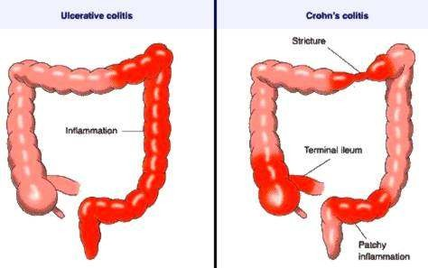

ETIOLOGY
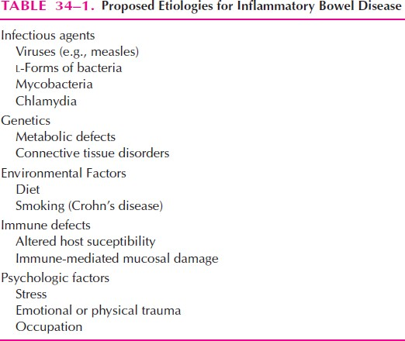

EPIDEMOLOGY

 | Ulcerative colitis | Crohn’s disease
Incidence (US) | 11/100 000 | 7/100 000
Age of onset | 15-30 & 60-80 | 15-30 & 60-80
Male:female ratio | 1:1 | 1,1-1,8:1
Smoking | May prevent disease | May cause disease
Oral contraceptive | No increased risk | Relative risk 1,9
Appendectomy | Not protective | Protective
Monozygotic twins | 8% concordance | 67% concordance

INFLAMMATORY RESPONSE
- Inflammatory response with IBD may indicate abnormal regulation of the normal immune response or an autoimmune reaction to self-antigens - microflora of the gastrointestinal tract may provide an environmental trigger to activate inflammation
- Crohn’s disease has been described as “a disorder mediated by T lymphocytes which arises in genetically susceptible individuals as a result of a breakdown in the regulatory constraints on mucosal immune responses to enteric bacteria”

INFECTIOUS FACTORS
- Microorganisms are a likely factor in the initiation of inflammation in IBD - Patients with inflammatory bowel diseases have increased numbers of surface-adherent and intracellular bacteria
- Suspect infectious agents include the measles virus, protozoans, mycobacteria, and other bacteria
- Bacteria elaborate peptides (e.g., formyl-methionylleucyl-phenylalanine) that have chemotactic properties - influx of inflammatory cells with subsequent release of inflammatory mediators and tissue destruction

GENETIC FACTORS
- Genetic factors predispose patients to inflammatory bowel diseases, particularly Crohn’s disease - studies of monozygotic twins, there has been a high concordance rate, with both individuals of the pair having an IBD (particularly Crohn’s disease) - first-degree relatives of patients with IBD had a 13-fold increase in the risk of disease
- Other investigators - genetic markers - more frequent in those with IBD (particularly major histocompatability complex, HLA-DR2 for ulcerative colitis and HLA-A2 for Crohn’s disease)

IMMUNOLOGICAL MECHANISMS
- Inflammatory process is a component of wound healing, the inflamed mucosa activates the typical inflammation
–associated genes and genes associated with wound healing
- Pro-inflammatory antigenic triggers in the intestinal lumen activate macrophages and t-helper lymphocytes to release inflammatory mediators

PATHOPHYSIOLOGY

Ulcerative colitis:
- UC is confined to be in rectum and colon and affects the mucosa and the sub mucosa - some instances, a short segment of terminal ileum may be inflamed
- Primary lesion of uc occurs in the crypts of the mucosa (crypts of liberkhun) in the form of crypt abscess
- Necrosis of the epithelium occurs and visible only in microscope
- Other typical ulceration patterns include a “collar button ulcer”, which results from extensive sub mucosal undermining at the ulcer edge which results in diarrhea and bleeding
- UC complications can be local (colon/rectum) or systemic
- Complications could be minor, serious or life threatening
- Minor complication occurs in the majority of ulcerative colitis patients. They include: hemorrhoids, anal fissures or perirectal abscesses

- Major complication is toxic megacolon (1-3%), massive colonic hemorrage
- Risk of colon cancer begins to increase after 10-15 years of uc diagnosis

Ulcerative colitis – microscopic features
- Process is limited to the mucosa and submucosa with deeper layer unaffected
- Two major histologic features:
- the crypt architecture of the colon is distorted
- some patients have basal plasma cells and multiple basal lymphoid aggregates
  - 40-50% of patients have disease limited to the rectum and rectosigmoid
  - 30-40% of patients have disease extending beyond the sigmoid
  - 20% of patients have a total colitis
  - Proximal spread occurs in continuity without areas of uninvolved mucosa

SYMPTOMS
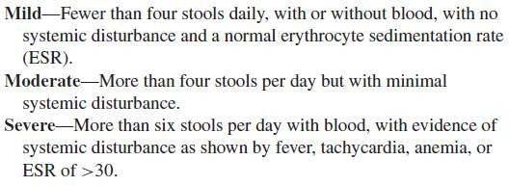
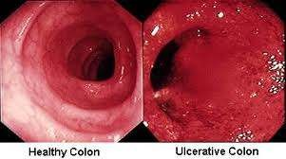

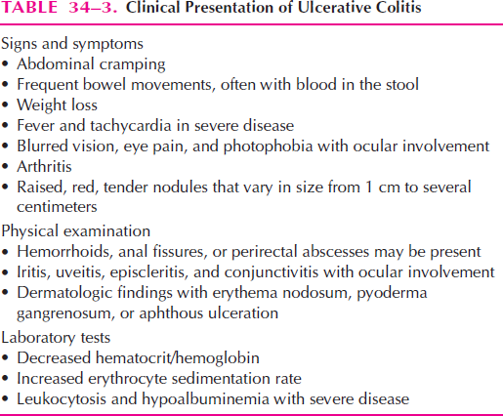

  - Target point for CD- terminal ileum

Crohn’s disease:

  - About two-thirds of patients have some colonic involvement, and 15% to 25% of patients have only colonic disease
  - Bowel wall injury is extensive and the intestinal lumen is often narrowed
  - Mesentery first becomes thickened and edematous and then fibrotic
  - Ulcers tend to be deep and elongated and extend along the longitudinal axis of the bowel, atleast into the submucosa
  - “Cobblestone” appearance of the bowel wall results from deep mucosal ulceration intermingled with nodular submucosal thickening
  - Fistula formation is common and occurs much more frequently than with ulcerative colitis
  - Fistulae often occur in the areas of worst inflammation, where loops of bowel have become matted together by fibrous adhesions
  - Nutritional deficiencies are common with Crohn’s disease
  - Weight loss, growth failure in children, iron deficiency anemia, vitamin B12 deficiency, folate deficiency, hypoalbuminemia, hypokalemia, and osteomalacia

Sign & Symptoms
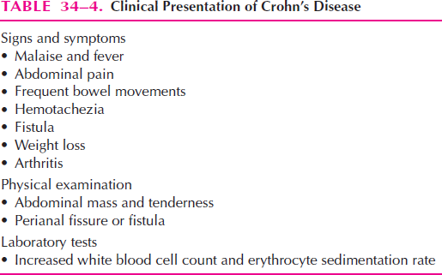

DIAGNOSIS
  - The first clue in the diagnosis of IBD are the symptoms:
  - Unrelenting diarrhea
  - Blood or mucus in the stool (more common with ulcerative colitis than Crohn’s disease)
  - Fever
  - Abdominal pain

TESTS :
  - Complete blood cell (CBC) count,
  - Electrolyte panel, and
  - Liver function tests (LFT)
  - Fecal occult blood test (also called stool gaiac or hemoccult test)

OTHER TESTS
- X-RAY
- BARIUM ENEMA
- COLONOSCOPY
- ENDOSCOPY
- SIGMOIDOSCOPY

COMPARISION

Features | Ulcerative colitis | Crohn’s
Abdominal pain | Variable | Common
Depth of inflammation | Mucosal | Transmural
Diarrhea | Severe | Less severe
Fistula and sinus tracts | Rare | Common
Distribution | Diffuse, contiguous spread; always involves rectum; spares proximal gastrointestinal tract | Segmental, noncontiguous spread (“skip lesions”); less common rectal involvement; occurs in entire GIT
CLINICAL FEATURES

 | UC | Crohn’s disease
Blood in stool | Yes | Occasionally
Mucus | Yes | Occasionally
Systemic symptoms | Occasionally | Frequently
Pain | Occasionally | Frequently
Abdominal mass | Rarely | Yes
Perineal disease | No | Frequently

SUMMARY
  - Inflammatory bowel disease describes two major chronic nonspecific inflammatory disorders of the gastro intestinal tract ulcerative colitis and crohns disease
  - Major causes of inflammatory bowel disease are infectious agents, environmental factors, genetics, diet
  - UC is confined to be in rectum and colon and affects the mucosa and the sub mucosa by release of inflammatory cells
  - Ulcers in crohn’s tend to be deep and elongated and extend along the longitudinal axis of the bowel, into the submucosa

