Hypertension

Persistently elevated arterial blood pressure [BP]
Associated with both functional and morphologic alteration of blood vessels
- Arterial BP - generated by the interplay between blood flow and the resistance to blood flow

- Measured in mmHg
2 types of arterial blood pressure
- Systolic BP (SBP)- achieved during cardiac contraction
- Diastolic BP (DBP)- achieved after contraction when the cardiac chambers are filling
SBP – DBP = pulse pressure (measure of arterial wall tension)
  - Cardiac output - major determinant of SBP
  - Total peripheral resistance determines DBP
- Mean arterial pressure [MAP] - Average pressure throughout the cardiac cycle of contraction
- During cardiac cycle 2/3rd time spent in diastole and 1/3rd time in systole

MAP= [SBP (1/3)] +[DBP (2/3)]
BP= Cardiac output × Total peripheral resistance

Clinical classification of hypertension

Category | Systolic (mm Hg) | Diastolic (mm Hg)
Normal | < 130 | <85
High normal | 130-139 | 85-89
Hypertension
- Mild (Stage 1) | 140-159 | 90-99
- Moderate (Stage 2) | 160-179 | 100-109
- Severe (Stage 3) | 180-209 | 110-119
- Very severe (Stage 4) | ≥ 210 | ≥ 120
Malignant hypertension | > 200 | ≥ 140

Etiological classification of hypertension

Primary essential hypertension
  - Genetic factors
  - Racial and environmental factors
  - Risk factors modifying the course of HT

Secondary hypertension
  - Renal – Renovascular
Renal parenchymal disease
  - Endocrine - Adrenocortical hyperfunction
Hyperparathyroidism Oral contraceptives
  - Coarctation of aorta
  - Neurogenic
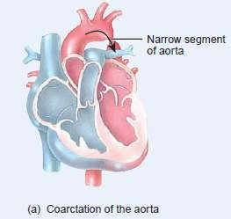

Clinical classification of primary and secondary hypertension

Benign hypertension
- Observed in 95% of patients
- Slow rise in BP taking years to develop Malignant/ accelerated hypertension
- Observed in 5-10% of patients
- Rapid rise in BP to 200/140 mm Hg or more
- If left untreated, patient’s life expectancy decreases

Symptoms

When BP is severe, following symptoms are observed
- Nose bleeding
- Irregular heart beat
- Head ache
- Dizziness
- Fatigue
- Flushed face
- Breathing difficulties
- Strong tendency to uinate
- Vertigo, tinnitus, etc.,
Malignant hypertension is characterized by
- Pulsating headache beneath the eye
- Visual disturbance
- Nausea and vomiting
- Disturbed sleep

Pathogenesis

BP is the product of
- Cardiac output
- Total peripheral vascular resistance

Cardiac output
- Volume of blood that circulates through systemic blood vessels each minute
  - Dependent on stroke volume (SV)
  - SV - Volume of blood ejected by the left ventricle during each contraction
- Peripheral resistance depends on
̶ Viscosity of blood
̶ Diameter of the blood vessel
̶ Compliance
- High viscosity - high pressure to pass through vascular bed
- High pressure to pass through constricted and non-complaint blood vessels

BP is controlled by
- Neural component
- Peripheral auto regulatory mechanism
- Humoral mechanism
- Vascular endothelial mechanism

Neural component
- Both CNS & ANS controls BP

Centers in CNS are
̶ Vasomotor center in Medulla
̶ Vagal nucleus
̶ Area postrema
̶ Nuclues tractus solitarii
̶ Maintenance of BP by sympathetic nervous system through α and β adrenergic receptors
++ post synaptic α1 receptors ― vasoconstriction ― ↑ BP
++ pre synaptic α2 receptors ― negative feedback on NA release
++ β1 in heart ― ↑ HR and contractility
++ β2 in arterioles and venules ― vasodilation
Change in BP senses by barro receptors in carotid artery and aortic arch
- Respond to change in arterial pressure
- Transmitted to brain through IX cranial nerve and vagus nerve
- ↑ discharge from barroreceptors − depression of vasomotor center − excitation of nucleus ambiguus − reverts change in BP

Peripheral auto regulatory mechanism
- Normal case – volume and pressure adaptive mechanism of kidney maintains BP
↓ BP – adaptation of kidney ̶ more Na⁺ and H2O retention
↑BP – adaptation of kidney ̶ Na⁺ and H2O excretion – ↓ blood volume & cardiac output

Humoral mechanism
- Renin Angiotensin Aldosterone system
- Natriuretic hormone
- Insulin resistance and hyperinsulinemia

Renin-Angiotensin-aldosterone system
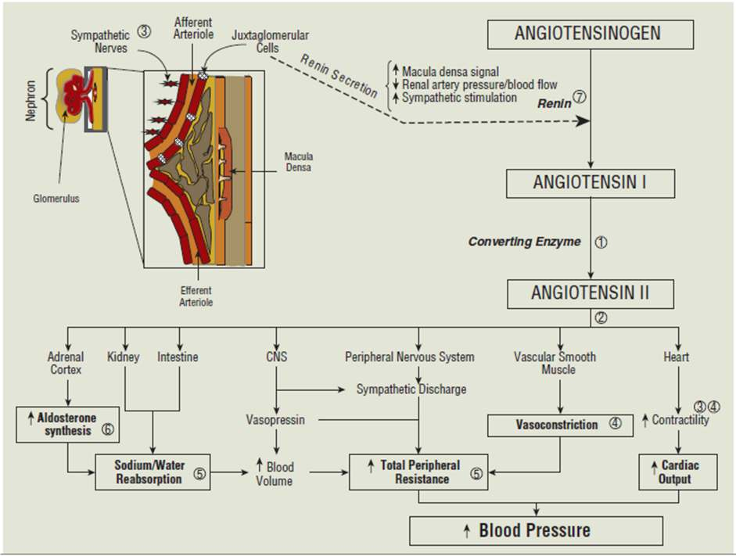

Natriuretic hormone
- Inhibits Na⁺ /K⁺ ATP ase
- Interferes with Na⁺ transport across cell membrane
- ↑ Na⁺ in body fluids - ↑ Natriuretic hormone - ↑ urinary excretion of Na⁺ and H2O
- Blocks active transport of Na⁺ out of the walls of arterioles - ↑ vascular tone and BP

Insulin resistance and hyper insulinemia
- Causes Na⁺ retention
- Increases sympathetic activity
- Increases vascular resistance
- Increases BP

Vascular endothelial mechanism
- Regulates blood vessel tone
- Vasodilating substances – Nitric oxide, Prostacyclin (PI2) and bradykinin – Hypotension
- Vasoconstrictors – Angiotensin II and Endothelin I - ↑BP

Effect of dietary Na⁺ Ca²⁺ K⁺ on BP
- ↑ intra cellular Ca²⁺ - alters smooth muscle function on blood vessels - ↑ Peripheral vascular resistance
- K⁺ depletion - ↑ Peripheral vascular resistance
- ↑ Na⁺ in body fluids & in arterial wall - ↑ BP

Complications of HT
- Blood vessels - Large arterioles dialatess
- Smaller arterioles get damaged
- Eye – Arterial narrowing, haemmorhage
- Heart - Hypertropy of left ventricles, heart failure
- Kidney – Nephrosclerosis, renal damage, death in uremia
- Brain – Rupture of damaged blood vessels, encephalopathy, cerebral edema

Summary
- Persistently elevated arterial blood pressure is called hypertension
- Hypertension can be classified as benign or malignant or accelerated hypertension
- HT can also be classifies as primary and secondary HT based on etiology
- BP is controlled by neuronal component, humoral mechanism, peripheral autoregultory mechanism and vascular endothelial mechanism
- Any defects in the functioning of these mechanisms leads to the development of HT
- HT is affects kidneys, blood vessels, brain and predisposed to many cardiovascular diseases
Chronic Obstructive Pulmonary

CONGESTIVE CARDIAC FAILURE

- Result from any disorder that impairs the ability of the ventricle to fill with or eject blood
- Rendering the heart unable to pump blood at a rate sufficient to meet the metabolic demands of the body
- Heart failure can result from any disorder that reduces ventricular filling (diastolic dysfunction) and/or myocardial contractility (systolic dysfunction)
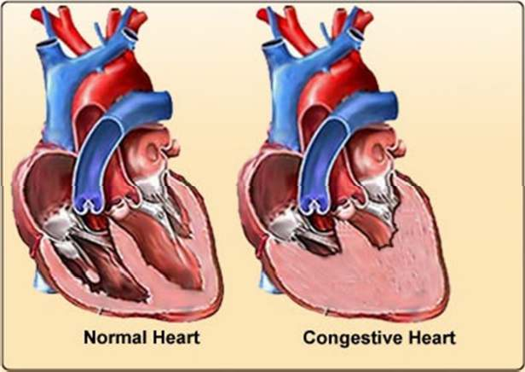

Etiology

Systolic dysfunction (decreased contractility)
  - Reduction in muscle mass (e.g. myocardial infarction)
  - Dilated cardiomyopathies
  - Ventricular hypertrophy
  - Pressure overload (e.g. systemic or pulmonary HT, aortic or pulmonic valve stenosis)
  - Volume overload (e.g., valvular regurgitation, shunts, high-output states)

Diastolic dysfunction (restriction in ventricular filling)
  - Increased ventricular stiffness
  - Ventricular hypertrophy (e.g. hypertrophic cardiomyopathy)
  - Infiltrative myocardial diseases (e.g. amyloidosis, sarcoidosis, endomyocardial fibrosis)
  - Myocardial ischemia and infarction
  - Mitral or tricuspid valve stenosis
  - Pericardial disease (e.g. pericarditis, pericardial tamponade)

Types of Heart Failure
  - Acute and chronic heart failure
  - High output and low output HF
  - Left sided, right sided and biventricular HF
  - Forward and backward HF

  - Systolic and diastolic HF

Acute heart failure
  - Heart is not able to pump the blood effectively
  - Also called as Decompensated heart failure
  - Compensatory mechanisms of human body cause increase in CO by stimulation of β1 receptors and also RAA-system
  - Both mechanism leads to vasoconstriction
  - Treatment with Inotropic drugs becomes necessary

Chronic heart failure
  - Failure of compensatory mechanism
  - Heart needs to undergo surgery for its repair
  - Further controlled by administration of drugs

High output HF:
  - There is high demands of the body, which are not met even with increased cardiac output
  - e.g.: anemia, pregnancy

Low output HF:
  - There is decreased contractility of heart leading to decreased cardiac output
  - e.g.: cardiomyopathy, valvular disease

Left sided (left ventricular) HF
  - Excess fluid accumulates upstream
  - Reduction in left ventricular output
  - Increase in left atrial pressure
  - Increase in pulmonary venous pressure
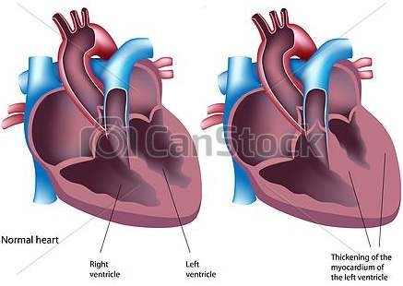
- Acute increase in left atrial pressure causes pulmonary congestion and pulmonary edema e.g.: MI
- Gradual increase in left atrial pressure causes reflex pulmonary hypertension but no pulmonary edema
e.g. : aortic stenosis

Right sided (right ventricular) HF:
  - Excess fluid accumulates upstream behind the failing right ventricle

  - Reduction in right ventricular output
  - Results in systemic venous congestion
Ex: pulmonary valvular stenosis, multiple pulmonary emboli

Systolic HF:
  - Characterized by an abnormality of ventricular contraction
  - As seen in ischemic heart failure and dilated cardiac myopathy

Diastolic HF:
  - Characterized by an impaired ventricular relaxation
  - Increased ventricular stiffness resulting in diastolic dysfunction e.g.: ischemia, left ventricular hypertrophy

PATHOPHYSIOLOGY

Preload: Pressure that fills the left ventricle during diastole
  - Main Determinant- left ventricular compliance and venous return
  - Small increase in end-diastolic volume
  - large increase in cardiac output
  - Primary compensatory mechanism in normal heart
  - Ability of heart to alter the force of contraction depends on preload

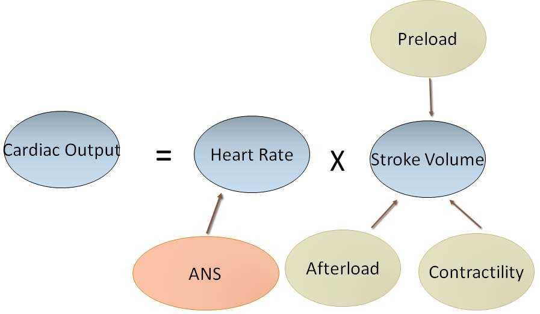
Afterload: Pressure against which the left ventricular contracts and is measured as the mean aortic pressure
- Main determinants - total peripheral resistance and left ventricle size
- Left ventricular dysfunction - an inverse relationship exist between afterload and stroke volume
- An increase in afterload causes a decrease in stroke volume

Key components of the pathophysiology of cardiac remodelling
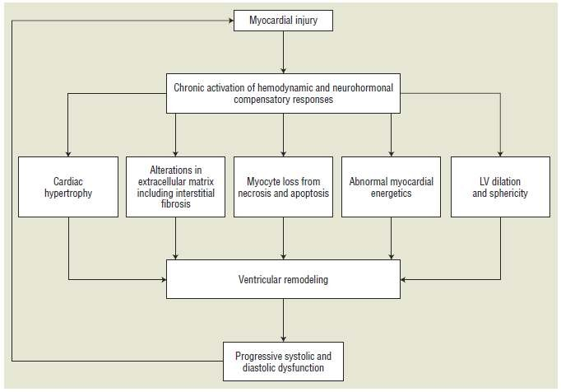

Compensatory Mechanisms

Cardiac compensatory mechanism:
- Ventricular dilation
- Ventricular hypertrophy

Peripheral compensatory mechanisms:
- Increased sympathetic activity
- Activation of renin angiotensin aldosterone system
- Increased release of arginine vasopressin
Renin Angiotensin Aldosterone system
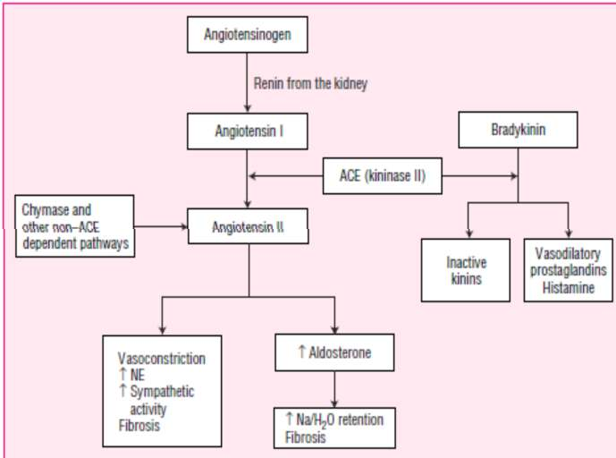

Clinical Presentation – Signs
  - Pulmonary edema
  - Pleural effusion
  - Tachycardia
  - Cardiomegaly
  - Peripheral edema
  - Jugular venous distension
  - Hepatojugular reflux
  - Hepatomegaly

SYMPTOMS
  - Dyspnea
  - Orthopnea
  - Paroxysmal nocturnal dyspnea
  - Exercise intolerance
  - Tachypnea
  - Ascites, Mental status changes
  - Cough
  - Fatigue
  - Nocturia
  - Hemoptysis
  - Abdominal pain, Anorexia, Nausea, Bloating

SUMMARY
  - CHF is a clinical syndrome that impairs the ability of the ventricle to fill with or eject blood
  - Heart is unable to pump blood at a rate sufficient to meet the metabolic demands of the body
  - It can be classified as: Acute and chronic heart failure,
  - High output and low output heart failure,
  - Left sided, right sided and biventricular heart failure,
  - Systolic and diastolic heart failure

