Haemophilia

Normal Clotting

a

Response to vessle injury
- Vasoconstriction to reduce blood flow
- Platelet plug formation (von willebrand factor binds damaged vessle and platelets)
- Activation of clotting cascade with generation of fibrin clot formation
- Fibrinlysis (clot breakdown)

Clotting Cascade

Normally the ingredients, called factors, act like a row of dominoes toppling against each other to create a chain reaction.
If one of the factors is missing this chain reaction cannot proceed.


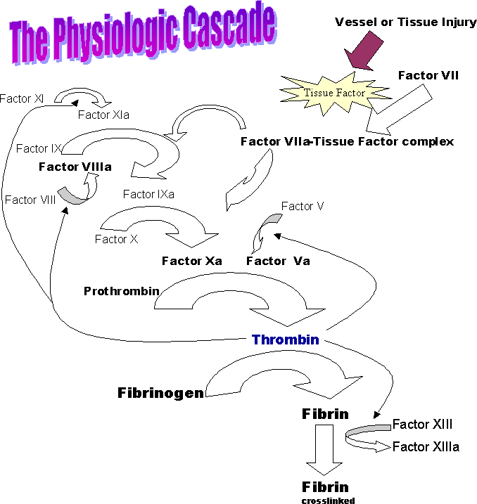

Response to vessle injury
- Vasoconstriction to reduce blood flow
- Platelet plug formation (von willebrand factor binds damaged vessle and platelets)
- Activation of clotting cascade with generation of fibrin clot formation
- Fibrinlysis (clot breakdown)

Clotting Cascade

Normally the ingredients, called factors, act like a row of dominoes toppling against each other to create a chain reaction.
If one of the factors is missing this chain reaction cannot proceed.

Hemophilia

Hemophilia is an inherited bleeding disorder in which there is a deficiency or lack of factor VIII (hemophilia A) or factor IX (hemophilia B)
COAGULATION DISORDERS: Disorders of plasma coagulation factors may have hereditary or acquired origin

HEREDITARY COAGULATION DISORDERS
- Classic haemophilia or haemophilia A (due to inherited deficiency of factor VIII) sex-(X)- linked disorders
- Christmas disease or haemophilia B (due to inherited deficiency of factor IX).
Types of Bleeding Disorders
  - Hemophilia A (factor VIII deficiency)
  - Hemophilia B (factor IX deficiency)
  - von Willebrand Disease (vWD)
  - Other

Inheritance of Hemophilia
  - Hemophilia A and B are X-linked recessive disorders
  - Hemophilia is typically expressed in males and carried by females
  - Severity level is consistent between family members
  - ~30 % of cases of hemophilia are new mutations

Haemophilia A
  - It is the second most common hereditary coagulation disorder next to von Willebrand’s disease occurring due to deficiency or reduced activity of factor VIII (anti-haemophilic factor).
  - Inherited as a sex-(X-) linked recessive trait- manifest in males
  - The frequency of haemophilia varies in different races, the highest incidence being in populations of Britain, Northern Europe and Australia.

PATHOGENESIS
  - Haemophilia A is caused by quantitative reduction of factor VIII in 90% of cases, while 10% cases have normal or increased level of factor VIII with reduced activity
  - Factor VIII synthesised hepatic parenchymal cells activate factor X (intrinsic coagulation pathway)
  - Factor VIII-vWF complex
  - 25% factor VIII level may develop bleeding, most symptomatic haemophilic patients have factor VIII levels below 5%.

CLINICAL FEATURES and TREATMENT

  - Patients of haemophilia suffer from bleeding for hours or days after the injury.

TREATMENT
  - Factor VIII replacement therapy,

Christmas Disease (Haemophilia B)
  - Inherited deficiency of factor IX (Christmas factor or plasma thromboplastin component) produces Christmas disease or haemophilia B.
  - TREATMENT. Therapy in symptomatic haemophilia B consists of infusion of either fresh frozen plasma or a plasma enriched with factor IX

Haemophilia Inheritance FVIII and FIX only
- Two chromosomes determine the sex of an individual, X and Y.
- Female XX
- Male XY
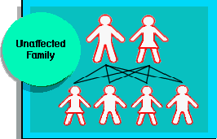

Father with Haemophilia
- Genetic defect causing haemophilia on that part of X chromosome not on Y chromosone
- Daughter of haemophiliac will inherit his X and be carrier.
- Sons of a haemophiliac will not be affected as they inherit fathers Y chromosome which does not carry FVIII or FIX gene.

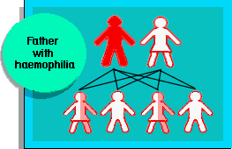

Carrier Mother (one normal gene and one defective gene)
- Chances carrier mother passing defective gene to a child are 50:50.
- Each daughter has 50:50 chance being a carrier
- Each son has 50:50 chance of having haemophilia.
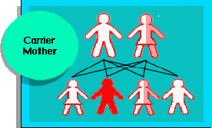

Spontaneous Mutation

In some 30% cases of haemophilia there is no known family history
Haemophilia is probably the result of spontaneous genetic mutation in these families.

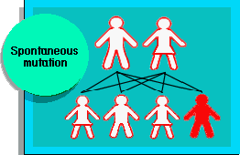

Summary

HEREDITARY COAGULATION DISORDERS
- Classic haemophilia or haemophilia A (due to inherited deficiency of factor VIII) sex-(X)- linked disorders and
Christmas disease or haemophilia B (due to inherited deficiency of factor IX
- Hemophilia A and B are X-linked recessive disorders
- Hemophilia is typically expressed in males and carried by females
- Haemophilia A is caused by quantitative reduction of factor VIII in 90% of cases, while 10% cases have normal or increased level of factor VIII with reduced activity
- Factor VIII replacement therapy

Hereditary Acquired Anemia
- Hereditary haemolytic anaemias are usually the result of intracorpuscular defects.
- Classified into 2 groups:
- Hereditary abnormalities of red cell membrane
- Hereditary disorders of the interior of the red cells

Hereditary Abnormalities of Red Cell Membrane

3 important types of inherited red cell membrane defects:
- Hereditary spherocytosis
- Hereditary elliptocytosis (hereditary ovalocytosis)
- Hereditary stomatocytosis.

Hereditary Spherocytosis Pathogenesis
  - The molecular abnormality in hereditary spherocytosis is a defect in proteins which anchor the lipid bilayer to the underlying cytoskeleton.
- Spectrin deficiency: deficiency in the structural protein of the red cell membrane, spectrin
  - Mutation in spectrin- α−spectrin- severe anaemia
  - Mutation by β-spectrin results in mild Anaemia.
- Ankyrin abnormality: defect in ankyrin, protein that binds protein 3 and spectrin

CLINICAL FEATURES
  - 1. Anaemia is usually mild to moderate.
  - 2. Splenomegaly is a constant feature.
  - 3. Jaundice occurs due to increased concentration of unconjugated (indirect) bilirubin in the plasma (also termed congenital haemolytic jaundice).
  - 4. Pigment gallstones are

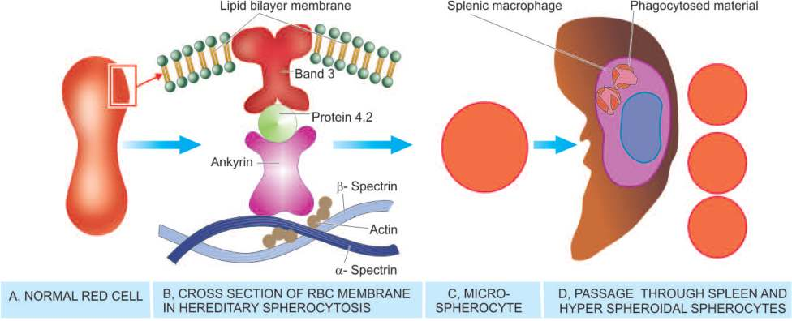

Hereditary Elliptocytosis (Hereditary Ovalocytosis)
  - It is autosomal dominant disorder involving red cell membrane protein spectrin.

Hereditary Stomatocytosis
  - Stomatocytes are cup-shaped RBCs having one surface concave and the other side as convex.
  - This causes a central slit-like or mouth-like appearance of red cells.
  - The underlying defect is in membrane protein stomatin

Hereditary Disorders of Red Cell Interior
  - Inherited disorders involving the interior of the red blood cells are classified into 2 groups:
- Red cell enzyme defects (Enzymopathies): These cause defective red cell metabolism involving 2 pathways
  - Defects in the hexose monophosphate shunt
  - Defects in the Embden-Meyerhof (glycolytic) pathway

Disorders of haemoglobin (haemoglobinopathies):
These are divided into 2 subgroups:
  - Structurally abnormal haemoglobin: Examples are sickle syndromes and other haemoglobinopathies.
  - Reduced globin chain synthesis: Common examples are various types of thalassaemias.
Red Cell Enzyme Defects (Enzymopathies) G6PD Deficiency
    - Defects in hexose monophosphate shunt- G6PD deficiency
    - G6PD gene is located on the X chromosome - affecting males

PATHOGENESIS

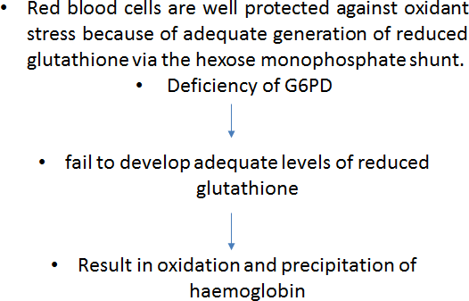

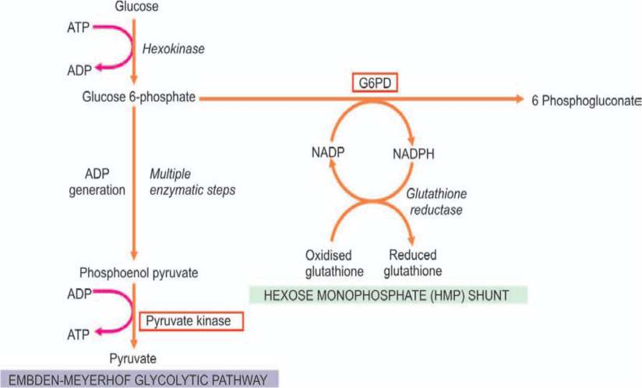

PK Deficiency
    - Pyruvate kinase (PK) deficiency is the only significant enzymopathy of the Embden-Meyerhof glycolytic pathway.
    - The disorder is inherited as an autosomal recessive pattern. Heterozygote state – asymptomatic
    - Homozygous individual presents during early childhood with anaemia, jaundice and splenomegaly.

Haemoglobinopathies
    - Haemoglobin in RBCs may be abnormally synthesised due to inherited defects. These disorders may be of two types:h
- Qualitative disorders in which there is structural abnormality in synthesis of haemoglobin e.g. sickle cell syndrome, other haemoglobinopathies.
- Quantitative disorders in which there quantitatively decreased globin chain synthesis of haemoglobin e.g. thalassaemias.

Summary
  - Important types of inherited red cell membrane defects:
- Hereditary spherocytosis
- Hereditary elliptocytosis (hereditary ovalocytosis)
- Hereditary stomatocytosis
  - Hereditary spherocytosis is a common type of hereditary haemolytic anaemia- defect in proteins which anchor the lipid bilayer to the underlying cytoskeleton
  - Hereditary elliptocytosis or hereditary ovalocytosis is another autosomal dominant disorder involving red cell membrane protein spectrin
  - Hererditary stomatocytes are swollen red cells (overhydrated red cells) due to increased permeability to sodium and potassium. The affected patients have mild anaemia and splenomegaly.
  - Inherited disorders involving the interior of the red blood cells are classified into 2 groups: Red cell enzyme defects (Enzymopathies) and disorders of haemoglobin (haemoglobinopathies)

