Haematological diseases

BLOOD
- Components of Blood
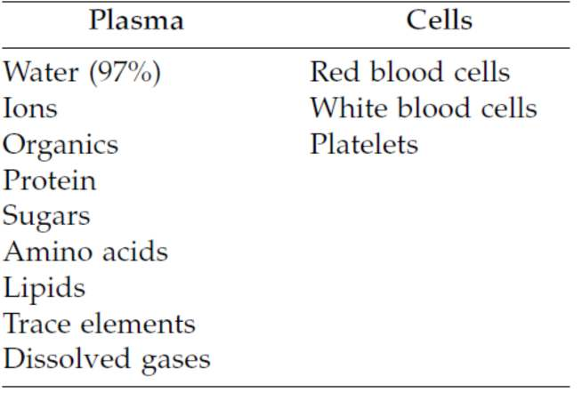
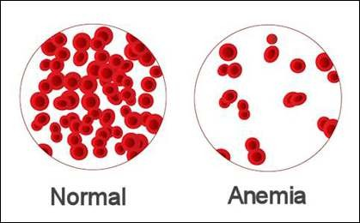

Anemia
- Condition in which the oxygen-carrying capacity of blood is reduced
- Characterized by reduced numbers of RBCs or a decreased amount of hemoglobin in the blood

General manifestations of anemia

Reduced oxygen delivery can result in the following:
- Ischemia
- Fatigability
- Breathlessness upon exertion
- Exercise intolerance
- Pallor

- Increased susceptibility to infection
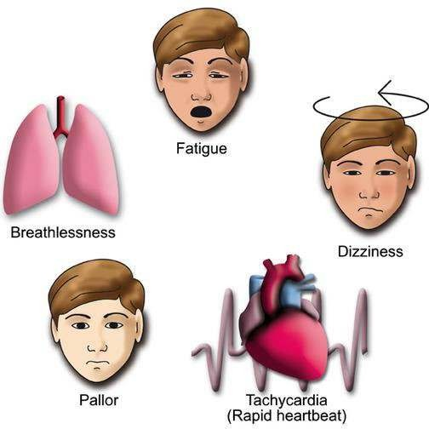

Classification of Anemia

- Based on Size changes



Normocytic
anemia
RBC size is
unchanged
Blood loss
anemia
Microcytic anemia
RBC size is reduced
Iron deficiency anemia
Macrocytic
anemia
RBC size is
increased
B12/folic
acid deficiency anemia
- Color changes (due to altered hemoglobin content)
  - Normochromic — Normal hemoglobin concentration
  - Hypochromic — Reduced hemoglobin concentration
Example: Iron deficiency anemia may be classified as a microcytic, hypochromic anemia as both red blood cell size and hemoglobin content are reduced
- Blood loss anemia: Anemia that results from acute blood loss.
- Iron-deficiency anemia: It can occur as a result of iron-deficient diets
- Cobalamin-deficiency or folate-deficiency anemia
- Inherited anemia- Sickle cell anaemia

Iron Deficiency Anemia
  - The commonest nutritional deficiency disorder present throughout the world is iron deficiency

Absorption
  - Haem iron is better in absorption than non haem iron
  - Non-haem iron is released as ferrous or ferric form
  - Transport across the membrane by divalent metal transporter 1 (DMT 1)

TRANSPORT:
  - Iron is transported in plasma bound to a β-globulin, transferrin, synthesised in the liver
  - Transferrin bound iron utilise for haemoglobin synthesis.
  - Transferrin is reutilised after iron is released from it.

EXCRETION:
The body is unable to regulate its iron content by excretion alone. The amount of iron lost per day is 0.5-1 mg.
DISTRIBUTION. In an adult, iron is distributed in the body as under:
  - 1. Haemoglobin—(65%).
  - 2. Myoglobin—(3.5%).
  - 3. Haem and non-haem enzymes—(0.5%).
  - 4. Transferrin-bound iron—(0.5%)
  - 5. Ferritin and haemosiderin—a (30%).

Iron absorption
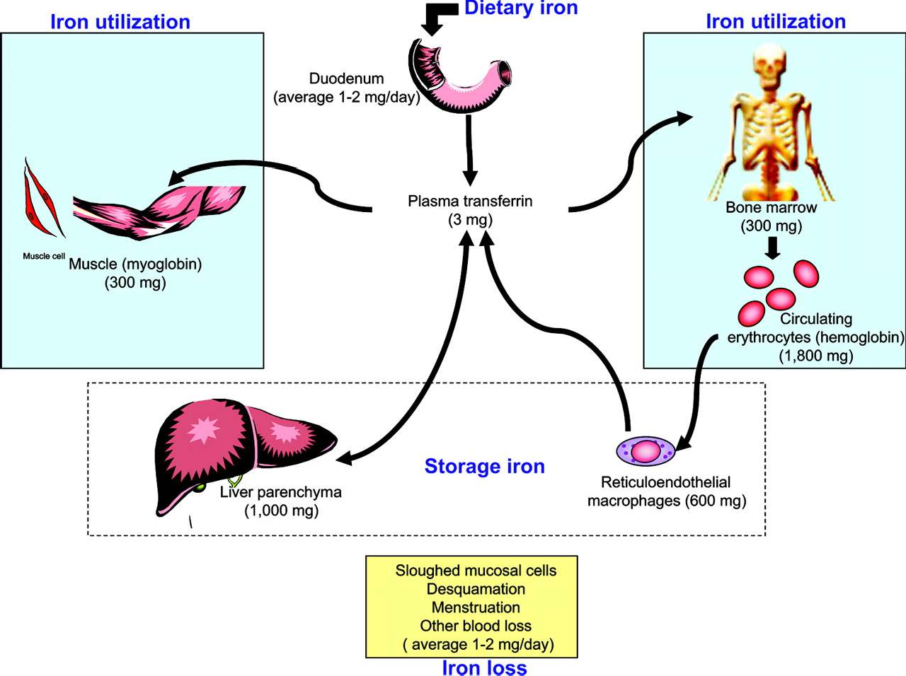

Absorption of Iron
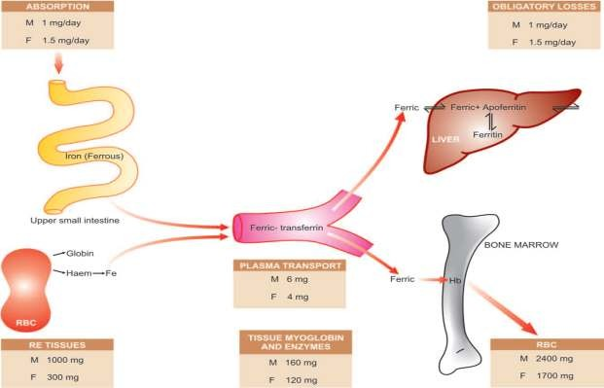

Pathogenesis
  - Iron deficiency anaemia develops when the supply of iron is inadequate for the requirement of haemoglobin synthesis.
  - The development of iron deficiency depends upon one or more of the following factors:

- Increased blood loss
- Increased requirements

- Inadequate dietary intake
- Decreased intestinal absorption

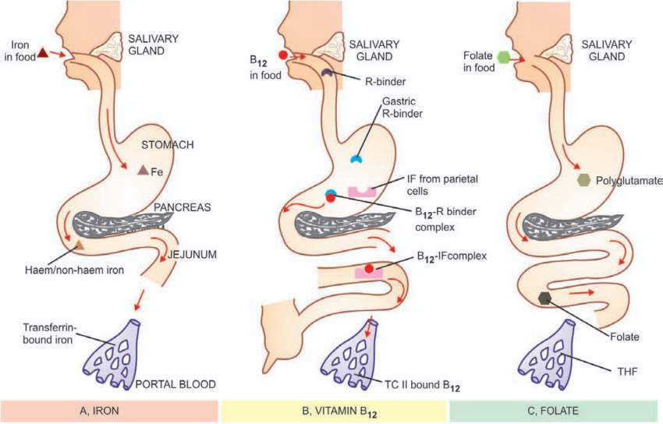

Etiology

INCREASED BLOOD LOSS
  - Uterine e.g. excessive menstruation in reproductive years, repeated miscarriages, at onset of menarche, post- menopausal
uterine bleeding
  - Gastrointestinal e.g. peptic ulcer, haemorrhoids, hookworm infestation, cancer of stomach and large bowel, oesophageal varices, hiatus hernia, chronic aspirin ingestion, ulcerative colitis, diverticulosis
  - Renal tract e.g. haematuria, haemoglobinuria
  - Nose e.g. repeated epistaxis
  - Lungs e.g. haemoptysis

INCREASED REQUIREMENTS
  - Spurts of growth in infancy, childhood and adolescence
  - Prematurity
  - Pregnancy and lactation

INADEQUATE DIETARY INTAKE
  - Poor economic status
  - Anorexia e.g. in pregnancy
  - Elderly individuals due to poor dentition, apathy and financial constraints

DECREASED ABSORPTION
  - Partial or total gastrectomy
  - Achlorhydria
  - Intestinal malabsorption such as in coeliac disease

Clinical Features
    - Iron deficiency anaemia is much more common in women between the age of 20 and 45 years than in men
    - More frequent in premature infants. Clinical consequences of iron deficiency: 1)anemia
- epithelial tissue changes

Treatment

The management of iron deficiency anaemia consists of 2 essential principles:
  - Correction of disorder causing the anaemia: checkup and investigations.
  - 2)Correction of iron deficiency: i) Oral therapy
ii) Parenteral therapy

Summary
- Anaemia is the condition in which the oxygen-carrying capacity of blood is reducd
- Characterized by reduced numbers of RBCs or a decreased amount of hemoglobin in the blood
- The commonest nutritional deficiency disorder present throughout the world is iron deficiency
- Iron deficiency anaemia develops when the supply of iron is inadequate for the requirement of haemoglobin synthesis

