HOMEOSTATIC CONTROL MECHANISMS

HOW HOMEOSTATIC CONTROL MECHANISMS WORK?
- Homeostatic control mechanisms work through ‘Feedback Mechanisms’.
- Status of a body condition is continually monitored, evaluated, changed, re-monitored & reevaluated.
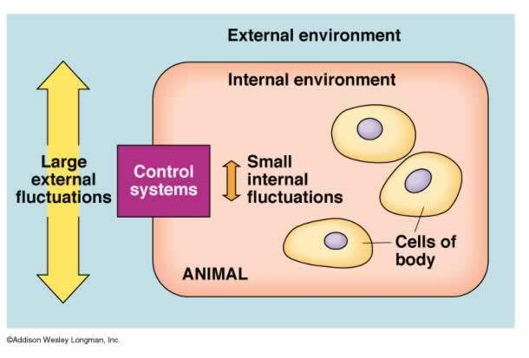

FEEDBACK MECHANISM
- A feedback mechanism is a cycle in which the output of a system “feeds back” to either modify or reinforce the action taken by the system.
- A feedback mechanism may operate at:
  - Tissue level
  - Organ level
  - Organ system level
  - Body level, integrating with other organ systems.
  - Feedback mechanism can be:

Negative feedback (more common)

  - Positive feedback

A FEEDBACK SYSTEM CONSISTS OF THREE COMPONENTS

- SENSOR (RECEPTOR): detects specific changes (stimuli) in the environment.
- INTEGRATOR: act to direct impulses to the place where a response can be made.
- EFFECTOR: performs the appropriate response.
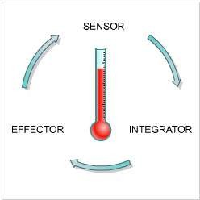
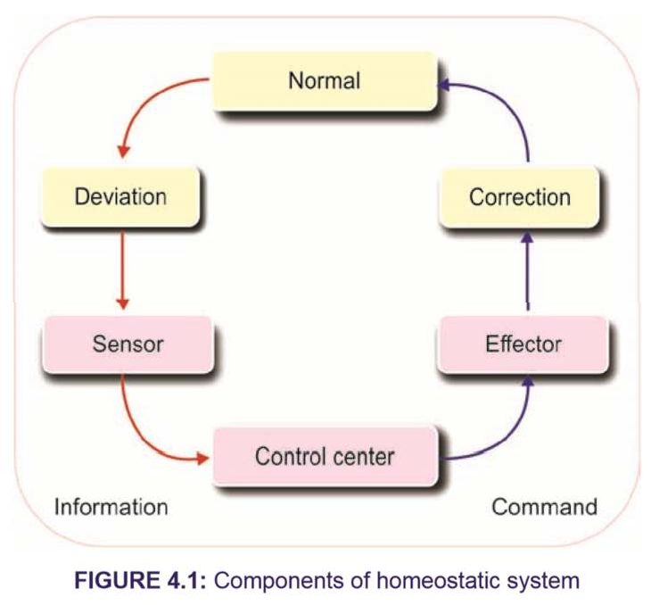

A FEEDBACK LOOP
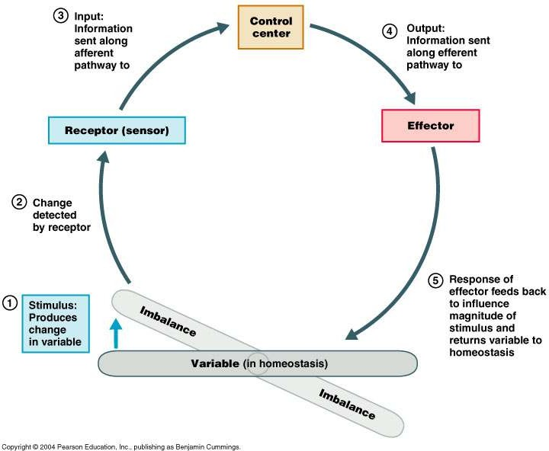

NEGATIVE FEEDBACK
- Mechanisms that maintain the factor at some mean value.
- Reverse a change
- Restore abnormal values to normal
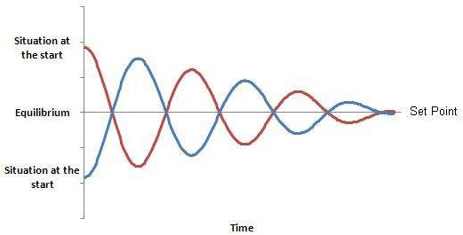

EXAMPLE: NEGATIVE FEEDBACK BLOOD PRESSURE REGULATION
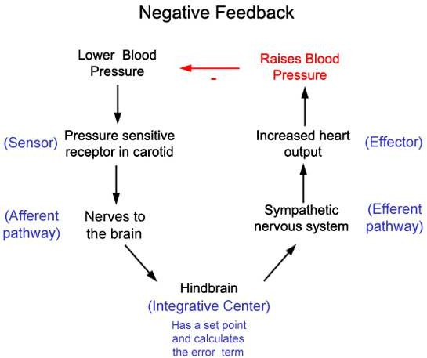
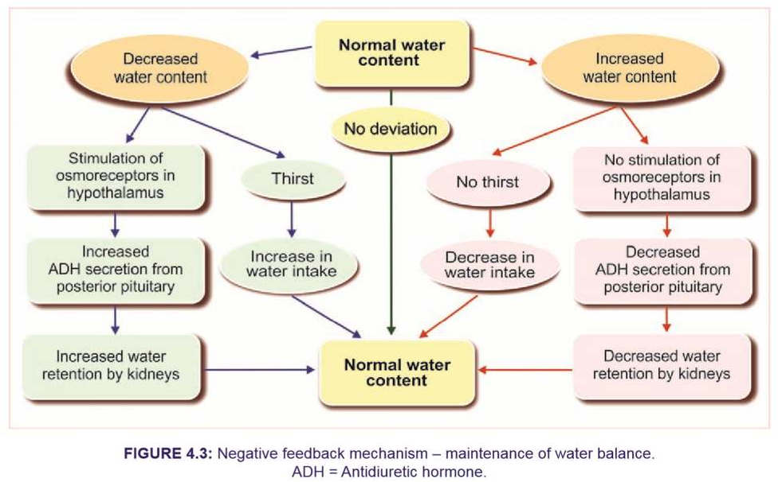

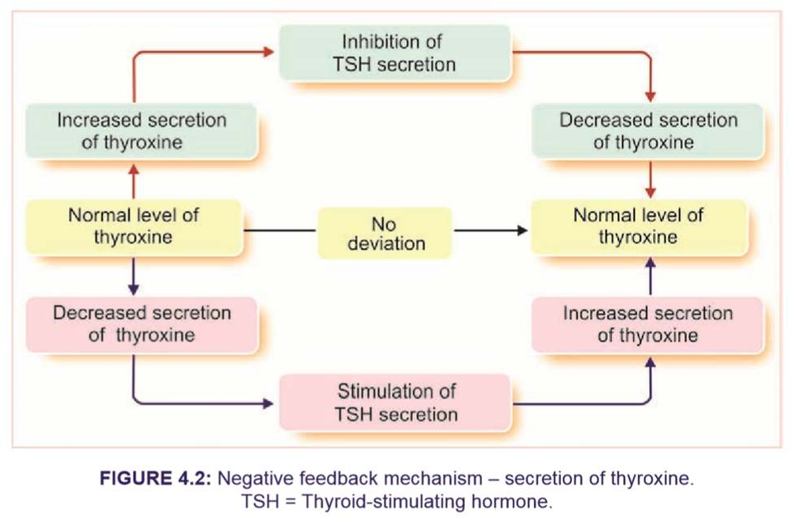

POSITIVE FEEDBACK
- Strengthens or reinforces a change.
- Makes abnormal values more abnormal.
- Produces ‘Vicious Cycle’.
- But in body a mild degree of positive feedback can be overcome by the negative feedback control mechanisms of the body, and the vicious cycle fails to develop.
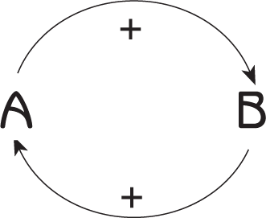

POSITIVE FEEDBACK LOOP
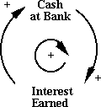

EXAMPLE: POSITIVE FEEDBACK MEMBRANE DEPOLARISATION
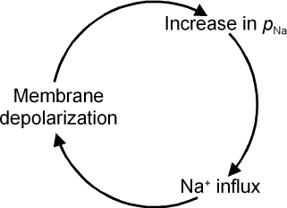
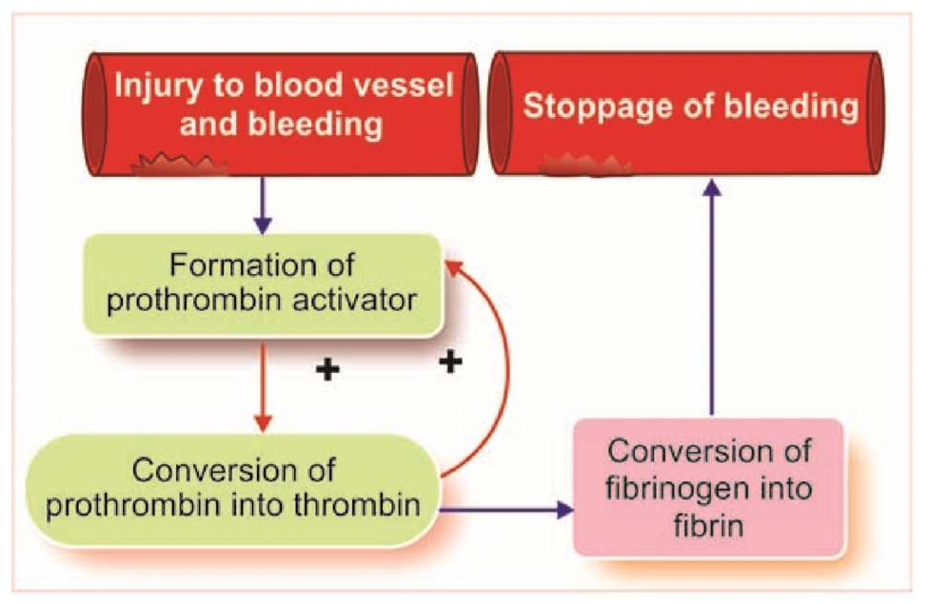

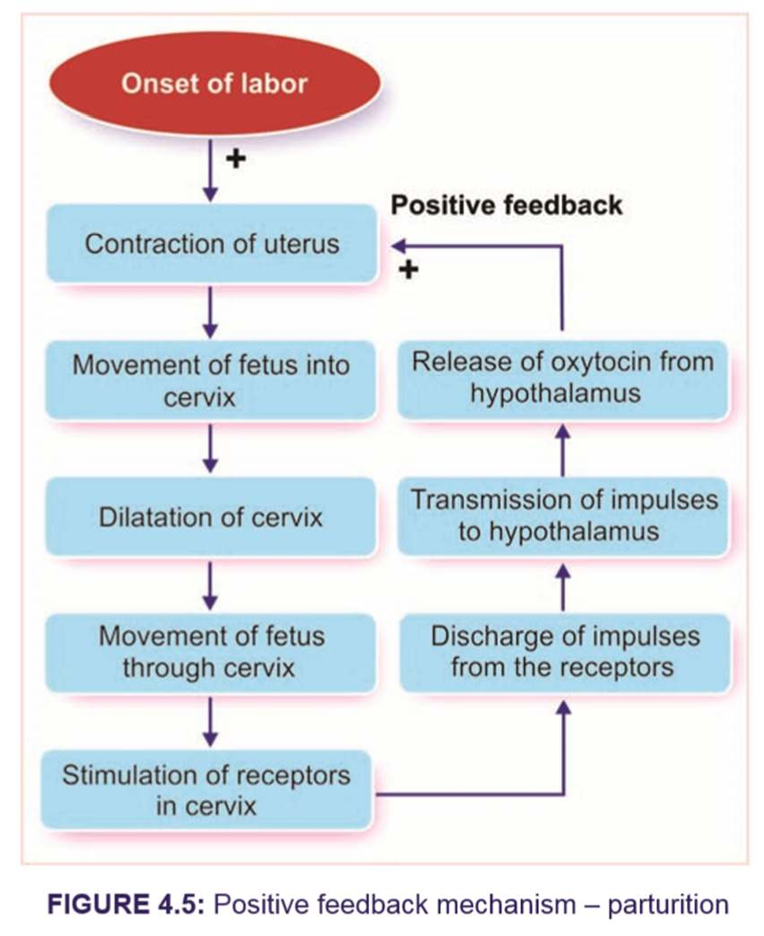

POSITIVE FEEDBACKS IN BODY
- Action potential
- Clotting of blood
- Parturition
- Release of calcium from SR
- Sexual arousal
- LH surge

Summary
- Homeostasis is involved in continuous monitoring of body’s internal environment with respect to altering external environment

- Components of homeostasis are ESI (Effector, Sensor, Integrator)
- Internal environment is maintained by positive and negative feedback mechanisms
- Most of the homeostasis mechanisms involve negative feedback

