Erectile Dysfunction (ED)
Erectile dysfunction is defined as “the failure to achieve a penile erection to allow for satisfactory sexual intercourse” Patients may refer to it as impotence

Main Causes of ED

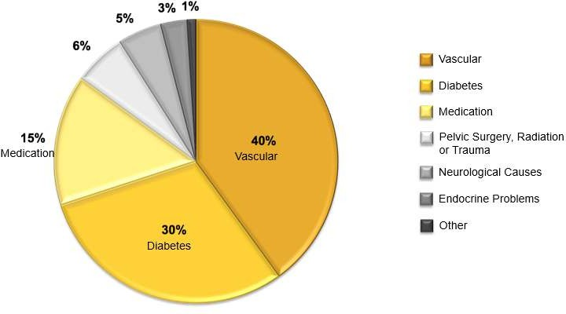

Etiology of ED
- Psychogenic
- Vasculogenic : - Cardiovascular disease - Hypertension - Diabetes mellitus - Major surgery or radiotherapy (pelvis or etroperitoneum).
- Neurogenic Central causes - Multiple sclerosis - Parkinson’s disease - Tumors - Stroke - Spinal cord disorders( disc disease ) Peripheral causes - Diabetes mellitus - Alcoholism - Polyneuropathy - Surgery (pelvis or retroperitoneum).
- Anatomical / structural - Peyronie’s disease - Penile fracture - Congenital curvature of the penis
- Hormonal - Hypogonadism - Hyperprolactinemia - Hyper-and hypothyroidism - Cushing's disease.
- Drug-induced - Antihypertensives (beta-blocker,thiazide and clonidine .less with ACE inhibitors ) - Antidepressants (tricyclic antidepressants and MAO inihibitor) - Antipsychotics - Antiandrogens - Antihistamines
- Recreational drugs (Heroin and cocaine)

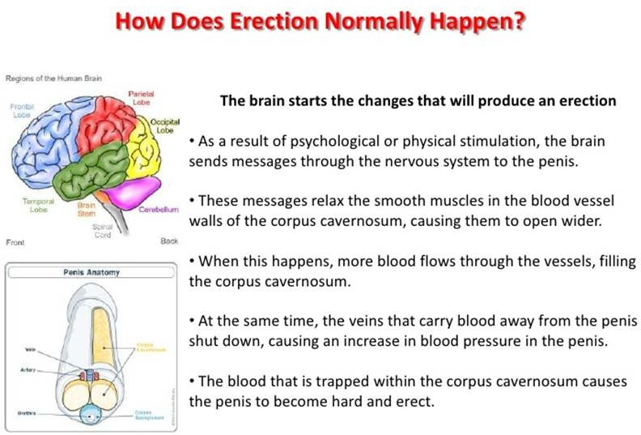

Process of Erection
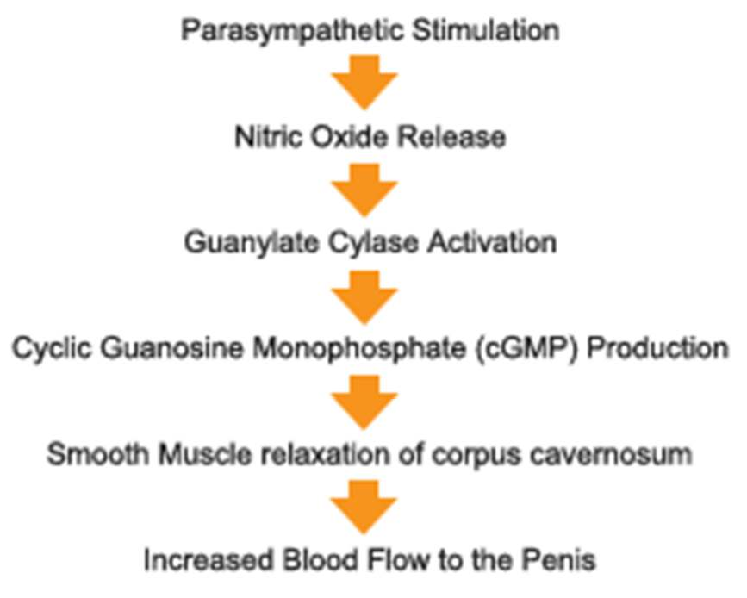

Pathophysiology
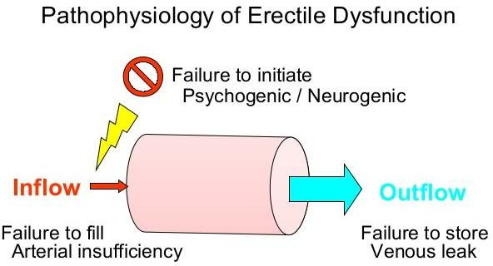
- Any single abnormality or combination of abnormalities of the four systems necessary for a normal penile erection
- Vascular, neurologic, or hormonal etiologies of erectile dysfunction are collectively referred to as organic erectile dysfunction
- Patients who do not respond to psychogenic stimuli have psychogenic erectile dysfunction
- Diseases that compromise vascular flow to the corpora cavernosum (e.g., peripheral vascular disease, arteriosclerosis, and essential hypertension) increases incidence of ED
- Diseases that impair nerve conduction to the brain (e.g., spinal cord injury or stroke) or conditions that impair peripheral nerve conduction to the penile vasculature
- Diseases associated with hypogonadism, primary or secondary, result in subphysiologic levels of testosterone, which cause diminished sexual drive (decreased libido) and secondary erectile dysfunction
- Vasoconstrictor effect of cigarette smoking may compromise blood flow to the corpora and decrease cavernosal filling
- Excessive ethanol intake may lead to androgen deficiency, peripheral neuropathy

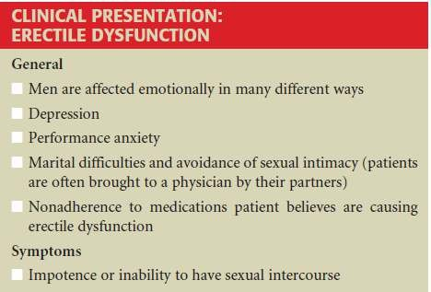

Summary
- Erectile dysfunction is defined as “the failure to achieve a penile erection to allow for satisfactory sexual intercourse”
- It can occur due to various causes like psychogenic, vasculogenic and neurogenic
- Failure to initiate psychogenic or neurogenic impulse or failure to increase arterial blood pressure may result in ED
- ED may ultimately lead to impotence

