Diabetes Mellitus (DM)
- Chronic metabolic disorder
- Characterized by hyperglycemia due to deficiency of insulin or defective response of tissues to insulin

Classification of Diabetes Mellitus

Primary (idiopathic) DM
- Primary disorder by itself
- Type – I (Insulin dependent DM/ IDDM)
- Type – II (Non- Insulin dependent DM/NIDDM)

Secondary DM
- Due to identifiable cause – pancreatitis, endocrine disorder
- Gets corrected/ reversed when primary disorder is controlled

Etio-pathogenesis of DM

Normal Insulin Physiology Regulated by 3 processes
- Glucose production by liver
- Uptake and utilization of glucose by peripheral tissues
- Insulin secretion

Normal Insulin Physiology
- Pre proinsulin – precursor for insulin
- Synthesized from insulin mRNA in rough ER of pancreatic β cells
- Delivered to golgi complex
- Series of proteolytic cleavage
- Pre proinsulin to pro insulin
- Finally to mature insulin + C- peptide
- Mature insulin + C- peptide – stored in equimolar concentration in secretory granules
- Glucose – important stimulus that triggers the syntheis & release of insulin
- Glucose taken up by pancreatic β cells through GLUT-2
- Immediate release of insulin
- Phase I of insulin secretion
- Released insulin is taken up by the insulin receptors present on the surface of tissues

- Series of intracellular reactions
- Activation of insulin dependent GLUT 4 transporter
- Uptake of glucose
Any defects in the above steps – Diabetes mellitus
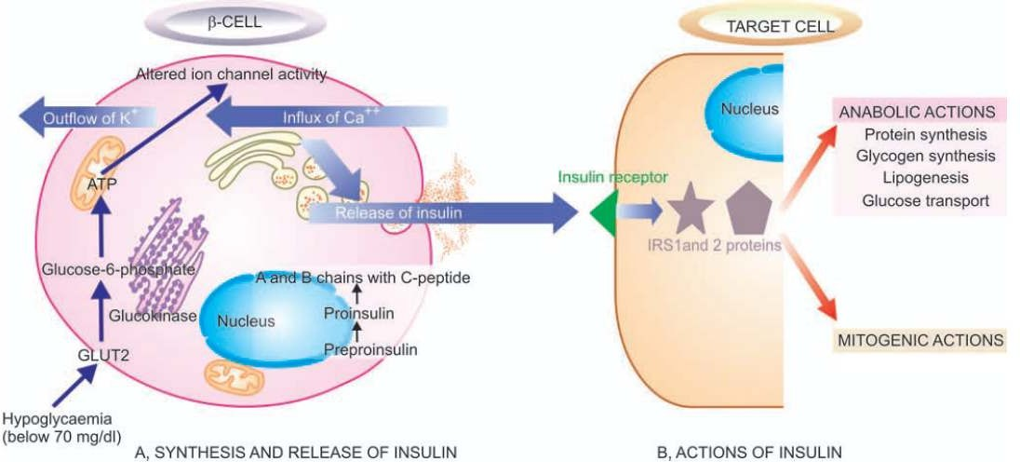
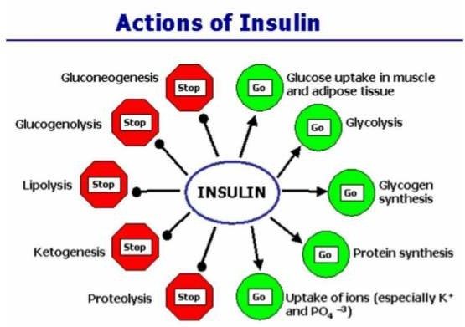

Type I Diabetes Mellitus
- Insulin dependent DM
- Absolute lack of insulin
- Reduction in β cell mass
- Starts at childhood, becomes sever at puberty
- Dependent on daily injections of insulin
- Hence, insulin dependent DM Involves 3 interconnected mechanism
- Genetic susceptibility
- Auto immunity
- Environmental factors

Genetic susceptibility
- Linked to race
- High among identical twins
- Susceptibility gene encodes class II antigen on MHC on chromosome 6p21 (HLA-D)
- Affects degree of immune response against pancreatic β cells

Auto immunity
- Onset of type I DM is abrupt
- Usually results from chronic auto immune attack of β cells
- Clinical manifestations occur after 90% of β cells mass has been destroyed by auto antibodies

Environmental factors
- Viral infections such as Measles, Mumps,
- Infection by COX sackie virus , Cytomegalo virus, Rubella virus
- Toxins – Pentamidine, Alloxan, Streptozotocin

Summary of pathogenesis of Type I DM

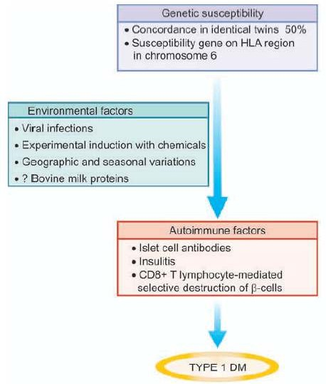

Type II DM
- Non insulin dependent DM
- Insulin therapy is not mandatory
- Disease is not linked to HLA gene
- Collection of multiple genetic defects
- Modified with environment factors

Pathogenesis of Type II DM

2 metabolic defects that characterize type II DM
- Derangement in β cell production of insulin
- Decreased response of peripheral tissues to insulin, rapid insulin resistance

Derangement in β cell production of insulin

Decreased secretion of insulin from β cell Due to
- β cell damage on persistant stimulation
- Chronic hyperglycemia exhaust the ability of β cell to function

Decreased response of peripheral tissues to insulin, rapid insulin resistance
- Reduced responsiveness of peripheral tissues
- Leads to complications
- Insulin resistance due to reduction in no. of receptors
- Sensitivity of insulin receptor decreases in obesity & pregnancy

Summary of pathogenesis of type II DM
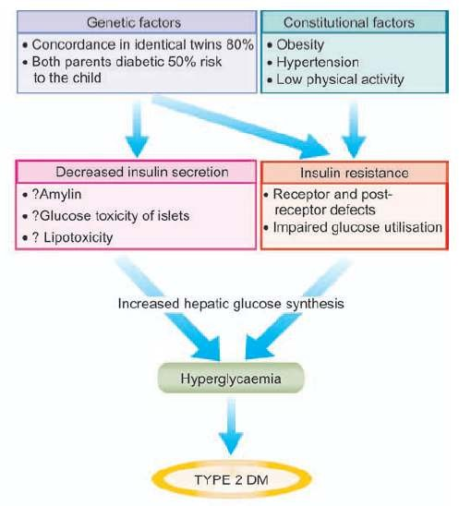

Summary
- Diabetes is a chronic metabolic disorder characterized by hyperglycemia due to deficiency of insulin or defective response of tissues to insulin
- DM is categorized as Type I and Type II
- Type I DM is dependent on insulin and occurs mainly due to the destruction of beta cells of pancreas
- Type II DM is independent of insulin and occurs either due to decreased insulin secretion or due to decreased sensitivity of insulin receptors

