Depression

Depression is a state of low mood and aversion that can affect a persons’s thoughts, behavior, feelings, and sense of well being

Causes of Depression

Family History
  - Having a family members who have depression may increase a person’s risk
  - Imbalances of certain chemicals in the brain may lead to depression

Major Life Changes
  - Positive or negative events can trigger depression. Examples include the death of a loved one or a promotion
  - Major Illnesses such as heart attack, stroke or cancer may trigger depression
  - Certain medications used alone or in combination can cause side effects much like the symptoms of depression
  - Use of Alcohol or other Drugs can lead to or worsen depression
  - Depression can also occur for no apparent reason!

Types of depression
- Major depression
  - Inability to enjoy life and experience pleasure
  - Symptoms are constant, ranging from moderate to severe
  - Some people experience just a single depressive episode in their lifetime, but more commonly, major depression is a recurring disorder
- Atypical Depression
  - Specific symptom pattern, including a temporary mood lift in response to positive events
  - Other symptoms include weight gain, increased appetite, sleeping excessively, a heavy feeling in the arms and legs
  - Atypical depression responds better to some therapies and medications than others
- Bipolar disorder
People with this type of illness change back and forth between periods of depression and periods of mania (an extreme high)
- Symptoms of mania may include:
  - Less need for sleep
  - Overconfidence
  - Racing thoughts
  - Reckless behavior
  - Increased energy

  - Mood changes are usually gradual, but can be sudden
- Season affective disorder
This is a depression that results from changes in the season. Most cases begin in the fall or winter, or when there is a decrease in sunlight

Pathophysiology
- Biogenic amine hypothesis: Decreased brain levels of the neurotransmitters norepinephrine (NE), serotonin (5-HT), and dopamine (DA)
- Postsynaptic changes in receptor sensitivity: Changes in sensitivity of NE or 5-HT2 receptors may relate to its onset
- Dysregulation hypothesis: A failure of homeostatic regulation of neurotransmitter systems, rather than absolute increases or decreases in their activities

Symptoms of depression
- Vary from person to person
- 2 key signs - loss of interest in things you like to do and sadness or irritability

Additional signs
  - Feeling empty
  - Inability to enjoy anything
  - Hopelessness
  - Loss of sexual desire
  - Loss of warm feelings for family or friends
  - Feelings of self-blame or guilt
  - Loss of self esteem
  - Inexplicable crying spells, sadness or irritability

Changes in behavior and attitude
These may include:
  - General slowing down
  - Neglect of responsibilities and appearance
  - Poor memory
  - Inability to concentrate
  - Suicidal thoughts, feelings or behaviors
  - Difficulty making decisions

Physical complaints
  - Sleep disturbances such as early morning waking, sleeping too much or insomnia
  - Lack of energy
  - Loss of appetite

  - Weight loss or gain
  - Unexplained headaches or backaches
  - Stomachaches, indigestion or changes in bowel habits

Summary
- Depression is a state of low mood and aversion that can affect a person's thoughts, behavior, feelings, and sense of well being
- Etiology: family history, major life changes, drugs, work
- Decreased brain levels of the neurotransmitters norepinephrine (NE), serotonin (5-HT), and dopamine (DA), changes in sensitivity of NE or 5-HT2 receptors - failure of homeostatic regulation of neurotransmitter systems, rather than absolute increases or decreases in their activities

Stroke

What is STROKE?
- Sudden brain damage
- A stroke occurs when a blood clot blocks a blood vessel or artery, or when a blood vessel breaks, interrupting blood flow to an area of the brain
- Lack of blood flow to the brain caused by a clot or rupture of a blood vessel
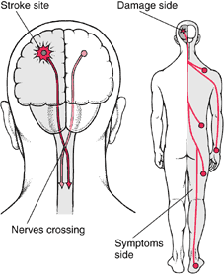

Strokes occur in the brain and affect the opposite side of the body
National Stroke Association encourages everyone to spread awareness about stroke in May about how to:
  - STOP primary and secondary stroke through risk factor management
  - Act F.A.S.T. to increase recognition of and response to stroke symptoms
  - Spread HOPE about recovery from stroke May is National Stroke Awareness Month

STROKE FACTS
- A leading cause of death in the United States
- 795,000 Americans suffer strokes each year
- 134,000 deaths each year
- From 1996 to 2006, the stroke death rate fell 33.5% and number of deaths fell by 18.4%
- A leading cause of adult disability
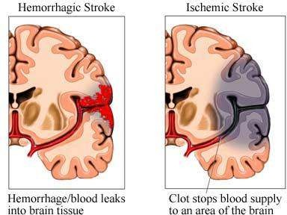
- Up to 80% of all strokes are preventable through risk factor management

Types of Strok
Hemorrhagic Stroke Ischemic Stroke

HEMORRHAGIC STROKE
- Hemorrhagic Stroke is a type of stroke which occurs when a blood vessel in the brain breaks or ruptures
- Approximately 20% of the strokes are hemorrhagic in nature
- Most leading cause is high blood pressure occurring when a blood vessel bursts and blood accumulates
- Two types of Hemorrhagic strokes:
- Subarachnoid hemorrhage and
- Intracerebral hemorrhage

ETIOLOGY:

- Traumatic head injury
- Burst of cerebral aneurysm
- A defect of the circulatory system/a cluster of abnormally formed blood vessels (also called arteriovenous malformation or AVMs, usually inherited at birth)

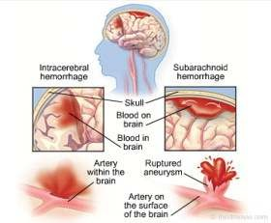

Subarachnoid Hemorrhage
  - Subarachnoid hemorrhage - most severe form of a stroke - permanent disability or death
  - It can happen suddenly when a major blood vessel bursts upon the surface of the brain causing spilling blood into the cerebrospinal fluid surrounding the brain
  - Due to bleeding, the amount of fluid increases in the affected area - enormous pressure on the whole brain - damage to the brain tissue
  - Aneurysm is a ballooning of a weakened area of an artery and when left untreated the aneurysm can continuously become weakened until it ruptures and finally bleeds into the brain
  - Burst aneurysm can lead to a sudden and severe headache, usually with a description of “thunderclap”
  - CT scan or an MRI - detect the presence of subarachnoid hemorrhage
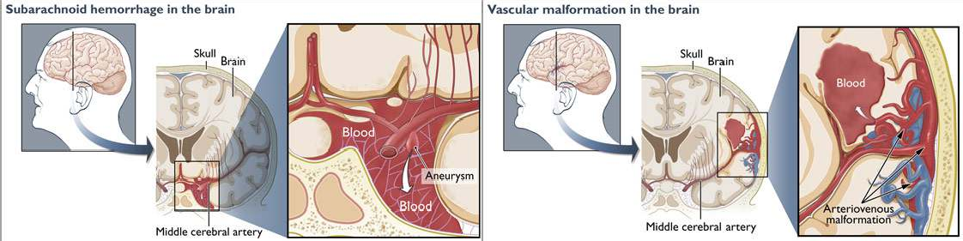

Intracerebral hemorrhage
  - Intracerebral hemorrhage happens when there is a burst of a blood vessel in the brain - leaking of blood into the brain
  - It is more common among people aged above 60 and can be most commonly caused by high blood pressure
  - It can also be a result of infections, a burst aneurysm tumors or head injuries
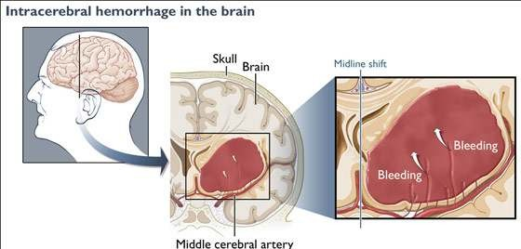

ISCHEMIC STROKE
  - Ischemic stroke is a sudden loss of brain function and can be caused by partial or complete obstruction of a blood vessel supplying the brain
  - Approximately 80% of strokes are ischemic in nature, and it occurs when there is a blockage inside the carotid arteries or in the vertebral arteries
  - A fatty deposit (a plaque) or mass of blood cells (a clot) travelling in the blood can get trapped in a narrowed or small artery - obstruct blood flow - occurrence of a stroke
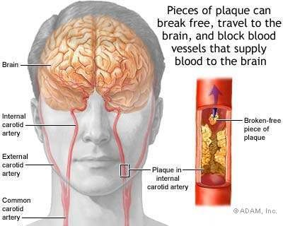

There are three types of Ischemic stroke:
- Lacunar stroke
- Thrombotic stroke
- Embolic stroke

Lacunar stroke:
  - Lacunar stoke contributes to 25% of ischemic strokes and occurs when there is a blockage in one of the smaller blood vessels found inside the brain
  - A “hole” of scar tissue is due to the blockage that starves a small part of the brain
  - As only small portion of the brain is affected, lacunar stroke is usually hard to be diagnosed
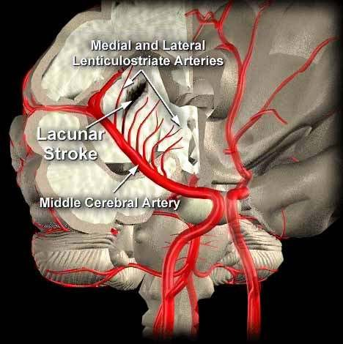

Thrombotic stroke:
  - It happens when the artery is clogged by plaque and hardens, or when a cholesterol-filled plaque of atherosclerosis especially in a brain (cerebral), carotid or vertebral artery breaks open - formation of a blood clot over the plaque obstructing blood flow
  - Thrombus (blood clot) is a condition where the blockage seals off the blood vessel

Embolic Stroke:
  - An embolus refers to a piece that breaks off and can block a blood vessel supplying the brain causing the occurrence of an embolic stroke which contributes 60% of ischemic strokes
  - Unless the source is found and treated immediately, people with embolic strokes are at potential risk of another stroke/s
  - Embolic strokes hit fast and sudden and are normally severe

RISK FACTORS OF STROKE

- High blood pressure is the number one risk factor for strokes.
- Atrial fibrillation

- Diabetes mellitus
- Family history of stroke
- High cholesterol
- Increasing age, especially after age 55
- Race (black people are more likely to die of a stroke)
- People who have heart disease or poor blood flow in their legs caused by narrowed arteries
- Being overweight or obese
- Drinking heavily
- Eating too much fat or salt
- Smoking
- Taking cocaine and other illegal drugs
- Birth control pills can increase the chances of having blood clots. The risk is highest in woman who smoke and are older than 35

Signs & Symptoms

Sudden and severe headache Trouble seeing in one or both eyes Sudden dizziness
Trouble walking Sudden confusion Trouble speaking
Sudden numbness or weakness of face, arm or leg
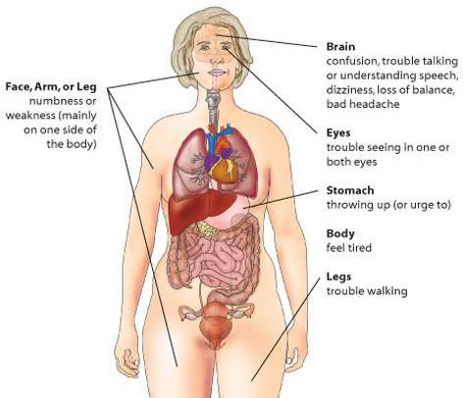

RECOGNIZE THE SYMPTOMS OF A STROKE
  - 3 Simple Questions
    - Ask the person to smile
    - Ask the person to raise both arms
    - Ask the person to say a simple sentence “The sky is blue ”

Diagnosis

Diagnostic Testing
- CT or MRI of the brain
- EKG
- Carotid Ultrasound
- Echocardiogram

Summary
  - stroke occurs when a blood clot blocks a blood vessel or artery, or when a blood vessel breaks, interrupting blood flow to an area of the brain
  - Hemorrhagic stroke occurs as a result of traumatic head injury, burst of cerebral aneurysm a defect of the circulatory system/a cluster of abnormally formed blood vessels
  - Ischemic stroke occurs due to sudden loss of brain function and can be caused by partial or complete obstruction of a blood vessel supplying the brain by atherosclerotic plaque

