Chronic Obstructive Pulmonary Disease (COPD)
“A chronic slowly progressing disorder characterized by air flow obstruction leading to reduced pulmonary inspiratory & expiratory capacity”
- Disease may co-exist with asthma Two major forms of COPD
- Chronic bronchitis
- Emphysema
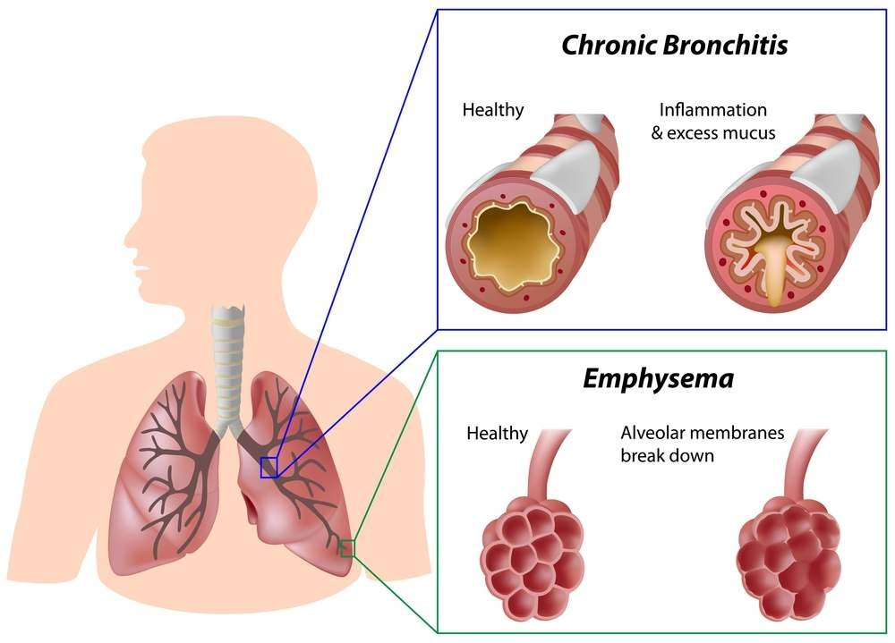

Chronic bronchitis
- Characterized by excessive mucus production by the tracheo-bronchial followed by edema & bronchial inflammation leading to airway obstruction
- It is associated with cigarette smoking & air pollution

Pathogenesis of chronic bronchitis

Two pathological processes underlining the development of chronic bronchitis include
- Hypersecretory disorder
  - Characterized by expectoration with increased susceptibility to respiratory infections
  - Normally, cilia & mucus in the bronchi protect against inhaled irritants which are trapped and expectorated

  - Persistent irritation causes proliferation of mucus secreting glands & goblet cells in the bronchial epithelium leading to hypersecretion of thick & viscous mucus
  - Accumulation of mucus inturn causes inflammation and recurrent viral & bacterial infections
- Chronic inflammation & edema causes thickening of bronchio & alveolar walls
  - Alveoli gets distorted, affects blood vessels closely associated with them, leading to vasoconstriction and pulmonary hypertension
  - Reduction of gas exchange across alveolar epithelium – hypoxemia
  - Sustained pulmonary hypertension – increased right ventricular pressure within heart, right ventricular hypertrophy and failure
  - Pulmonary edema results followed by activation of renin angiotensin, aldosterone system, salt & water retention – reduction in renal blood flow

Emphysema
  - Condition of permanent destructive enlargement of respiratory bronchioles, alveolar ducts & alveolar sac
  - Adjacent alveoli becomes indistinguishable from one another 2 main consequence of emphysema
  - Loss of available gas space & impaired gas exchange
  - Loss of elastic recoil in the small airways leading them to collapse during expiration

Pathogenesis of emphysema

Arise as a consequence of 2 critical imbalances
- Protease – antiprotease imbalance
- Oxidant – antioxidant imbalance Protease – anti protease theory
  - Emphysema results from gradual progressive loss of elastic tissue in lungs due to an imbalance between proteolytic enzymes & protective factors
  - Macrophages & neutrophills releases lysosomal enzymes (elastase) – capable of destroying connective tissue in the lungs
  - Normal condition – protective mechanism called α1 – anti trypsin or α1 – protease inhibitor inhibits proteolytic enzyme and prevent damage
  - α1 – anti trypsin is present in serum, tissue fluids & macrophages
  - Deficiency of α1 – anti trypsin causes destruction of elastic tissue leading to emphysema Oxidant – antioxidant imbalance
  - Normally lungs contains anti-oxidants like SOD, glutathione - reduces oxidative damage
  - Tobacco smoke, activated neutrophills – increases oxygen free radicals – depletes antioxidant mechanism – tissue damage
  - Inactivation of antiproteases, functional deficiency without enzyme deficiency

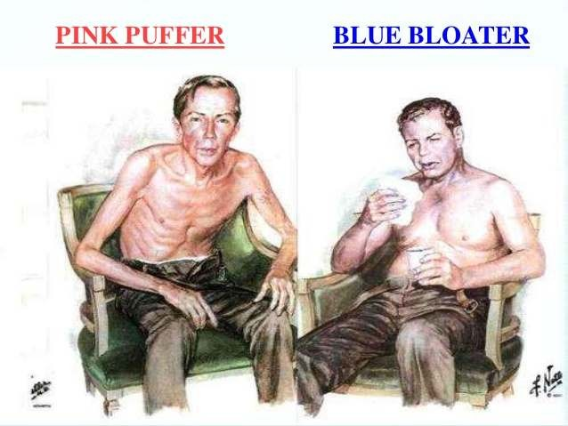

Symptoms
  - Chronic cough ( after 20 or > cigarettes/day)
  - Dyspnea (during physical activity and rest)
  - Frequent respiratory infections
  - Production of purulent sputum
  - Bluish discoloration of lips and nail beds
  - Morning headaches
  - Wheezing
  - Weight loss
  - Pulmonary hypertension
  - Peripheral oedema
  - Hemoptysis

Summary
  - COPD is the most prevalent manifestation of obstructive lung disease, mainly comprises chronic bronchitis and emphysema
  - Reduction of overall personal exposure to tobacco smoke, occupational dusts, chemicals and pollutants is an important goal to prevent the onset and progression of COPD
  - Risk factors for COPD include host factors (a, -antitrypsin deficiency and airway hyperresponsiveness) and exposures (tobacco smoke, occupational dusts and chemicals, indoor and outdoor pollutants, infections) and socio-economic

