Chemical mediators of inflammation
- Endogenous compounds
- Released during inflammation
- Increases vascular permeability
- Edema, Destruction of inflammatory agents
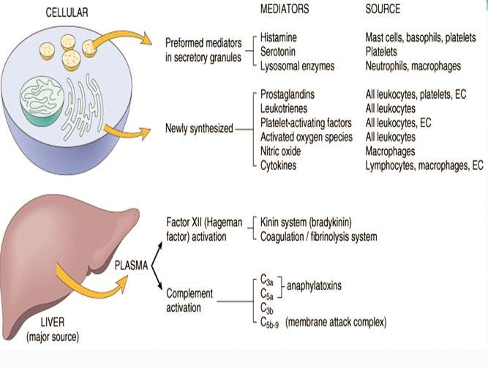

Chemical mediators of inflammation

Cell derived mediators
- Vasoactive amines – Histamine, Serotonin, Neuropeptides
- Arachidonic acid metabolites
  - Via COX pathway - Prostaglandins, Thromboxane A2, prostacyclin
  - Via LOX pathway - 5-HETE, leukotrienes
- Lysosomal system
- Platelet activating factor
- Nitric oxide and oxygen metabolites

Plasma derived mediators of inflammation
- The kinin system
- The clotting system

- The fibrinolytic system
- The complement system

Vasoactive amines (Autocoids)

Amine autocoids
- Histamine
- 5 – HT / Serotonin
Released within 1 hour of inflammatory response

Histamine
- Stored in mast cells, basophills & platelets Released due to – Heat/cold radiations
  - Chemical irritant & immunological reactions
  - Anaphyla toxins

Main actions of Histamine
- Vaso dilation
- ↑ permeability of venules
- Itching & pain
- Release of other cell derived mediators
- Broncho constriction

Serotonin
- Present in chromaffin cells of GIT
- In spleen, nervous system, mast cells & platelets

Actions
- Vasodilation
- ↑vascular permeability
- Less potent than histamine

Neuropeptides
- Tachykinin neuropeptides - substance P, neurokinin A, vasoactive intestinal polypeptide (VIP) & somatostatin
- Produced in the central and peripheral nervous systems Actions
- Increased vascular permeability
- Transmission of pain stimuli
- Mast cell degranulation

Arachdonic acid Metabolite
- Tissue injury – Phospholipase A2 activation
- Conversion of phospholipids into arachdonic acid Metabolism of arachdonic acid follows 2 pathway
- COX (Cyclo-oxygenase) – Pathway
- LOX (Lipo- oxygenase) – Pathway

COX Pathway
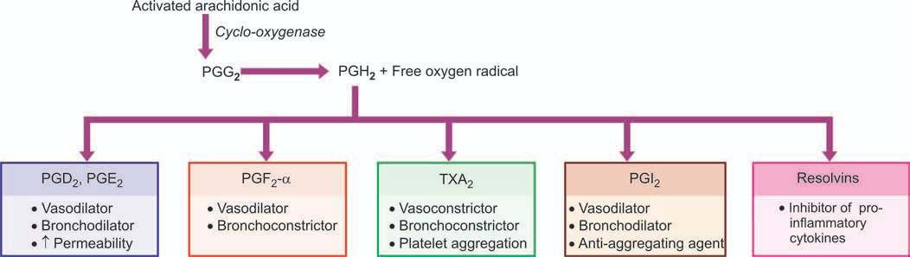
LOX Pathway

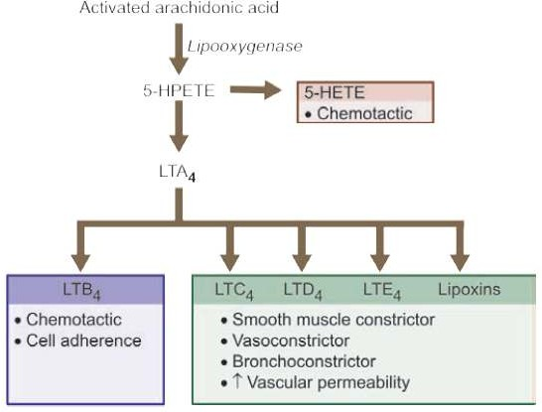

Lysosomal components

Granules of Neutrophills Primary granules
- Myeloperoxidase

- Acid hydrolase
- Neutral proteases

Secondary granules
- Lactoferrin
- Lysozyme
- Alkaline phosphatase
- Collagenase

Granules of Monocytes & Tissue macrophages
- Cells on degranulation releases mediators like
- Acid proteases
- Collagenase
- Elastase
- Plasminogen activator
More involved in chronic inflammation

Platelet Activating Factor (PAF)

IgE-sensitised basophils or mast cells, other leucocytes, endothelium and platelets
- ↑ vascular permeability
- Vasodilatation in low concentration and vasoconstriction
- Broncho constriction
- Adhesion of leucocytes to endothelium
- Chemotaxis

Cytokines
- Group of polypeptide substances
- Produced by activated lymphocytes/ monocytes
- Interleukin 1 & 8
- Tumor necrosis factor
- Interferon
- Platelet factor Actions:
- IL –I, TNF α & β - ↑ leucocyte adherence, Platelet aggregation, proliferation of fibroblast
- Interferon gamma – activation of macrophages & neutrophils
- IL-8 – Chemotactic of neutrophills
- PF – 4 – Chemotactic for neutrophills, monocytes & eosinophills

Nitric oxide & oxygen metabolites
- Released by activated macrophages from vascular endothelium
- Vasodilation
- Inhibiton of platelet aggregation
- Killing of micro organism
- O2 free radicals released from activated neutrophills & macrophages
- Endothelial damage
- ↑vascular permeability
- Tissue matrix damage

Plasma derived mediators
- Interlinked system
- Include
  - Clotting system
  - Kinin system
  - Fibrinolytic system
  - Complement system
- Hageman factor (Factor XII) – connects the other 4 system
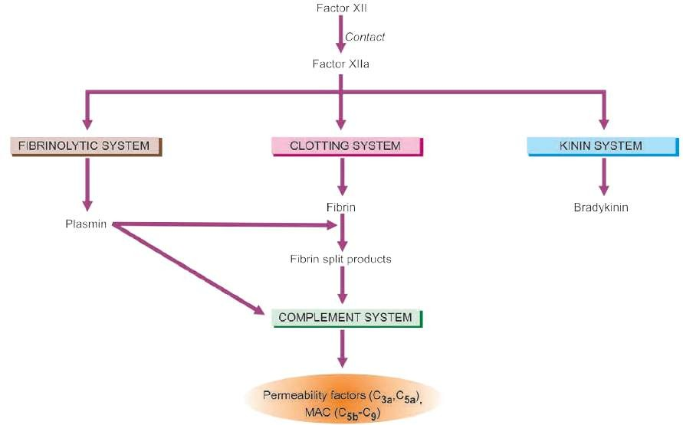

Clotting system
- Results in formation of fibrinogen
- Thrombin converts fibrinogen to fibrin & fibrinopeptide

  - ↑ vascular permeability
  - Chemotaxis of leucocytes
  - Anticoagulant activity

Fibrinolytic system
- Activated by plasminogen
- Plasminogen activator – plasminogen – plasmin- breakdown of fibrin - fibrinopeptides or fibrin split products
Actions
  - Activation of factor XII
  - Splits complement fraction C3to C3a– permeability factor
  - Degrade fibrin to form fibrin split products

Complement system

Involves 2 pathways
- Classic pathway through antigen-antibody complexes
- Alternate pathway via non-immunologic agents such as bacterial toxins, cobra venoms and IgA Anaphylatoxins (C3a, C5a, C4a)
  - Activate mast cells and basophils to release of histamine
  - cause increased vascular permeability
  - augments phagocytosis
- C3b - an opsonin
- C5a - chemotactic for leucocytes
- Membrane attack complex (MAC) (C5b-C9) is a lipid dissolving agent and causes holes in the phospholipid membrane

Chemical mediators of inflammation
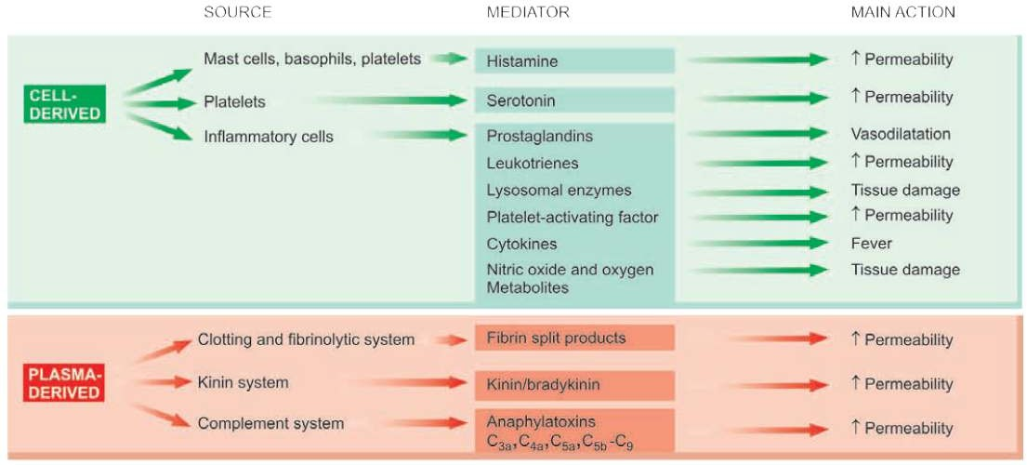

Summary
- Chemical mediators are endogenous compounds released during inflammation which increases vascular permeability, bring about edema and destruction of inflammatory agents
- Chemical mediators of inflammation are derived from cell and plasma
- Cell derived mediators include histamine, serotonin, leukotrienes, platelet activating factors, cytokinines, prostaglandins
- Plasma derived mediators include kinin system, cltting and fibrinolytic system and clotting system

