CANCER

General biology of cancer

Neoplasm/ Tumour - “A mass of tissue formed as a result of abnormal, excessive, uncoordinated, autonomous and purposeless proliferation of cells”
- Oncology – Branch of science dealing with the study of neoplasm
- Transformation from a living normal cell into a living tumor cell

Basic features of change in neoplasia
- Change is irreversible; becomes fixed character of a transformed cell
- Acquired fixed character is heritable; tumor cell divide to give tumor cell
- Change once occurred is self-perpetuating
- Tumor cell has uncontrolled passion for continued proliferation

Classification of tumors
- Based on the nature of tumors, they are classified as Benign tumor – Harmless and self-limited Malignant tumor – Harmful and rapidly growing
- Names of every tumor ends with ‘oma’
- Malignant tumor of epithelial tissue – Carcinoma
- Malignant tumor of connective tissue - Sarcoma

Classification of tumor based on tissue of origin

Tissue of origin | Benign | Malignant
Epithelial tumors
1. Squamous epithelium | Squamous cell papilloma | Squamous cell carcinoma
2. Transitional epithelium | Transitional epithelium papilloma | Transitional epithelium carcinoma
3. Glandular epithelium | Adenoma | Adenocarcinoma
4. Hepatocytes | Liver cell adenoma | Hepatocellular carcinoma (Hepatoma)

Tissue of origin  (Non epithelial tumors) | Benign | Malignant
Adipose tissue | Lipoma | Liposarcoma

Fibrous tissue | Fibroma | Fibrosarcoma
Cartilage | Chondroma | Chondrosarcoma
Bone | Osteoma | Osteosarcoma
Blood vessels | Haemangioma | Angiosarcoma
Nerve cells | Ganglia Neuroma | Neuroblastoma

Contrasting features of benign and malignant tumor

Features Benign Malignant
Macroscopic features

1. Boundaries | Encapsulated/ well circumscribed | Irregular & poorly circumscribed
2. Surrounding tissues | Often compressed | Usually invaded
3. Size | Usually small | Often large
4. Secondary changes | Occurs less often | Occurs more often
Microscopic Features
1. Pattern
Closely resembles the tissue of
origin
Poor resemblance to the tissue of
origin
- Basal polarity Retained Lost

3. Pleomorphism | Normal | Increased
Features | Benign | Malignant
Microscopic features (cont..d)
4. Neuclio- cytoplasmic ratio | Normal | Increased
5. Hyperchromatism | Absent | Present

6. Mitosis | Always typical mitosis | Atypical & abnormal mitosis
7. Tumor giant cells | May be present but with atypical nucleus | Always present with atypical nucleus
8. Cytoplasm | With normal constituents | Elements are reduced or lost
9. Functions | Usually well maintained | Retained/ lost/ abnormal
Growth rate | Usually slow | Rapid
Local invasion | Often compresses the surroundings; no invasion/ infiltration | Invade & infiltrate the adjacent tissue
Metastatis (Spreading) | Absent | Present

Structure of tumor

Tumor mass consists of:
  - Parenchyma
  - Stroma

Parenchyma
- Formed by proliferating tumor cells
- Parenchyma of benign tumor – organised pattern with resemblance to tissue of origin, differentiation
- Parenchyma of malignant tumor – unorganised, atypical, distorted, relation of tumor cell with basement is lost,

anaplasia
Stroma
- Supporting tissue of tumor
- Consists of fibrous tissue carrying blood vessels for nourishing tumor cell
- More malignant the tumor, Cirrhous
- Carcinoma with scanty stroma – celluloid & medullary
- New blood vessels form from pre existing onesless is the fibrous tissue
- Carcinoma with extensive stroma – with the help of a factor, “tumor angiogenesis factor”

Spread of cancer

(Two mechanism for the spread of cancer)
Direct spread (Invasion,
Infilteration, direct spread)
- Spread to surrounding tissue; no loss of
contunity between primary tumor & secondary extension masses
- Benign tumors push aside the surrounding normal tissues without invading or metastasing
- Maliganant tumor infiltrates, invades &
destroys surrounding tissues

Metastasis
- Transplantation of tumor cells from the primary mass to distant cell without an anatomic continuity between primary and secondary masses
- Important feature to distinguish malignant from a benign tumor

Routes of spread of cancer

Infiltration of tissue spaces
  - Tissue spaces - preformed passages; paths of least resistance
  - Most vulnerable tissues – soft tissues – adipose, muscle,
  - Gamete/ compact tissues like capsule of organs, cartilage and bone (not marrow) offer greater resistance
  - Tissue subjected to infiltration are destroyed by the proteolytic enzymes & lytic substances elaborated by cancer tissue
  - Tissue space invasion brings the tumor cell in direct contact with normal cells, lymphatic and blood vessels

Hematogenous spread:
  - Carcinoma of lungs, thyroid, kidney and the prostate spread through blood vessels Tumor cells enter blood stream by 2 ways
- Via thorasic duct – either by perforation of vein or by lymphatic drainage
- By direct invasion of blood vessels (large veins, venules & capillaries); arteries not involved due to their thick wall

- Spread via lymphatics: Most common with carcinoma; results in both invasion & metastasis


Lymphatic

permeatio n

Wall of lymphatic vessels are attacked by cancer cells
- Form continous column to reach the draining lymph node

Lymphatic embolism
- Common in large lymph vessels
- Small permeated lymphatic vessel opens in to large vessel
- Causes fragmentation of tumor tissue; gets detached as emboli
- Emboli gets lodged in regional lymph nodes, produce metastasis

Metastasis in lymph nodes
- Tumor emboli enters the lymph node at a convex surface, lodged into
- subcapsular space
- Whole lymph node may be replaced by tumor mass

Spread via lymphatics
Lymphatic spread begins by lodgement of tumour cells in subcapsular sinus via afferent lymphatics entering at the convex surface of the lymph node
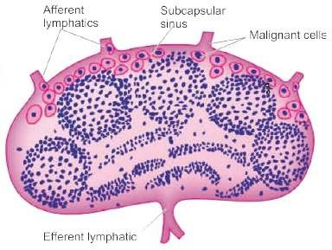

Hematogenous spread
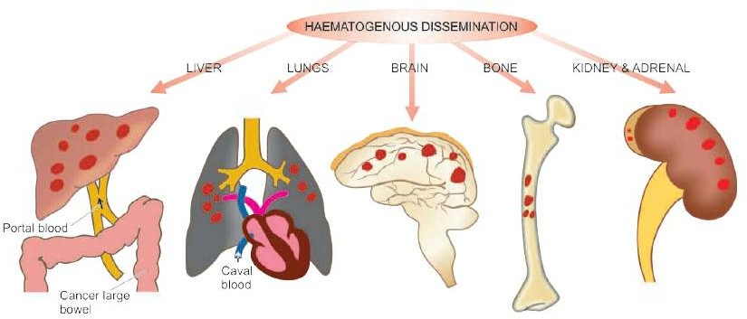
- Spread via serous sacs
  - Spread through peritoneal cavity; common in cancer of GIT & ovary
  - Trans pleural spread - in carcinoma of lungs and breast
  - Trans pericardial spread may also occur

Spread along epithelium line surfaces
  - Intact epithelium, mucous coat acquires resistance for penetration of tumor
  - Implantation tumor – tumor spread along the surface of epithelium

Spread via CSF
  - Cerebrospinal cavities are affected by the escape of tumor cells from
  - the malignant tumor in the brain or meninges
Summary
  - A tumour is a mass of tissue formed as a result of abnormal, excessive, uncoordinated, autonomous and purposeless proliferation of cells
  - Tumors are classified as benign and malignant
  - Benign tumors are harmless and do not spread while malignant tumors are harmful and spread
  - Tumor is made up of parenchyma and stroma
  - Tumor spread by two mechanism – Haematogenous spread and lymphatic spread

