Atherosclerosis

- Patchy focal disease of arterial wall
- Patchy thickening of the intimal layer of arterial wall
- Due to lipid deposition or fibrosis tissue formation
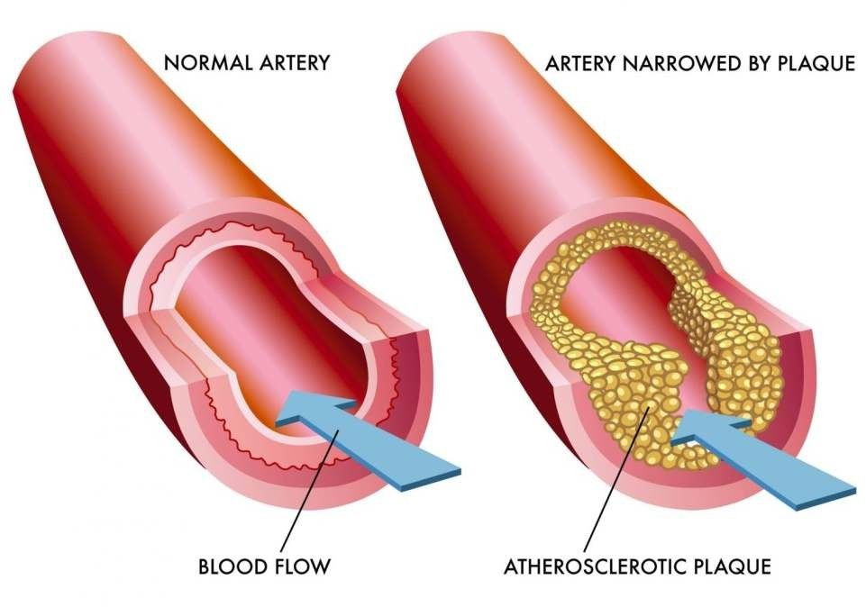

Major risk factors
- Age
- Family history & genetics
- Racial risk – whites are at greater risk than blacks
- Excess lipid deposition
- Hypertension
- Smoking
- Diabetes mellitus

Minor risk factors
- Obesity
- Lack of exercise
- Sedentary life style
- Use of oral contraceptives
- Alcohol consumption
- Stressful life
- Dietary factors
- Viral infection

Symptoms
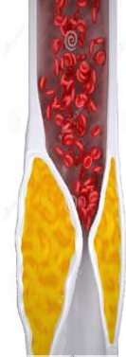
Symptoms vary depending on the organ involved

Heart

- Restricted blood supply to heart
- Angina & Myocardial infarction
- Shortness of breath
- Sweat
- Nausea
- Dizziness
- Palpitation

Brain

- Narrowing of arteries supplying brain
- Causes ischemic attacks
- Head ache
- Paralysis of one side of the body
- Numbness in various parts
- Visual disturbance
- Stroke

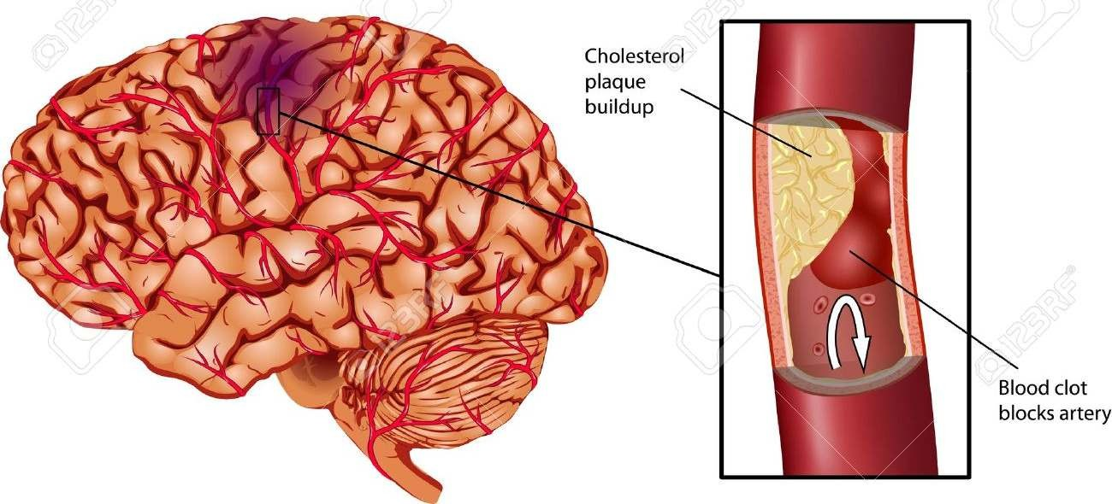

Abdomen

- Dull pain is felt in the abdomen
- Due to blockage of arteries supplying intestine
- Vomiting
- Diarrhoea
- Constipation

Leg

- Narrowing of artery supplying leg
- Pain in the leg
- Hair loss in leg

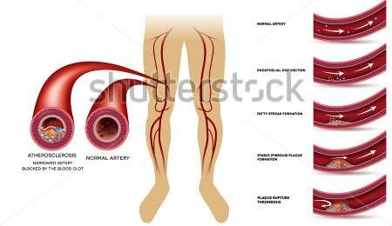

Pathogenesis

Endothelial injury
  - Atherosclerosis is initiated by injury of endothelium
  - In large & medium size arteries
  - Causes include smoking
  - Hypertension
  - Chronic hyperlipidemia
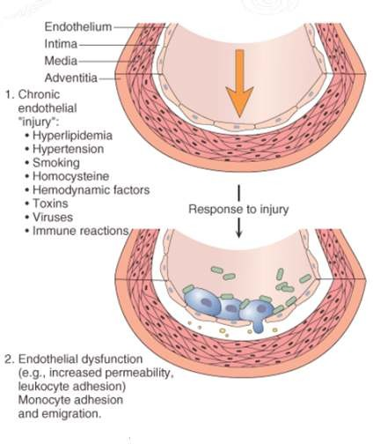

Internal smooth muscle cell proliferation
  - Subsequent to endothelial injury
  - Following disruption of endothelial layer
  - Smooth muscle cell of blood vessels
  - Cells of endothelium
  - Proliferate under influence of – PGDF, EDGF, TGF β
  - More synthesis of matrix protein
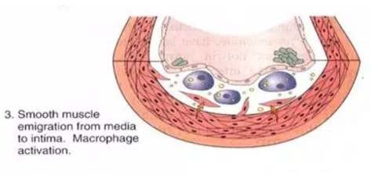

Lipoprotein entry into intima
  - LDL from blood enters intima & get oxidized
  - Oxidized LDL attracts monocytes
  - Activates monocytes to macrophages
  - Combination of oxidized LDL & macrophages - Lipid laden foam cells
  - Major factor contributing to plaque formation
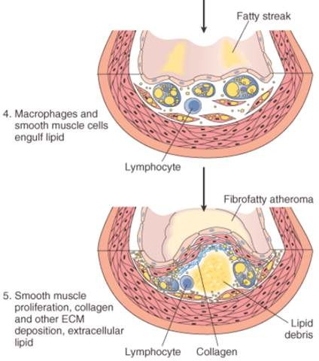

Mechanism involved in the formation of Foam cells

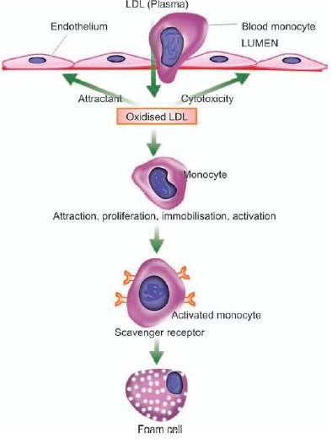

Summary
  - Atherosclerosis or atheroma is a patchy focal disease of arterial wall
  - Patchy thickening of the intimal layer of arterial wall due to lipid deposition or fibrosis tissue formation
  - The main mechanism involved in the development of atheroma is endothelial injury
  - Endothelial injury is followed by proliferation and formation of foam cells

ARTERIOSCLEROSIS
  - Arteriosclerosis refers to the thickening and hardening of the medium or large arteries.
  - Atherosclerosis is a form of arteriosclerosis in which cholesterol deposits line the inner wall of the artery.
  - Arteriosclerotic plaque is a build-up of calcium on the inside of the artery walls. Both terms tend to be used interchangeably to describe the clogging and hardening of the arteries.
  - Arteriosclerosis occurs either as a result of high blood pressure, high cholesterol or both.
  - High blood pressure can cause the arteries to become stiff and thick, which restricts blood flow throughout the body.
  - High cholesterol can cause an excessive build-up of plaque inside the arteries that significantly restrict blood flow.
  - Arteriosclerosis most commonly occurs in the arteries of the heart, but it can affect any arteries within the body.

Factors that causes arteriosclerosis
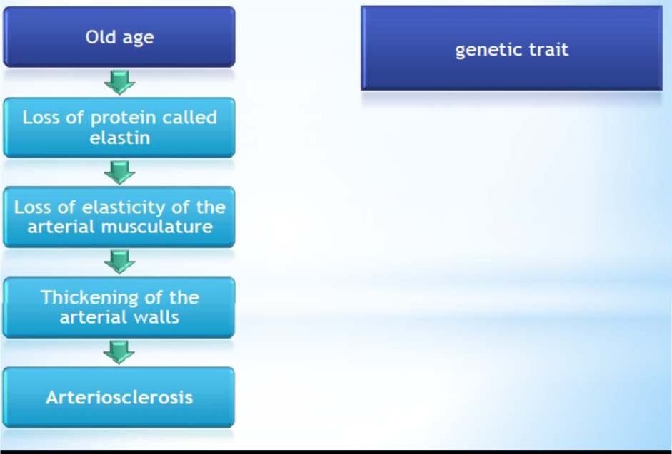
Risk factors
  - obesity
  - smoking
  - diabetes
  - Inactivity
  - diet high in saturated fat & low in healthy fruits, vegetables

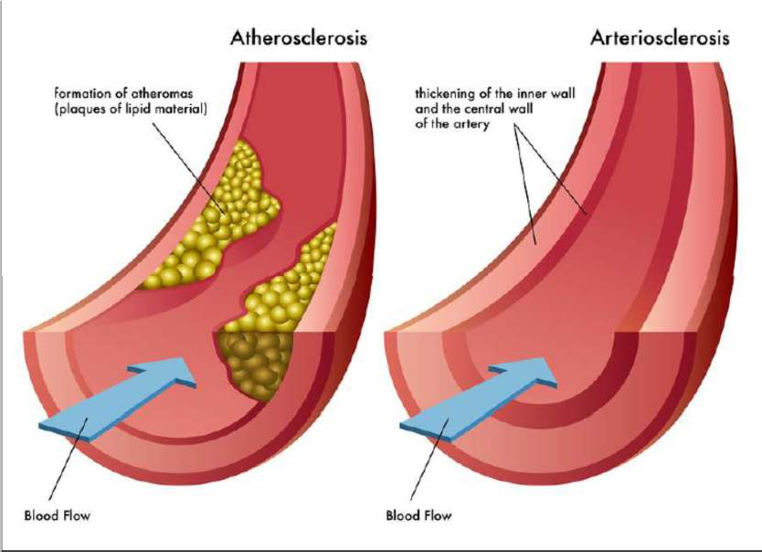
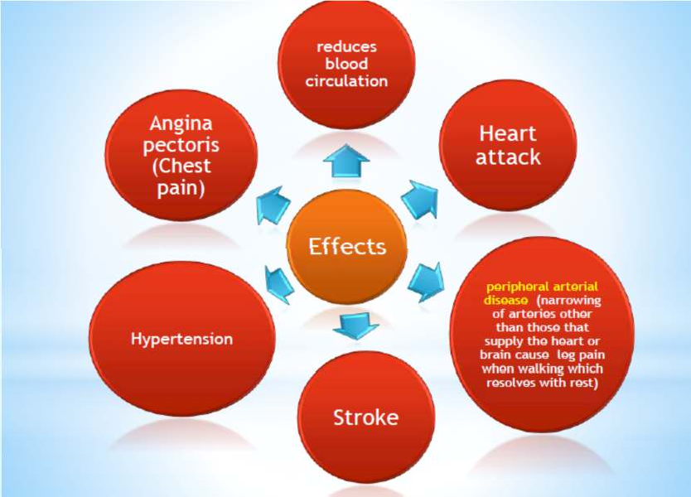

Treatment
  - Lifestyle Modifications-In the early stages of arteriosclerosis, lifestyle modifications include eating a diet low in cholesterol and salt.
  - A healthy diet, along with getting regular exercise, might help slow and possibly even stop the progression of the disease.
  - smokers should stop in order to prevent further artery damage.
  - Medications-Medications, including those for blood pressure and high cholesterol, may be used to control conditions that have contributed to the development of arteriosclerosis.

  - aspirin and anticoagulants
  - Bypass Surgery-using a blood vessel from another part of the body or a synthetic tube to completely bypass the damaged artery.

Signs of Arteriosclerosis
  - A decreased pulse in a narrowed artery
  - Decreased blood pressure in a limb
  - A bulge in the abdomen or behind the knee
  - High blood pressure
  - Kidney infection
  - Shortness of breath
  - Dizziness
  - Neurological Symptom-Arteriosclerosis may affect the arteries that supply the brain.

Summary
  - Arteriosclerosis refers to the thickening and hardening of the medium or large arteries
  - artery walls become calcified or hardened which results in a loss of flexibility and elasticity
  - Arteriosclerosis is a disease process that occurs gradually over time, and although the hardening of the heart’s arteries receives most attention, arteriosclerosis can happen anywhere along the miles of these blood vessels in your body
  - Avoid smoking as this can increase the risk of complications such as stroke and heart attack

