Asthma
- Disorder of the respiratory system that leads to episodic difficulty in breathing
- Chronic inflammatory disorder of the airways in which many cells and cellular elements play a role
- Mast Cells, Eosinophils, T Lymphocytes, Macrophages, Neutrophils , Epithelial Cells

Bronchial Asthma
- Also called reversible airway obstruction
- Clinical syndrome characterized by recurrent bouts of bronchospasm
- Increased responsiveness of the tracheobronchial smooth muscles to various stimuli
- Results in narrowing of the airway
- Chronic inflammatory disorder with reversible airflow obstruction
- Inflammation of bronchial wall mediated by eosinophils, mast cells & lymphocytes
- Hyper-responsiveness of bronchi – narrow readily with stimuli
- In late stages – irreversible

Etiology

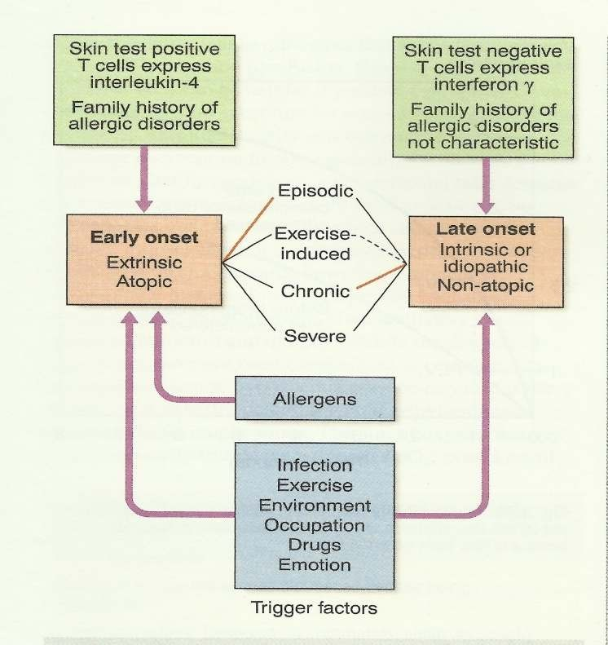
Extrinsic or allergic
- History of `atopy` in childhood
- Family history of allergies
- Positive skin test
- Raised IgE level
- Below 30 years of age
- Less prone to status asthmaticus

Intrinsic or idiosyncratic
- No family history of allergy
- Negative skin test
- No rise in IgE level
- Middle age onset
- Prone to status asthmaticus

Triggers Drugs
Aspirin, ibuprofen and other prostaglandin synthetase inhibitors, beta blockers

Foods
Nuts, fish, sea food, dairy products, food colouring

Other industrial chemicals
Wood or grain dust, cotton dust, cigarette etc

Miscellaneous
Cold, exercise, hyperventilation ,viral respiratory tract infections, emotion or stress
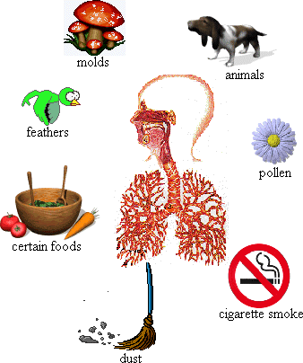

Pathophysiology

Main features of asthma:
- Hypertrophy of bronchial smooth muscle
- Hyperplasia of epithelial cells
- Mucus gland hypertrophy
- Airway oedema
- Acute bronchoconstriction
- Impaired mucociliary clearance
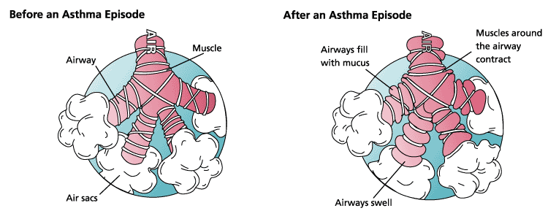

Pathophysiology
- Early exposure to
  - Allergens
  - Viral infections
  - Diet induced
- Early onset: Atopic
-Positive family history
-Readily form IgE to common allergens react with mast cells on surface & activate IgE – histamine release
-Many more mediators
- Changes in the airway
  - Epithelial shedding
  - Airway hyper-responsiveness
  - Microvascular leakage – exudate mucus plugging
  - Neuronal imbalance – bronchoconstriction
- IgE-antibody-mediated reaction on the surface of the mast cell leads to release of mast cell components
- Histamine - triggers rapid bronchoconstriction
- Eosinophils release LTC4 and PAF
- Epithelial damage and thick viscous mucus produced causing deterioration in lung function
- Epithelial damage
- Increases access of various irritants to the cholinergic receptors,
- Bronchoconstriction mediated by the parasympathetic nervous system
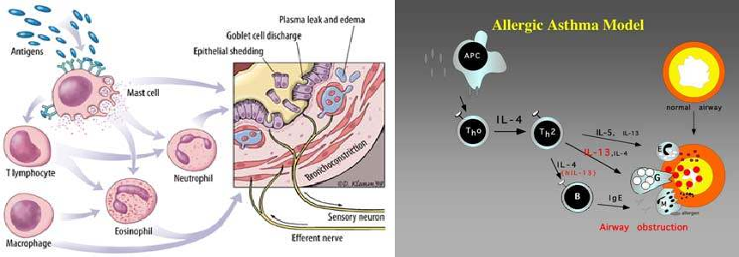
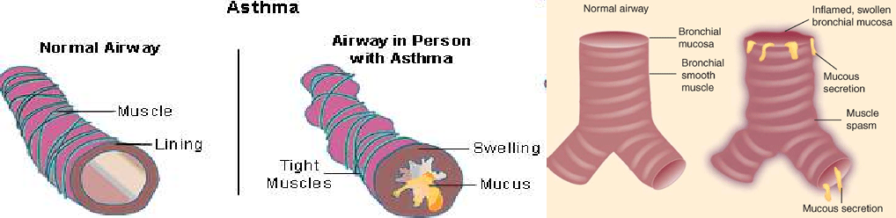

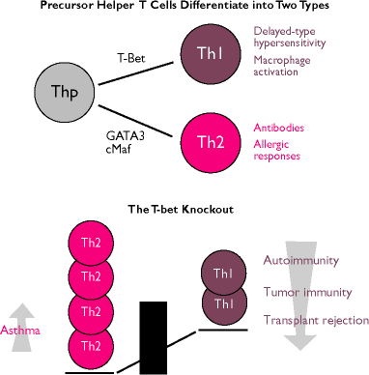

Signs and Symptoms
- Persistent cough
- Dyspnoea - difficulty in breathing
- Wheezing - a high pitched noise due to turbulent airflow through a narrowed airway
- Tightness of chest
- Shortness of breath
- During attacks - fatigue, cyanosed, lethargic, confused, breathless, rapid breathing (> 30 breaths/minute)
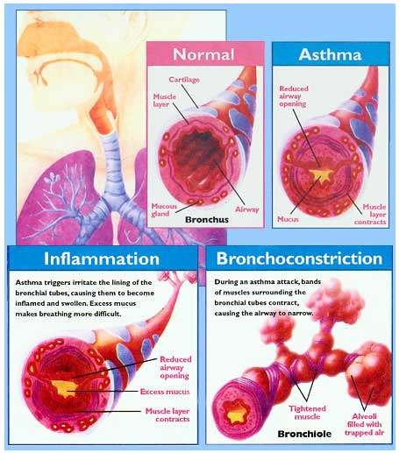

Clinical Features
- Episodic or chronic
- Triad of:
  - Dyspnea (difficulty in breathing)
  - Wheezing (additional sounds)
  - Cough (persistent)
- Productive sputum
- Others Tachycardia

Pulsus paradoxus Sweating
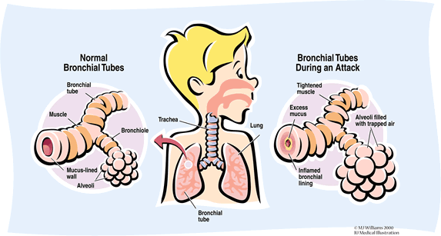
Cyanosis, bradycardia in severe cases Silent chest

SUMMARY
- Chronic inflammatory disorder with reversible airflow obstruction
- Inflammation of bronchial wall mediated by eosinophils, mast cells & lymphocytes
- IgE-antibody-mediated reaction
- Release of mast cell components which triggers rapid bronchoconstriction
- Persistent cough, recurrent episodes of difficulty in breathing associates with wheezing, chest tightness, shortness of breath, abnormal lung function are the common symptoms

