HIV

AIDS

- HIV stands for the Human Immunodeficiency Virus
- A group of viruses known as retroviruses
- After getting into the body, the virus kills or damages cells of the body's immune system
- Body tries to keep up by making new cells or trying to contain the virus
- Destroys the body's ability to fight infections and certain cancers

TYPES OF HIV
- HIV 1 & HIV 2
- Although all HIV viruses are similar
- Small variations or mutations in the genetic material of the virus create drug-resistant viruses
- Larger variations in the viral genes are found in different viral subtypes
- HIV-1 is the predominant subtype that causes HIV/AIDS

HIV Structure
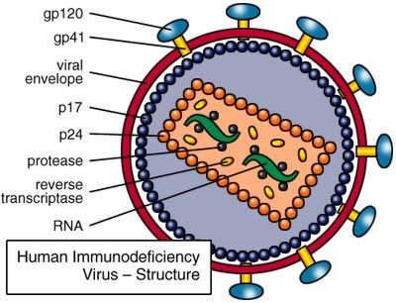
AIDS

Acquired Immunodeficiency Syndrome
- HIV is the virus that causes AIDS
- Disease limits the body’s ability to fight infection
- A person with AIDS has a very weak immune system
- No Cure

Aetiology
- Virus can enter the body through the lining of the vagina, vulva, penis, rectum, or mouth – during sexual contact
- HIV frequently spreads among injection

- Drug users who share needles or syringes contaminated with blood from an infected person
- Women can transmit HIV to their babies during pregnancy or birth
- When infected maternal cells enter the baby's circulation, or through breastfeeding
- HIV can be spread in health-care settings through accidental needle sticks or contact with contaminated fluid
- Very rarely - transfusion of contaminated blood or blood components
- People who already have a sexually transmitted infections, such as
  - Syphilis, genital herpes
  - Chlamydial infection
  - Human papillomavirus (HPV)
  - Gonorrhea or bacterial vaginosis

Pathogenesis

Two main systems which are targets of HIV
- Immune system
- CNS

Immunopathogenesis
- Profound immunosuppression
- Depletion of CD4+ T- cells
- Infections & impairment of function
- Macrophages and dendritic cells are main targets

Sequence of events
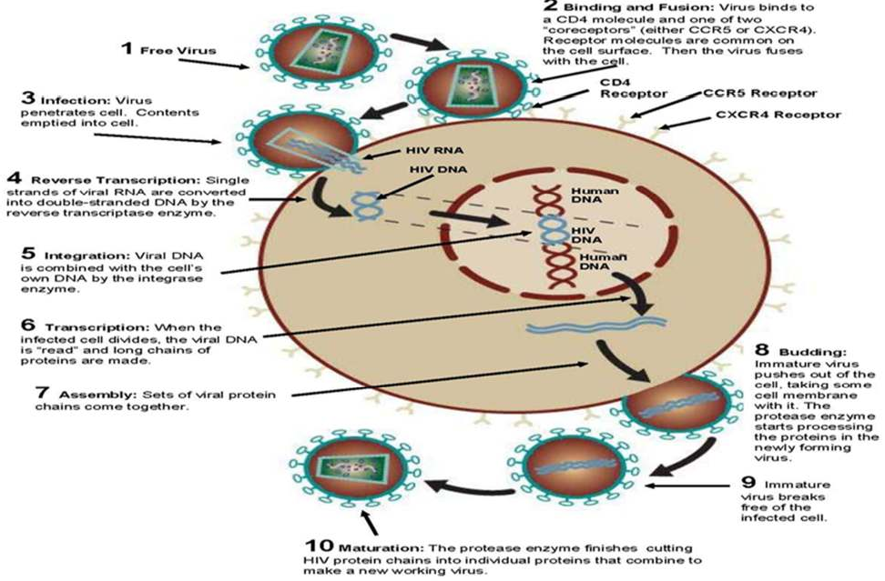

- Selective tropism and internalisation
- Uncoding and proviral DNA integration
- Budding and cynctia formation
- Cytopathic effect
- Effect on monocyte and macrophages
- B- cell dysfunction
- CNS involvement

Signs & symptoms
- Many people with HIV do not know they are infected
- No symptoms after infection with HIV
- Others - flu-like illness within several days to weeks after exposure
- Early HIV symptoms - fever, headache, tiredness, and enlarged lymph nodes in the neck

Major symptoms
- Weight loss
- Chronic diarrhoea for more than one month
- Fever lasting for more than one month

Minor
- Recurrent candidiasis in oropharyngeal membrane
- Lymph adenopathy
- Persistent cough for more than 1 month
- Pruritic dermatitis
- The infections that happen with AIDS are called opportunistic infections
  - Pneumonia caused by Pneumocystis
  - brain infection with toxoplasmosis which can cause trouble thinking or symptoms that mimic a stroke
  - widespread infection with a bacteria called MAC (mycobacterium avium complex) which can cause fever and weight loss
  - Certain fungi like histoplasmosis, which can cause fever, cough, anemia, and other problems
  - lymphoma in (a form of cancer of the lymphoid tissue) in the brain, which can cause fever and trouble thinking
  - A cancer of the soft tissues - Kaposi's sarcoma, which causes brown, reddish, or purple spots that develop on the skin or in the mouth

Summary
- HIV is a retro virus that causes AIDS and weekens the immune system of the body

- Main causes are IV drug users, multiple sex partners, sex with infected partner, in hospital needle sticks, contamination of blood products, pregnant mothers to babies
- Currently 40 million people live with that and 25 million died
- Free virus after binding and fusion in to the cell wall causes infection by reverse transcription followed by integration and transcription which forms mature virus

