Tryptophan
Tryptophan (Trp, W) was the first to be identified as an essential amino acid. It contains an indole ring and chemically it is D-amino E-indole propionic acid. Tryptophan is both glucogenic and ketogenic in nature. It is a precursor for the synthesis of important compounds, namely NAD+ and NADP+ (coenzymes of niacin), serotonin and melatonin.
The metabolism of tryptophan is divided into
I.Kynurenine (kynurenine-anthranilate) pathway,
II. Serotonin pathway.
Serotonin pathway:
Serotonin or 5-hydroxytryptamine (5HT) is a neurotransmitter, synthesized from tryptophan. Normally, about 1% of the tryptophan is converted to serotonin. The production of 5HT occurs in the target tissues.
In mammals, the largest amount of serotonin is synthesized in the intestinal cells.
Platelets contain high concentration of 5HT, the significance of which is not clear. As such, platelets cannot synthesize serotonin.
Degradation of serotonin: Monoamine oxidase (MAO) degrades serotonin to 5- hydroxyindoleacetate (5HIA) which is excreted in urine.
Functions of serotonin : Serotonin is a neurotransmitter and performs a variety of functions. 1. Serotonin is a powerful vasoconstrictor and results in smooth muscle contraction in bronchioles and arterioles.
2. It is closely involved in the regulation of cerebral activity (excitation).
3. Serotonin controls the behavioural patterns, sleep, blood pressure and body temperature.
4. Serotonin evokes the release of peptide hormones from gastrointestinal tract.
5. It is also necessary for the motility of GIT (peristalsis).
Serotonin and brain : The brain itself synthesizes 5HT which is in a bound form. The outside serotonin cannot enter the brain due to blood-brain barrier. Primarily, serotonin is a stimulator (excitation) of brain activity, hence its deficiency causes depression. Serotonin level is decreased in psychosis patients.
Defects in monoamine oxidase gene (lowered MAO activity) are linked to violent behaviour and slight mental retardation.
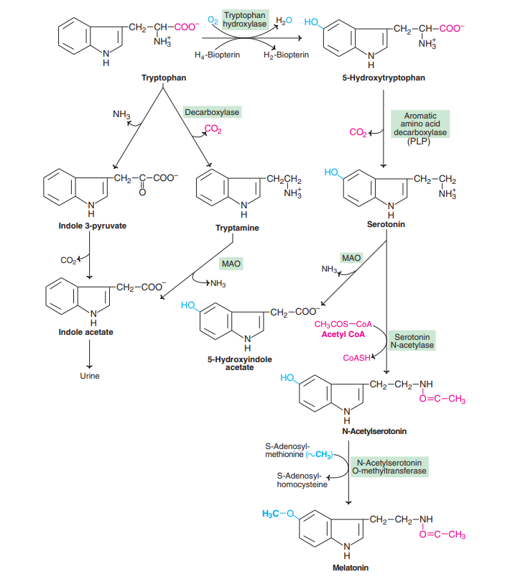
Metabolism of tryptophan-serotonin and melatonin synthesis

Melatonin:
Melatonin is a hormone, mostly synthesized by the pineal gland. Serotonin—produced from tryptophan is acted upon by serotonin N-acetylase (the rate limiting enzyme), to give N- acetylserotonin. The latter undergoes methylation, S-adenosylmethionine being the methyl group donor to produce melatonin or N-acetyl 5-methoxyserotonin . The synthesis and secretion of melatonin from pineal gland is controlled by light.
Functions of melatonin :
1. Melatonin is involved in circadian rhythms or diurnal variations (24 hr cyclic process) of the body. It plays a significant role in sleep and wake process.
2. Melatonin inhibits the production of melanocyte stimulating hormone (MSH) and adrenocorticotropic hormone (ACTH).
3. It has some inhibitory effect on ovarian functions.
4. Melatonin also performs a neurotransmitter function
Biosynthesis of catecholamines:
The name catechol refers to the dihydroxylated phenyl ring. The amine derivatives of catechol are called catecholamines.
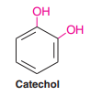
Tyrosine is the precursor for the synthesis of catecholamines, namely dopamine, nor-epinephrine (noradrenaline) and epinephrine (adrenaline).
The conversion of tyrosine to catecholamines occurs in adrenal medulla and central nervous system involving the following reactions.
Tyrosine is hydroxylated to 3,4-dihydroxyphenylalanine (DOPA) by tyrosine hydroxylase. This enzyme catalyses the rate limiting reaction and requires tetrahydrobiopterin as coenzyme (like phenylalanine hydroxylase). In contrast to this enzyme, tyrosinase present in melanocytes converts tyrosine to DOPA. Hence, two different enzyme systems exist to convert tyrosine to DOPA. DOPA undergoes PLP-dependent decarboxylation to give dopamine which, in turn, is hydroxylated to produce norepinephrine. Methylation of norepinephrine by S-adenosylmethionine gives epinephrine. The difference between epinephrine and norepinephrine is only a methyl group (remember that norepinephrine has no methyl group). There exists tissue specificity in the formation of catecholamines. In adrenal medulla, synthesis of the hormones, norepinephrine and epinephrine is prominent. Norepinephrine is produced in certain areas of the brain while dopamine is predominantly synthesized in substantia nigra and coeruleus of brain.
Functions of catecholamines :
Norepinephrine and epinephrine regulate carbohydrate and lipid metabolisms. They stimulate the degradation of triacylglycerol and glycogen. They cause an increase in the blood pressure. Dopamine and norepinephrine serve as neurotransmitters in the brain and autonomous nervous system.
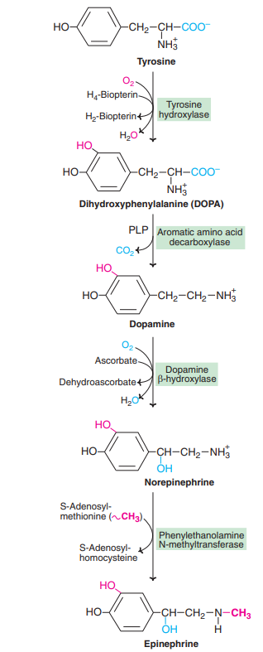
Dopamine and Parkinson’s disease:
Parkinson’s disease is a common disorder in many elderly people, with about 1% of the population above 60 years being affected. It is characterized by muscular rigidity, tremors, expressionless face, lethargy, involuntary movements etc. Biochemical basis : The exact biochemical cause of this disorder has not been identified. Parkinson’s disease is, however, linked with a decreased production of dopamine. The disease is due to degeneration of certain parts of the brain (substantia nigra and locus coeruleus), leading to the impairment in the synthesis of dopamine.
Treatment :
Dopamine cannot enter the brain, hence its administration is of no use. DOPA (levodopa or L-dopa) is used in the treatment of Parkinson’s disease. In the brain, DOPA is decarboxylated to dopamine which alleviates the symptoms of this disorder. Unfortunately, dopamine synthesis occurs in various other tissues and results in side-effects such as nausea, vomiting, hypretension etc. Administration of dopa analogs—that inhibit dopa decarboxylase (in various tissues) but not enter brain (due to blood-brain barrier)—are found to be effective. Carbidopa and J-methyl-dopa (dopa analogs) are administered along with dopa for the treatment of Parkinson’s disease.

