Important Ecological Concepts/ Functions

1. Food Chain

The sun is the ultimate source of energy on earth. It provides the energy required for all plant life. The plants utilise this energy for the process of photosynthesis, which is used to synthesise their food.
During this biological process, light energy is converted into chemical energy and is passed on through successive trophic levels. The flow of energy from a producer, to a consumer and eventually, to an apex predator or a detritivore is called the food chain.

Dead and decaying matter, along with organic debris, is broken down into its constituents by scavengers. The reducers then absorb these constituents. After gaining the energy, the reducers liberate molecules to the environment, which can be utilised again by the producers.

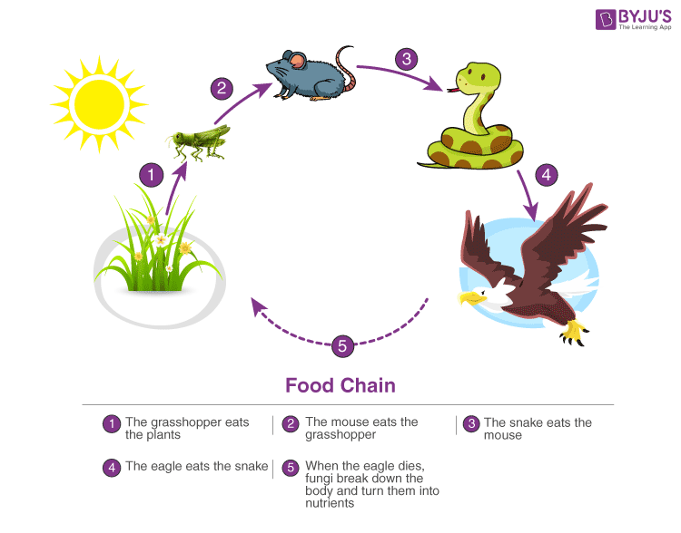

Types of Food Chains:
a) Grazing Food Chain: This type of food chain starts from living green plants goes to grazing herbivores and onto carnivores. Ecosystem with such type of food chain directly depends upon the solar energy for their food requirements. Most of the ecosystem in nature follows this type of food chain.
b) Detritus food Chain: This type of food chain goes from dead organic matter onto microorganisms and then to the organisms feeding on detritus and their predators. Such ecosystems are less dependent on direct solar energy.
c) Parasitic Food Chain: This type of food chain starts from big hosts and ends with parasitic organisms

2. Ecological Pyramids:

An ecological pyramid is the graphical representation of the number, energy, and biomass of the successive trophic levels of an ecosystem. Charles Elton was the first ecologist to describe the ecological pyramid and its principals in 1927.
The biomass, number, and energy of organisms ranging from the producer level to the consumer level are represented in the form of a pyramid; hence, it is known as the ecological pyramid.

The base of the ecological pyramid comprises the producers, followed by primary and secondary consumers. The tertiary consumers hold the apex. In some food chains, the quaternary consumers are at the very apex of the food chain.
The producers generally outnumber the primary consumers and similarly, the primary consumers outnumber the secondary consumers. And lastly, apex predators also follow the same trend as the other consumers; wherein, their numbers are considerably lower than the secondary consumers.
For example, Grasshoppers feed on crops such as cotton and wheat, which are plentiful. These grasshoppers are then preyed upon by common mouse, which are comparatively less in number. The mice are preyed upon by snakes such as cobras. Snakes are ultimately preyed on by apex predators such as the brown snake eagle.
In essence:

Grasshopper →Mouse→ Cobra → Brown Snake Eagle

Types of Ecological Pyramid

Three types of ecological pyramids exist. They are as follows:

1.Pyramid of Numbers

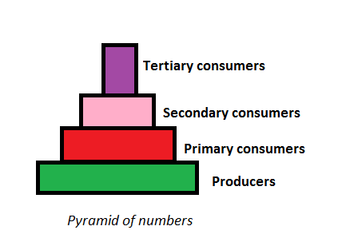

In this type of ecological pyramid, the number of organisms in each trophic level is considered as a level in the pyramid. The pyramid of numbers is usually upright except for some situations like that of the detritus food chain, where many organisms feed on one dead plant or animal.

2.Pyramid of Biomass

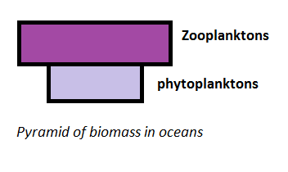

In this particular type of ecological pyramid, each level takes into account the amount of biomass produced by each trophic level. The pyramid of biomass is also upright except for that observed in oceans where large numbers of zooplanktons depend on a relatively smaller number of phytoplanktons.
Pyramid of Energy
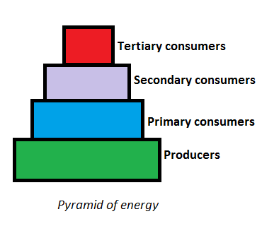

3.Pyramid of Energy
Pyramid of energy is the only type of ecological pyramid, which is always upright as the energy flow in a food chain is always unidirectional. Also, with every increasing trophic level, some energy is lost into the environment.

Importance of Ecological Pyramid
The importance of ecological pyramid can be explained in the following points:
They show the feeding of different organisms in different ecosystems.
It shows the efficiency of energy transfer.
The condition of the ecosystem m can be monitored, and any further damage can be prevented.

3. Food Web

Food web is a network of interconnected food chains. It comprises all the food chains within a single ecosystem. It helps in understanding that plants lay the foundation of all the food chains. In a marine environment, phytoplankton forms the primary producer.

The interconnected, interlocking pattern of food chain is known as food web.
•Under natural condition of the linear arrangement of food chain hardly occurs and they remain interconnected with each other through different types of organisms at different levels Such a interconnected and interlocking pattern of food chain is known as food web.
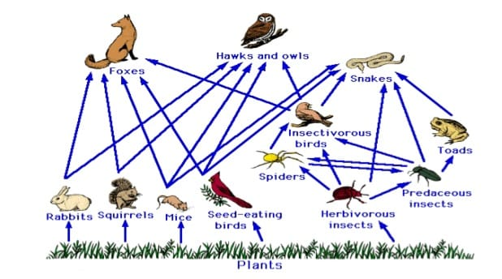

Nutrient Cycle
- Circulation or exchange of nutrient elements between the living and nonliving components of an ecosystem is called the nutrient cycle or biogeochemical cycle.
- The term biogeochemical cycles represent the interactions among the organic (bio-) and inorganic (geo-) components and concentrate on the chemistry (chemical-) and movement (cycles) of chemical elements and compounds Nutrient cycling represents the movement of elements through various forms and their return to their original state.
- The amount of nutrients such as carbon, Nitrogen, Phosphorus, calcium, etc., present in the soil at any given time is referred to as the standing state. The soil has nutrients in a standing state; they are picked by plants, also known as producers and made part of organic matter.
- From producers, the nutrients pass to the higher trophic level in the form of organic matter. Nutrient cycling involves various factors such as biotic, abiotic, chemical and physical factors. Examples of nutrient cycles are the carbon cycle, oxygen cycle, nitrogen cycle, water cycle, phosphorus cycle, etc.

Types of Nutrient Cycle

There are three types of nutrient cycles that are observed in an ecosystem based on their reservoirs.

Gaseous Cycles: In these cycles, the main reservoirs of chemicals are the atmosphere and ocean. This type of cycle includes non-mineral chemicals. Nutrient cycles like the Nitrogen cycle, Carbon cycle, Hydrogen cycle and Oxygen cycle are examples of this type.

Sedimentary Cycles: In these cycles, the main reservoirs of chemicals are soil and rocks. These cycles include mineral chemicals. Phosphorus and Sulphur cycles are two examples of sedimentary cycles.

Hydrological Cycle: In this cycle, the reservoir may be in the atmosphere or in the soil. The water cycle is an example of this type.
We will learn about these cycles in detail in this article.

Characteristics of Nutrient Cycle

The main characteristic features of nutrient cycles or biogeochemical cycles are:
All the subdivisions of the biosphere provide nutrients to the biotic components.
Materials involved in these cycles do not come from outside.
There is a specific rate of exchange of each biogenetic nutrient between biotic and abiotic components.
.

Gaseous Cycles

This type includes the carbon cycle, nitrogen cycle and oxygen cycle.

1. Carbon Cycle
The atmospheric carbon dioxide is virtually the only source of carbon. The carbon cycle is the process through which carbon elements are interchanged between the biosphere, geosphere, hydrosphere, and atmosphere in the Earth.
The complete carbon cycle looks like the figure below:

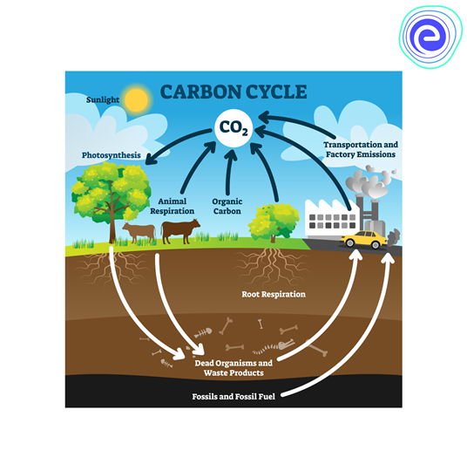
Fig: Carbon Cycle

Steps involved in the process of the carbon cycle:

- Carbon present in the atmosphere is absorbed by the plants through photosynthesis.
- All living organisms release carbon dioxide by respiration.
- The carbon that is present in the plants is transferred to herbivores animals when they eat plants. Carnivores also get carbon through different food chains.
- Dead bodies of animals and dead parts of plants decay (decompose), and carbon is transferred back to the soil.
- Some amount of carbon that is not transferred to the soil is buried deep and forms fossil fuels. Carbon enters back to the atmosphere as carbon dioxide gas when these fossil fuels are burned.

2. Nitrogen Cycle
Nitrogen is also one of the important components in life. However, though Nitrogen is the most abundant gas present in the atmosphere, living organisms cannot utilize it in its elemental form. Therefore, Nitrogen mu st be converted into ammonia and other nitrogen compounds like nitrites and nitrates to be used by living organisms. This process of conversion is named Nitrogen Fixation. This process is carried out by various soil microorganisms in different steps.

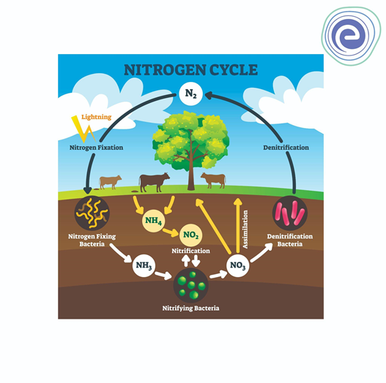
Fig: Nitrogen Cycle

Steps involved in the process of the Nitrogen cycle:

- Nitrogen-fixing bacteria fix atmospheric nitrogen into ammonia, and nitrifying bacteria present in the soil convert ammonia into nitrate, which is absorbed by the plants. This process is called Nitrogen fixation.
- Atmospheric Nitrogen is converted into nitrates by the process of assimilation and lightning by plants.
- Decomposers like bacteria present in the soil break down complex proteins and acids of decaying organic matter.
- During the process of denitrification, denitrifying bacteria converts ammonia, nitrates into nitrogen. Free nitrogen gas is released into the atmosphere.
3. Oxygen Cycle
Oxygen is one of the most abundant elements on Earth after carbon. Around 21%21% of our atmosphere is formed of oxygen.

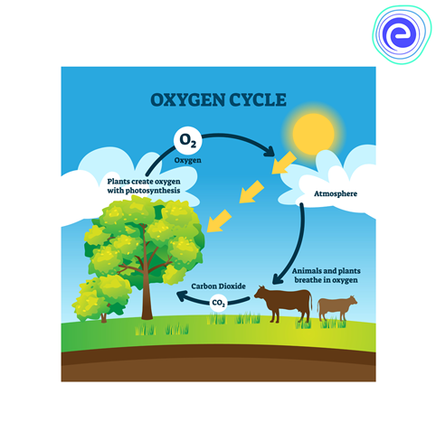
Fig: Oxygen Cycle

The steps involved in the Oxygen cycle are:

- During the process of photosynthesis, all the green plants release oxygen into the atmosphere.
- Aerobic organisms use free oxygen present in the atmosphere for the respiration process.
- Animals release carbon dioxide in the atmosphere, which is utilized by plants for photosynthesis, and the cycle continues.

Sedimentary Cycles:

Mineral elements needed by living organisms are initially taken from inorganic sources. Most of the available forms occur as salts dissolved in water or soil. This type includes the Phosphorus cycle and Sulphur cycle.

1. Phosphorus Cycle
Phosphorus is a component of nucleic acids, ADP, ATP, NADP, phospholipids, etc. It is found in the soil in various forms like phosphate of rock, calcium, and iron or aluminium phosphate, fluorapatite, etc. Like many other mineral elements, Phosphorus also arrives in the oceans and settles down as sediment. A large proportion of Phosphorus percolates down to deep layers of soil. Biological processes like the formation of teeth and bones also keep Phosphorus locked up for some time.

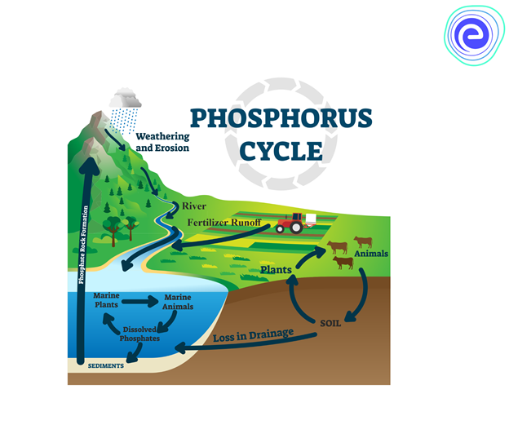
Fig: Phosphorus cycle

The steps involved in the Phosphorus cycle are:

- The dissolved Phosphorus is assimilated by plants and transformed into an organic form.
- It travels to various trophic levels from plants in the form of organic phosphates.
- The action of decomposers on dead parts of plants and animals releases Phosphorus into the environment. Consequently, this process proceeds cyclically.

2. Sulphur Cycle
The sulphur cycle connects soil, water, and air. Sulphur is found as sulphides or crystalline sulphates in the ground and rocks and as SO2SO2 and H2SH2S in the atmosphere. Most of the organisms take sulphur as inorganic sulphates, except for a few organisms that require organic forms of sulphur like amino acids and cysteine. Most of the biologically fused sulphur is composed in the soil from the aerobic decomposition of proteins by microbes like bacteria and fungi. The sulphur cycle includes an excellent example of interaction and complex biochemical regulation between the different mineral cycles.

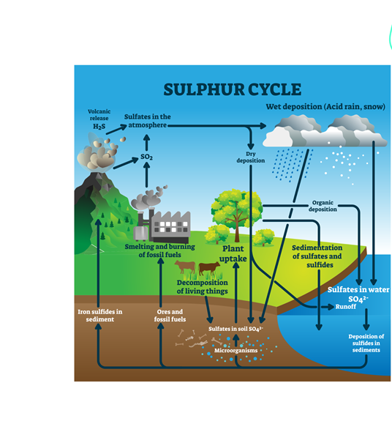
Fig: Sulphur Cycle

The steps involved in the Sulphur cycle are:

- Green and purple photosynthetic bacteria utilize hydrogen molecules of H2SH2S as the oxygen acceptor to reduce carbon dioxide.
- Green bacteria can oxidize sulphide to elemental sulphur, whereas purple bacteria can lead to oxidation to the sulphate stage.
- In the ecosystems, sulphur is carried from plants to animals, then to decomposers, and lastly, it returns to the environment through the breakdown of dead organic remains.
- Sedimentary features of sulphur cycling include precipitation of sulphur in the presence of iron under anaerobic conditions.

Hydrologic or Water Cycle:

Water plays a vital role in the existence of life. The exchange of water between atmosphere, land, sea, and living organisms and their habitats is achieved through the water cycle. The water cycle or hydrologic cycle involves various steps like evaporation, transpiration, cloud formation, and precipitation. The following diagram illustrates the steps involved in the water cycle.

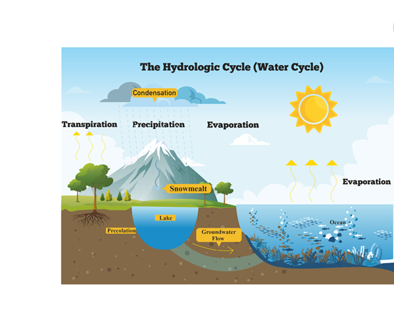
Fig: Hydrologic or Water Cycle

The steps involved in the process of water or hydrologic cycle are:

- Transfer of Water from the Earth takes place in the form of water vapour in the atmosphere by evaporation and transpiration. Evaporation occurs when water reaches its boiling point.
- Water present in the lakes, oceans and other water reservoirs is converted into vapours through evaporation. Transpiration occurs from the surface of the plants.
- After the water is converted into vapours, the vapours are converted back into liquid form due to the increase in temperature; this process is called condensation.
- These tiny droplets of water fall down due to Earth’s gravity which is called precipitation.
- Water falling on the ground in the form of rain fills the water bodies, which is called runoff or stored as groundwater.

ENERGY FLOW IN AN ECOSYSTEM
- Biological activities require energy which ultimately comes from the sun. Solar energy is transformed into chemical energy by a process of photosynthesis this energy is stored in plant tissue and then transformed into heat energy during metabolic activities
- Thus in biological world the energy flows from the sun to plants and then to all heterotrophic organisms. The flow of energy is unidirectional and non-cyclic. This one way flow of energy is governed by laws of thermodynamics which states that:
- Energy can neither be created nor be destroyed but may be transformed from one form to another (b) During the energy transfer there is degradation of energy from a concentrated form (mechanical, chemical, or electrical etc.) to a dispersed form (heat). No energy transformation is 100 % efficient; it is always accompanied by some dispersion or loss of energy in the form heat. Therefore, biological systems including ecosystems must be supplied with energy on a continuous Basis.
MODELS OF ENERGY FLOW IN ECOSYSTEM
- Single Channel Energy Flow Model:
The flow of energy takes place in a unidirectional manner through a single channel of producers to herbivores and carnivores. The energy captured by autotrophs does not revert back to solar input but passes to herbivores; and that which passes to herbivores does not go back to autotrophs but passes to consumers. Due to one way flow of energy, the entire system would collapse if primary source of energy were cut off. At each tropic level there occurs progressive decrease in energy which is mainly due to loss of energy as heat in metabolic reactions and also some of the energy is utilized at each tropic level
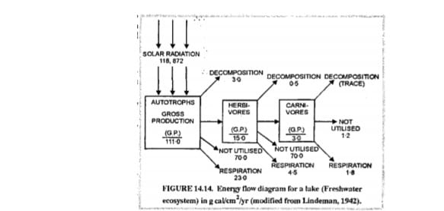
- Y- shaped model:
shows a common boundary, light and heat flow as well as import, export and storage of organic matter . Decomposers are placed in separate box to partially separate the grazing and detritus food chains. In terms of energy levels decomposers are in fact a mixed group.
•Y- shaped energy flow is more realistic and practical than the single channel energy flow model because:
•It conforms to the basic stratified structure of ecosystems
•It separates the two chains i.e. grazing & detritus food chain in both time and space.
•Micro consumers (bacteria & fungi) and the macro consumers (animals) differ greatly in size- metabolism relations in two models.

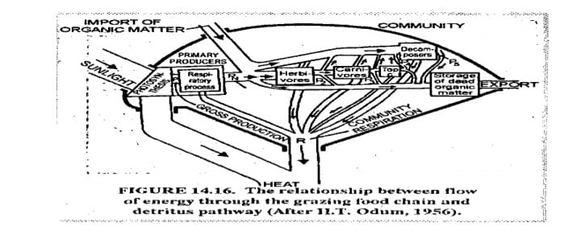

3.Universal energy flow model :
As the flow of energy takes place, there is gradual loss of energy at each level there by resulting in less energy available at the next tropic level as indicated by narrower pipes (energy flow) and smaller boxes (stored energy in biomass). The loss of energy is mainly the energy which is not utilized (U). This is the energy loss in locomotion, excretion etc. or it the energy lost in respiration (CR) which is for maintenance. The remaining energy is used for production (P).

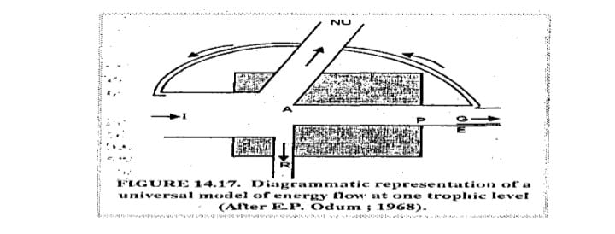

ECOLOGICAL SUCCESSION
Ecological Succession is the phenomenon or process by which a community progressively transforms itself until a stable community is formed. It is a fundamental concept in ecology, refers to more or less predictable and orderly changes in the composition or structure of an ecological community. Succession may be initiated either by formation of new, unoccupied habitat (e.g., a lava flow or a severe landslide) or by some form of disturbance (e.g. fire, severe wind throw , logging) of an existing community. Succession that begins in areas where no soil is initially present is called primary succession, whereas succession that begins in areas where soil is already present is called secondary succession.

