ECOSYSTEM

An ecosystem is a structural and functional unit of ecology where the living organisms interact with each other and the surrounding environment. In other words, an ecosystem is a chain of interactions between organisms and their environment. The term “Ecosystem” was first coined by A.G.Tansley, an English botanist, in 1935.
The self-sustaining structural and functional interaction between living and non-living
components Ecology: Scientific study of the interactions between organisms and the
There are different type of ecosystems around us which involves living organisms and non living organisms. If we combine all the ecosystems present on earth, it is called Biosphere.”
Read on to explore the structure, components, types and functions of the ecosystem in the notes provided below.

Structure of the Ecosystem
The structure of an ecosystem is characterised by the organisation of both biotic and abiotic components. This includes the distribution of energy in our environment. It also includes the climatic conditions prevailing in that particular environment.

The structure of an ecosystem can be split into two main components, namely:

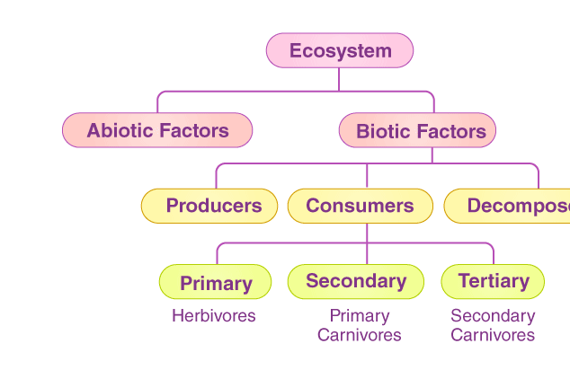
1.Biotic Components
2.Abiotic Components

The biotic and abiotic components are interrelated in an ecosystem. It is an open system where the energy and components can flow throughout the boundaries.

1.Biotic Components
Biotic components refer to all living components in an ecosystem. Based on nutrition, biotic components can be categorised into autotrophs, heterotrophs and saprotrophs (or decomposers).
Producers include all autotrophs such as plants. They are called autotrophs as they can produce food through the process of photosynthesis. Consequently, all other organisms higher up on the food chain rely on producers for food.
Consumers or heterotrophs are organisms that depend on other organisms for food. Consumers are further classified into primary consumers, secondary consumers and tertiary consumers.
Primary consumers are always herbivores as they rely on producers for food.
Secondary consumers depend on primary consumers for energy. They can either be carnivores or omnivores.
Tertiary consumers are organisms that depend on secondary consumers for food. Tertiary consumers can also be carnivores or omnivores.
Quaternary consumers are present in some food chains. These organisms prey on tertiary consumers for energy. Furthermore, they are usually at the top of a food chain as they have no natural predators.
Decomposers include saprophytes such as fungi and bacteria. They directly thrive on the dead and decaying organic matter. Decomposers are essential for the ecosystem as they help in recycling nutrients to be reused by plants.
2.Abiotic Components
Abiotic components are the non-living component of an ecosystem. It includes air, water, soil, minerals, sunlight, temperature, nutrients, wind, altitude, turbidity, etc.

Functions of Ecosystem
The functions of the ecosystem are as follows:
- It regulates the essential ecological processes, supports life systems and renders stability.
- It is also responsible for the cycling of nutrients between biotic and abiotic components.
- It maintains a balance among the various trophic levels in the ecosystem.
- It cycles the minerals through the biosphere.
- The abiotic components help in the synthesis of organic components that involve the exchange of energy.
- So the functional units of an ecosystem or functional components that work together in an ecosystem are:
Productivity – It refers to the rate of biomass production.
Energy flow – It is the sequential process through which energy flows from one trophic level to another. The energy captured from the sun flows from producers to consumers and then to decomposers and finally back to the environment.
Decomposition – It is the process of breakdown of dead organic material. The top-soil is the major site for decomposition.
Nutrient cycling – In an ecosystem nutrients are consumed and recycled back in various forms for the utilisation by various organisms.

Types of Ecosystem
An ecosystem can be as small as an oasis in a desert, or as big as an ocean, spanning thousands of miles. There are two types of ecosystem:
Terrestrial Ecosystem
Aquatic Ecosystem
Terrestrial Ecosystem
Terrestrial ecosystems are exclusively land-based ecosystems. There are different types of terrestrial ecosystems distributed around various geological zones. They are as follows:
Forest Ecosystem
Grassland Ecosystem
Tundra Ecosystem
Desert Ecosystem
Forest Ecosystem
A forest ecosystem consists of several plants, particularly trees, animals and microorganisms that live in coordination with the abiotic factors of the environment. Forests help in maintaining the temperature of the earth and are the major carbon sink.
Grassland Ecosystem
In a grassland ecosystem, the vegetation is dominated by grasses and herbs. Temperate grasslands and tropical or savanna grasslands are examples of grassland ecosystems.
Tundra Ecosystem
Tundra ecosystems are devoid of trees and are found in cold climates or where rainfall is scarce. These are covered with snow for most of the year. Tundra type of ecosystem is found in the Arctic or mountain tops.
Desert Ecosystem
Deserts are found throughout the world. These are regions with little rainfall and scarce vegetation. The days are hot, and the nights are cold.
Aquatic Ecosystem
Aquatic ecosystems are ecosystems present in a body of water. These can be further divided into two types, namely:
Freshwater Ecosystem
Marine Ecosystem
Freshwater Ecosystem
The freshwater ecosystem is an aquatic ecosystem that includes lakes, ponds, rivers, streams and wetlands. These have no salt content in contrast with the marine ecosystem.
Marine Ecosystem
The marine ecosystem includes seas and oceans. These have a more substantial salt content and greater biodiversity in comparison to the freshwater ecosystem.

Important Ecological Concepts
1. Food Chain
The sun is the ultimate source of energy on earth. It provides the energy required for all plant life. The plants utilise this energy for the process of photosynthesis, which is used to synthesise their food.
During this biological process, light energy is converted into chemical energy and is passed on through successive trophic levels. The flow of energy from a producer, to a consumer and eventually, to an apex predator or a detritivore is called the food chain.

Dead and decaying matter, along with organic debris, is broken down into its constituents by scavengers. The reducers then absorb these constituents. After gaining the energy, the reducers liberate molecules to the environment, which can be utilised again by the producers.

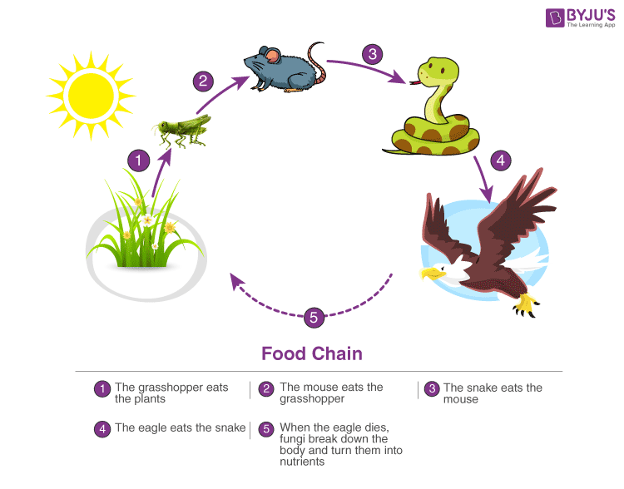

Types of Food Chains:
a) Grazing Food Chain: This type of food chain starts from living green plants goes to grazing herbivores and onto carnivores. Ecosystem with such type of food chain directly depends upon the solar energy for their food requirements. Most of the ecosystem in nature follows this type of food chain.
b) Detritus food Chain: This type of food chain goes from dead organic matter onto microorganisms and then to the organisms feeding on detritus and their predators. Such ecosystems are less dependent on direct solar energy.
c) Parasitic Food Chain: This type of food chain starts from big hosts and ends with parasitic organisms

2. Ecological Pyramids
An ecological pyramid is the graphical representation of the number, energy, and biomass of the successive trophic levels of an ecosystem. Charles Elton was the first ecologist to describe the ecological pyramid and its principals in 1927.
The biomass, number, and energy of organisms ranging from the producer level to the consumer level are represented in the form of a pyramid; hence, it is known as the ecological pyramid.
The base of the ecological pyramid comprises the producers, followed by primary and secondary consumers. The tertiary consumers hold the apex. In some food chains, the quaternary consumers are at the very apex of the food chain.
The producers generally outnumber the primary consumers and similarly, the primary consumers outnumber the secondary consumers. And lastly, apex predators also follow the same trend as the other consumers; wherein, their numbers are considerably lower than the secondary consumers.
For example, Grasshoppers feed on crops such as cotton and wheat, which are plentiful. These grasshoppers are then preyed upon by common mouse, which are comparatively less in number. The mice are preyed upon by snakes such as cobras. Snakes are ultimately preyed on by apex predators such as the brown snake eagle.
In essence:
Grasshopper →Mouse→ Cobra → Brown Snake Eagle
Types of Ecological Pyramid
Three types of ecological pyramids exist. They are as follows:
Pyramid of Numbers
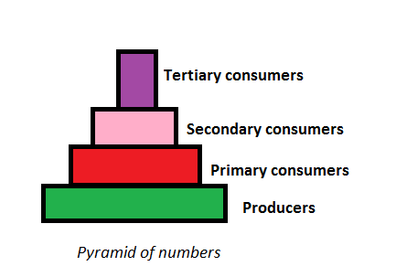
Pyramid of Numbers
In this type of ecological pyramid, the number of organisms in each trophic level is considered as a level in the pyramid. The pyramid of numbers is usually upright except for some situations like that of the detritus food chain, where many organisms feed on one dead plant or animal.
Pyramid of Biomass
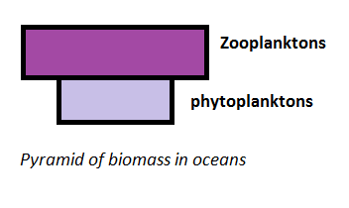
Pyramid of Biomass
In this particular type of ecological pyramid, each level takes into account the amount of biomass produced by each trophic level. The pyramid of biomass is also upright except for that observed in oceans where large numbers of zooplanktons depend on a relatively smaller number of phytoplanktons.
Pyramid of Energy
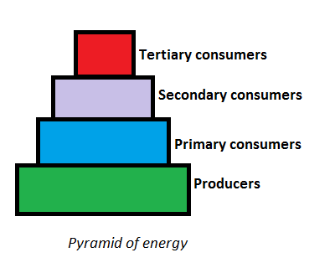
Pyramid of Energy
Pyramid of energy is the only type of ecological pyramid, which is always upright as the energy flow in a food chain is always unidirectional. Also, with every increasing trophic level, some energy is lost into the environment.
Importance of Ecological Pyramid
The importance of ecological pyramid can be explained in the following points:
They show the feeding of different organisms in different ecosystems.
It shows the efficiency of energy transfer.
The condition of the ecosystem can be monitored, and any further damage can be prevented.

3. Food Web
Food web is a network of interconnected food chains. It comprises all the food chains within a single ecosystem. It helps in understanding that plants lay the foundation of all the food chains. In a marine environment, phytoplankton forms the primary producer.

The interconnected, interlocking pattern of food chain is known as food web.
•Under natural condition of the linear arrangement of food chain hardly occurs and they remain interconnected with each other through different types of organisms at different levels Such a interconnected and interlocking pattern of food chain is known as food web.
