BIOCHEMISTRY– BP203T

UNIT: I BIOMOLECULES

CLASS:2

TOPIC: Types of Bioenergetics Reactions

Exergonic Reaction

- Exergonic implies the release of energy from a spontaneous chemical reaction without any concomitant utilization of energy.
- The reactions are significant in terms of biology as these reactions have an ability to perform work and include most of the catabolic reactions in cellular respiration.
- Most of these reactions involve the breaking of bonds during the formation of reaction intermediates as is evidently observed during respiratory pathways. The bonds that are created during the formation of metabolites are stronger than the cleaved bonds of the substrate.
- The release of free energy, G, in an exergonic reaction (at constant pressure and temperature) is denoted as ΔG = Products – Reactants < 0

Endergonic Reactions
- Endergonic in turn is the opposite of exergonic in being non-spontaneous and requires an input of free energy.
Most of the anabolic reactions like photosynthesis and DNA and protein synthesis are endergonic in nature.
- The release of free energy, G, in an exergonic reaction (at constant pressure and temperature) is denoted as
ΔG = Products – Reactants = 0
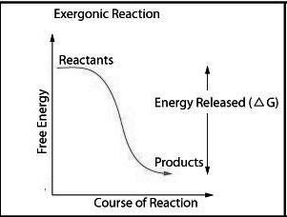
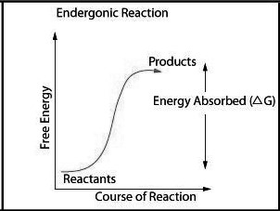
-

3.Activation Energy
- Activation energy is the energy which must be available to a chemical system with potential reactants to result in a chemical reaction. Activation energy may also be defined as the minimum energy required starting a chemical reaction.

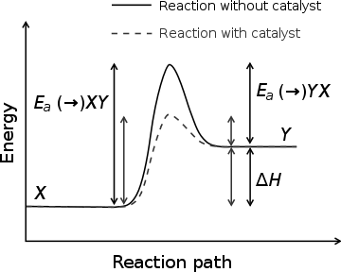

Very Short Answer Questions:
1.what are Exergonic and Endergonic reactions and examples.

