UREA CYCLE

Urea is the end product of protein metabolism (amino acid metabolism). The nitrogen of amino acids, converted to ammonia (as described above), is toxic to the body. It is converted to urea and detoxified. As such, urea accounts for 80-90% of the nitrogen containing substances excreted in urine.
Urea is synthesized in liver and transported to kidneys for excretion in urine. Urea cycle is the first metabolic cycle that was elucidated by Hans Krebs and Kurt Henseleit (1932), hence it is known as Krebs-Henseleit cycle. The individual reactions, however, were described in more detail later on by Ratner and Cohen.
Urea has two amino ( NH2) groups, one derived from NH3 and the other from aspartate. Carbon atom is supplied by CO2. Urea synthesis is a five-step cyclic process, with five distinct enzymes. The first two enzymes are present in mitochondria while the rest are localized in cytosol.
- Synthesis of carbamoyl phosphate :
Carbamoyl phosphate synthase I (CPS I) of mitochondria catalyses the condensation of NH4 + ions with CO2 to form carbamoyl phosphate. This step consumes two ATP and is irreversible, and rate-limiting. CPS I requires N-acetylglutamate for its activity. Another enzyme, carbamoyl phosphate synthase II (CPS II)— involved in pyrimidine synthesis—is present in cytosol. It accepts amino group from glutamine and does not require N-acetylglutamate for its activity.
- Formation of citrulline :
- Citrulline is synthesized from carbamoyl phosphate and ornithine by ornithine transcarbamoylase. Ornithine is regenerated and used in urea cycle. Therefore, its role is comparable to that of oxaloacetate in citric acid cycle. Ornithine and citrulline are basic amino acids. (They are never found in protein structure due to lack of codons). Citrulline produced in this reaction is transported to cytosol by a transporter system.
- Synthesis of arginosuccinate :
Argino-succinate synthase condenses citrulline with aspartate to produce arginosuccinate. The second amino group of urea is incorporated in this reaction. This step requires ATP which is cleaved to AMP and pyrophosphate (PPi). The latter is immediately broken down to inorganic phosphate (Pi).
- Cleavage of arginosuccinate :
Arginosuccinase cleaves arginosuccinate to give arginine and fumarate. Arginine is the immediate precursor for urea. Fumarate liberated here provides a connecting link with TCA cycle, gluconeogenesis etc..
5. Formation of urea : Arginase is the fifth and final enzyme that cleaves arginine to yield urea and ornithine. Ornithine, so regenerated, enters mitochondria for its reuse in the urea cycle. Arginase is activated by Co2+ and Mn2+. Ornithine and lysine compete with arginine (competitive inhibition). Arginase is mostly found in the liver, while the rest of the enzymes (four) of urea cycle are also present in other tissues. For this reason, arginine synthesis may occur to varying degrees in many tissues. But only the liver can ultimately produce urea.
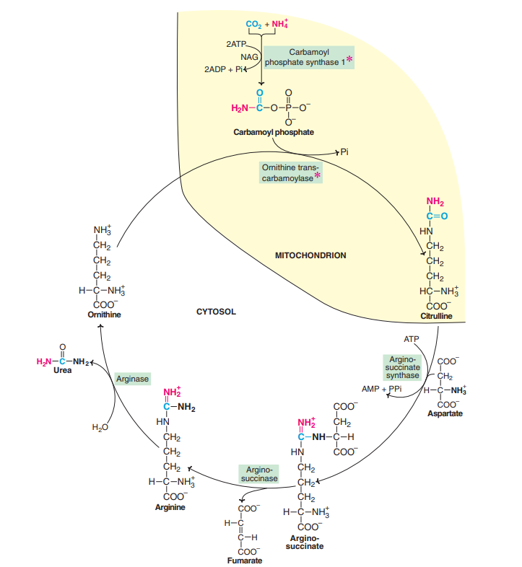

Overall reaction and energetics:

The urea cycle is irreversible and consumes 4 ATP. Two ATP are utilized for the synthesis of carbamoyl phosphate. One ATP is converted to AMP and PPi to produce arginosuccinate which equals to 2 ATP. Hence 4 ATP are actually consumed.
NH4 + + CO2 + Aspartate + 3ATP …… Urea + Fumarate + 2 ADP + 2 Pi + AMP + PPi

Metabolic disorders of urea cycle:

Metabolic defects associated with each of the five enzymes of urea cycle have been reported. All the disorders invariably lead to a build-up in blood ammonia (hyperammonemia), leading to toxicity. Other metabolites of urea cycle also accumulate which, however, depends on the specific enzyme defect. The clinical symptoms associated with defect in urea cycle enzymes include vomiting, lethargy, irritability, ataxia and mental retardation.

