HUMAN ANATOMY AND PHYSIOLOGY-II (Theory)
Subject code: BP201T
Class – 02
STRUCTURE OF THE ALIMENTARY CANAL
- The layers of the walls of the alimentary canal follow a consistent pattern from the Oesophagus onwards.
- In the organs from the Oesophagus onwards, structural modifications are associated with specific functions.
- The walls of the alimentary tract are formed by four layers of tissue:
Adventitia or Serosa – Outer Covering
Muscle layer
Submucosa
Mucosa – mucosal lining

Adventitia or Serosa: This is the Outermost layer. In the thorax it consists of loose fibrous tissue, and in the abdomen the organs are covered by a serous membrane (Serosa) called Peritoneum.

Peritoneum:
- It is largest serous membrane of the body. It is a single membrane, forming a closed sac and containing a small amount of serous fluid, within the abdominal cavity.
- It is richly supplied with blood and lymph vessels, and contain many lymph nodes.
- It provides a physical barrier to local spread infection and can isolate an infective focus such as appendicitis, preventing involvement of other abdominal structures.
- It has two layers: Parietal Peritoneum, which lines the abdominal wall and the visceral peritoneum, which covers the organs (Viscera) within the abdominal and pelvic cavities.
- The parietal peritoneum lines the anterior abdominal wall. The two layers of Peritoneum are in close contact, and friction between them is prevented by the presence of peritoneal fluid.
- The abdominal organs are covered to varying degrees by the loops and folds of the visceral peritoneum, which attaches them firmly to the abdominal wall.
- If the organ is almost completely covered by the visceral peritoneum, it is said to be intraperitoneal.
- If the organ is covered on its anterior side only, it is said to be retroperitoneal (meaning behind the Peritoneum). This means that:
- Pelvic organs are covered only on their superior surface.
- The stomach and intestines are almost completely surrounded by Peritoneum and have a double fold (the mesentery) that attaches them to the posterior abdominal wall.
- The fold of peritoneum enclosing the stomach extends beyond the greater curvature of the stomach, and hangs down in front of the abdominal organs like an apron.
- This is the greater Omentum, which stores fat that provides both insulation and a long-term energy store.
- The anterior surfaces of the pancreas, spleen. Kidneys and adrenal glands is covered, so these organs are retroperitoneal (lie behind the Peritoneum).
- The liver is almost completely covered by peritoneum, which attaches it to the inferior surface of the diaphragm.
- The main blood vessels and nerves pass close to the posterior abdominal wall and send branches to the organs between folds of peritoneum.

Muscle layer:
- This consists of two layers of smooth (involuntary) muscle. The muscle fibres of the outer layer are arranged longitudinally, and those of the inner layer are circular.
- Between these two muscle layers are blood vessels. Lymph vessels and plexus (network) of sympathetic and Parasympathetic nerves, called the myenteric plexus. These nerves supply the adjacent smooth muscle and blood vessels.
- Contraction and relaxation of these muscle layers occur in waves, which push the contents of the tract onwards.
- This type of rhythmical contraction of smooth muscle is called peristalsis and is under the influence of sympathetic and parasympathetic nerves. Muscle contraction also mixes food with the digestive juices.
- Onward movement of the contents of the tract is controlled at various points by sphincters, which are thickened rings of circular muscle. They also act as valves, preventing backflow into the tract. This control allows time for digestion and absorption to take place.
Submucosa:
- This layer consists of loose areolar connective tissue containing Collagen and some elastic fibres, which binds the muscle layer to the mucosa.
- Within it are blood vessels, nerves, lymph vessels and varying amounts of lymphoid tissue. The blood vessels are arterioles, venules and capillaries. The nerve plexus is the submucosal plexus, which contains sympathetic and parasympathetic nerves that supply the mucosal lining.

Mucosa:
- The mucosa is the lining of the tract. Its most superficial layer is the mucous membrane, which is made from columnar epithelium and has three main functions: protection, secretion and absorption.
- Below this lies a thin layer of loose connective tissue that supports the blood vessels and the protective and lymphatic tissue.
- The deepest layer is a thin layer of smooth muscle that provides features of the tract wall, e.g. Gastric glands and Villi.

Mucous membrane: In parts of the tract that are subject to great wear and tear or mechanical injury, this innermost layer consists of stratified squamous epithelium with mucus-secreting glands just below the surface.
In areas where food is already soft and moist, and where secretion of digestive juices and absorption occur, the mucous membrane consists of columnar epithelial cells interspersed with mucus-secreting goblet cells.
Mucus lubricates the walls of the tract and provides a physical barrier that protects them from the damaging effects of digestive enzymes. At several points along the tract, specialised sub epithelial glands release secretions into the lumen, including:
- Saliva from the Salivary glands
- Gastric juice from the gastric glands
- Intestinal juice from the intestinal glands
- Pancreatic juice from the pancreas
- Bile from the liver
These are digestive juices and most contain enzymes that chemically breakdown food. Under the epithelial lining are varying amounts of lymphoid tissue that protect against ingested microbes.

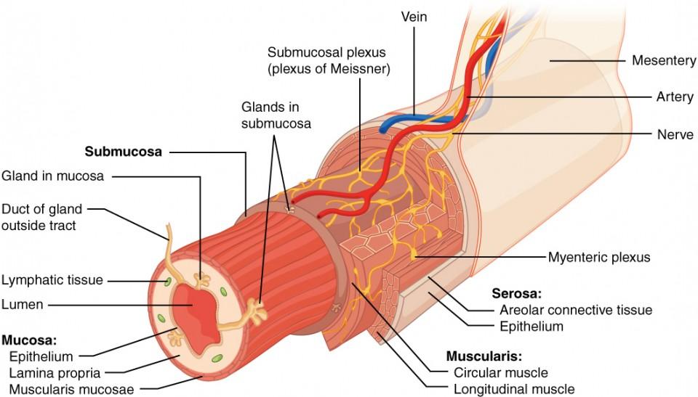

Wall of the alimentary canal

Nerve Supply:
- The alimentary canal and its related accessory organs are supplied by nerves from both divisions of the autonomic nervous system, i.e. both parasympathetic and sympathetic parts.
- Increased parasympathetic activity to the digestive organs promotes digestive processes, and increased sympathetic activity inhibits them.
The Parasympathetic supply
- One pair of Cranial nerves, the vagus nerves, supplies most of the alimentary canal and the accessory organs.
- Sacral Nerves supply the most distal part of the GI Tract.
- The effects of parasympathetic stimulation on the digestive system are:
- Increased Muscular activity, especially Peristalsis, stimulated by increased activity of the Myenteric Plexus
- Increased glandular Secretion, through increased activity of the Submucosal Plexus

The Sympathetic Supply
- This is provided by numerous nerves that emerge from the spinal cord in the thoracic and lumbar regions.
- These form plexuses (ganglia) in the thorax, abdomen and pelvis from which nerve pass to the organs of the alimentary tract.
- The effects of sympathetic stimulation on the digestive system are to:
- Decrease muscular activity, especially peristalsis, because there is reduced stimulation of the myenteric plexus.
- Decrease glandular secretion, as there is less stimulation of the submucosal plexus.
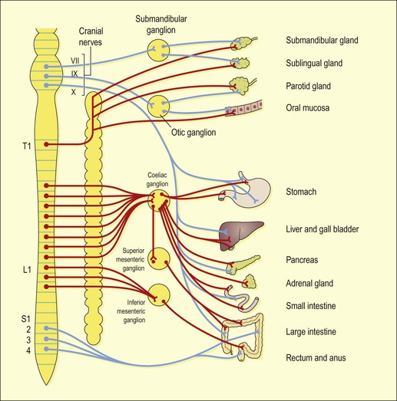

Autonomic Nerve Supply to the Digestive System

