HUMAN ANATOMY AND PHYSIOLOGY-II (Theory)
Subject code: BP201T
Class – 06
STOMACH
- Stomach is a j-shaped and dilated portion of the alimentary tract situated in the epigastric, umbilical and hypochondriac regions of the abdominal cavity.

Organs associated with the stomach:
Anteriorly-left lobe of liver and anterior abdominal wall.
Posteriorly-abdominal aorta, pancreas, spleen, left kidney and adrenal gland.
Superiorly-diaphragm, oesophagus and left lobe of liver.
Inferiorly-transverse colon and small intestine.
To the left-diaphragm and spleen.
To the right- liver and duodenum.

STRUCTURE:
Stomach is continuous with the oesophagus at the lower oesophageal sphincter and with the duodenum at the pyloric sphincter.
- It has two curvatures. Lesser Curvature is short, lies on the posterior surface of the stomach and is the downward continuous of the posterior wall of the oesophagus.
- Just below the pyloric sphincter it curves upwards to complete the J shape. Where the oesophagus joins the stomach the anterior region angles acutely upwards, curves downwards forming the greater curvature and then slightly upwards towards the pyloric sphincter.
- Stomach is divided into three regions
- Fundus
- Body
- Pylorus
- At the distal end of the pylorus is the pyloric sphincter, guarding the opening between the stomach and the duodenum.
- When the stomach is inactive the pyloric sphincter is relaxed and open, and when the stomach contains food the sphincter is closed.
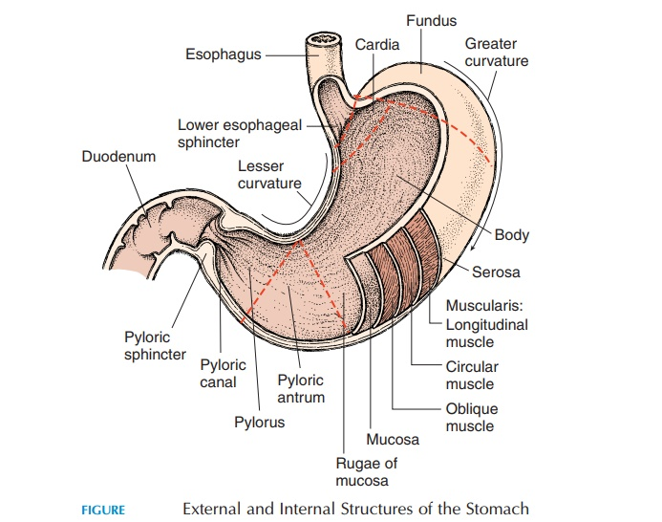

WALLS OF THE STOMACH
The four layers of tissue that comprise the basic structure of the alimentary canal are found in the stomach but with some modifications.
Muscle layer
It consists of three layers of smooth muscle fibres
- Outer layer of longitudinal fibres
- Middle layer of Circular fibres
- Inner layer of oblique fibres
- In this respect the stomach is different from other regions of the alimentary tract, as it has three layers of muscle instead of two.
- This arrangement allows for the churning action characteristic of gastric activity, as well as peristaltic activity.

Mucosa
When the stomach is empty the mucous membrane lining is thrown into longitudinal folds or rugae, and when it is full the rugae are ‘ironed out’, giving the surface a smooth, velvety appearance. Numerous gastric glands are situated below the surface in the mucous membrane and open on to it. They contain specialised cells, including chief cells and parietal cells which secrete constituents of gastric juice into the stomach as well as enteroendocrine cells.

Blood Supply
Arterial supply to the stomach is by the left gastric artery, a branch of the coeliac artery, the right gastric artery and the gastroepiploic arteries. Venous drainage is through veins of corresponding names into the portal vein.

Gastric Juice and Functions of the Stomach
- Stomach size Varies with the Volume of food it contains, which may be 1.5 Litres or more in an adult.
- After a meal food accumulates in the stomach in layers, the last part of the meal remaining in the fundus for some time.
- Mixing with the gastric juice takes place gradually and it may be some time before the food is sufficiently acidified to stop the action of salivary amylase.
- The gastric muscles generates a churning action that breaks down the bolus and mixes it with gastric juice.
- Peristaltic waves in the stomach wall propels the contents towards the pylorus.
- When the stomach is active the pyloric sphincter closes. Strong peristaltic contraction of the pylorus forces chyme, gastric contents after they are sufficiently liquefied, through the pyloric sphincter into the duodenum in small spurts.
- Parasympathetic stimulation increases the motility of the stomach and secretion of gastric juice; sympathetic stimulation has the opposite effect.

Gastric juice
- About 2 litres of gastric juice are secreted daily by specialised secretory glands in the mucosa. It consists of:
- Mucus secreted by mucous neck cells in the glands and surface mucous cells on the stomach surface inactive enzyme precursors: pepsinogens secreted by chief cells in the glands.

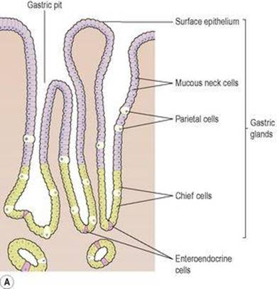
Structure of the gastric mucosa showing gastric glands
Functions of gastric juice
- Water further liquefies the food swallowed.
- Hydrochloric acid:
– acidifies the food and stops the action of salivary amylase
– kills ingested microbes
– provides the acid environment needed for effective digestion by pepsins.
- Pepsinogens are activated to pepsins by hydrochloric acid and by pepsins already present in the stomach. These enzymes begin the digestion of proteins, breaking them into smaller molecules.
- Pepsins act most effectively at a very low pH, between 1.5 and 3.5.
- Intrinsic factor (a protein) is necessary for the absorption of vitamin B12 from the ileum.
- Mucus prevents mechanical injury to the stomach wall by lubricating the contents. It prevents chemical injury by acting as a barrier between the stomach wall and the corrosive gastric juice. Hydrochloric acid is present in potentially damaging concentrations and pepsins would digest the gastric tissues.
Secretion of gastric juice
There is always a small quantity of gastric juice present in the stomach, even when it contains no food. This is known as fasting juice. Secretion reaches its maximum level about 1 hour after a meal then declines to the fasting level after about 4 hours.
There are three phases of secretion of gastric juice

1 Cephalic phase
This flow of juice occurs before food reaches the stomach and is due to reflex stimulation of the vagus (parasympathetic) nerves initiated by the sight, smell or taste of food. When the vagus nerves have been cut (vagotomy), this phase of gastric secretion stops. Sympathetic stimulation, e.g. during emotional states, also inhibits gastric activity.

2 Gastric phase
When stimulated by the presence of food the enteroendocrine cells in the pylorus (Fig. 12.21) and duodenum secrete gastrin, a hormone which passes directly into the circulating blood. Gastrin, circulating in the blood which supplies the stomach, stimulates the gastric glands to produce more gastric juice. In this way secretion of digestive juice is continued after completion of a meal and the end of the cephalic phase. Gastrin secretion is suppressed when the pH in the pylorus falls to about 1.5.

3 Intestinal phase
When the partially digested contents of the stomach reach the small intestine, two hormones, secretin and cholecystokinin, are produced by endocrine cells in the intestinal mucosa. They slow down the secretion of gastric juice and reduce gastric motility. By slowing the emptying rate of the stomach, the chyme in the duodenum becomes more thoroughly mixed with bile and pancreatic juice. This phase of gastric secretion is most marked following a meal with a high fat content. The rate at which the stomach empties depends largely on the type of food eaten. A carbohydrate meal leaves the stomach in 2 to 3 hours, a protein meal remains longer and a fatty meal remains in the stomach longest.

Functions of the stomach
These include:
- Temporary storage allowing time for the digestive enzymes, pepsins, to act
Chemical digestion – pepsins convert proteins to polypeptides
Mechanical breakdown – the three smooth muscle layers enable the stomach to act as a churn, gastric juice is added and the contents are liquefied to chyme. Gastric motility and secretion are increased by parasympathetic nerve stimulation
- Limited absorption of water, alcohol and some lipid-soluble drugs
- Non-specific defence against microbes – provided by hydrochloric acid in gastric juice. Vomiting may occur in response to ingestion of gastric irritants, e.g. microbes or chemicals
- Preparation of iron for absorption further along the tract – the acid environment of the stomach solubilises iron salts, which is required before iron can be absorbed
- Production and secretion of intrinsic factor needed for absorption of vitamin B12 in the terminal ileum
- Regulation of the passage of gastric contents into the duodenum. When the chyme is sufficiently acidified and liquefied, the pylorus forces small jets of gastric contents through the pyloric sphincter into the duodenum. The sphincter is normally closed, preventing backflow of chyme into the stomach
- Secretion of the hormone gastrin

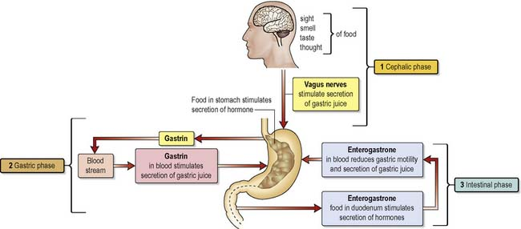
Three phases of Gastric Secretion

