HUMAN ANATOMY AND PHYSIOLOGY-II (Theory)
Subject code: BP201T
Class – 03
STRUCTURE OF THE MOUTH
- The mouth or oral cavity is formed by muscles and bones:
Anteriorly – by the lips
Posteriorly- it is continuous with the oropharynx
Laterally – By the muscles of the Cheeks
Superiorly- by the bony hard palate and muscular soft palate
Inferiorly- by the muscular tongue & the soft tissues of the floor of mouth
- The oral cavity is lined throughout with mucous membrane, consisting of sturdy, stratified squamous epithelium containing small mucus-secreting glands.
- The part of the mouth between the gums and the cheeks is the vestibule, and the remainder of its interior is the oral cavity.
- The mucous membrane lining of the cheeks and the lips is reflected on to the gums or alveolar ridges and is continuous with the skin of the face.
- The palate forms the roof of the mouth and is divided into anterior hard palate and the posterior soft palate.
- The hard palate is formed by the maxilla and the palatine bones.
- The soft palate which is muscular, curves downward from the posterior end of the hard palate and blends with the walls of the pharynx at the sides.
- The uvula is curved fold of muscle covered with mucous membrane, hanging down from the middle of the free border of the soft palate.
- Originating from the upper end of the Uvula are four folds of mucous membrane, two passing downwards at each side to form membranous arches.
- The posterior folds, one on each side, are the palatopharyngeal arches, and the two anterior folds are the palatoglossal arches.
- On each side, between the arches, is a collection of lymphoid tissue called the Palatine tonsil.
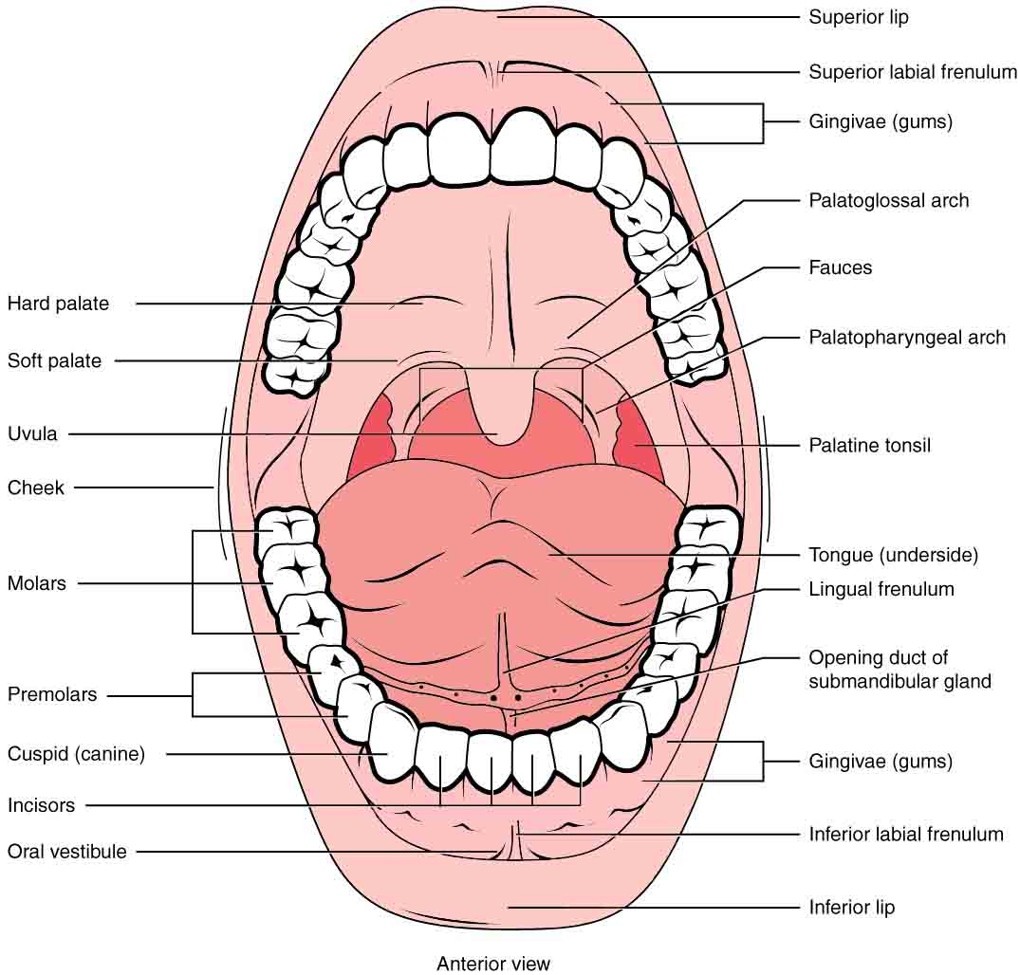

Tongue
- It is composed of Voluntary Muscle. It is attached by its base to the hyoid bone and by a fold of its mucous membrane covering, called the frenulum, to the floor of the mouth.
- The superior surface consists of stratified squamous epithelium, with numerous Papillae (little projections).
- Many of these contain sensory receptors (specialised nerve endings) for the sense of taste in the taste buds.

Blood supply
- The main arterial blood supply to the tongue is by the lingual branch of the external carotid artery.
- Venous drainage is by the lingual vein, which joins the internal jugular vein.

Nerve Supply
The nerves involved are:
- The hypoglossal nerves (12th Cranial Nerves), which supply the Voluntary muscle.
- The lingual branch of the mandibular nerves, which arise from the 5th Cranial nerves, the nerves of somatic (ordinary) sensation, i.e. pain, temperature and touch.
- The facial and glossopharyngeal nerves (7th and 9th cranial nerves), the nerves of taste.
Functions
The tongue plays an important part in:
- Chewing (mastication)
- Swallowing (deglutition)
- Speech
- Taste
Nerve endings of the sense of taste are present in the papillae and widely distributed in the epithelium of the tongue.

Teeth
- The teeth are embedded in the alveoli, or sockets, of the alveolar ridges of the mandible and the maxilla.
- Babies are born with two sets, or dentitions: temporary or deciduous (baby) teeth and the permanent teeth.
- The teeth of both dentitions are present, in immature form, in the mandible and maxilla at birth.
- There are 20 temporary teeth, 10 in each jaw. They begin to erupt at about 6 months of age, and should all be present by 24 months.
- The permanent teeth begin to replace the deciduous teeth between the ages of 6 and 13 years.
- This dentition consisting of 32 teeth, is usually complete by the age of 20. The third molars (wisdom teeth) are the last to erupt.

Structure:
Although the shapes of the different teeth vary, the structure is the same and consists of:
The crown- the part that protrudes from the gum
The root- the part embedded in the bone
The neck- the slightly narrowed region where the crown merges with the root.
In the centre of the tooth is the pulp cavity, containing blood vessels, lymph vessels and nerves, and surrounding this is a hard, ivory-like substance called dentine.
The dentine of the crown is covered by a thin layer of a very hard substance, enamel.
The root of the tooth, on the other hand, is covered with a substance resembling bone, called cementum, which secures the tooth in its socket. Blood vessels and nerves pass to the tooth through a small foramen (hole) at the apex of each root.

Blood Supply:

- Most of the arterial blood supply to the teeth is by branches of the maxillary arteries.
- The venous drainage is by a number of veins that empty into the internal jugular veins.

Nerve Supply:

- Nerve supply to the upper teeth is by branches of the maxillary nerves and that to the lower teeth by branches of the mandibular nerves. These are both branches of the trigeminal nerve (5th cranial nerves).

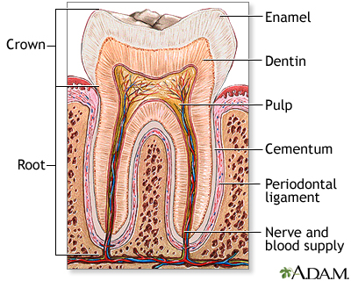

STRUCTURE OF TOOTH

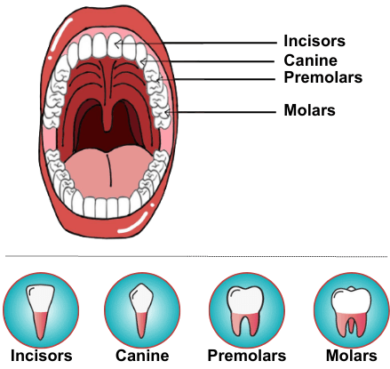
TYPES OF TEETH

