HUMAN ANATOMY AND PHYSIOLOGY-II (Theory)
Subject code: BP201T
Class – 05
PHARYNX
- Pharynx is divided into three parts: nasopharynx, oropharynx, and laryngopharynx.
- The nasopharynx is important in respiration. The oropharynx and laryngopharynx are common passages to both the respiratory and digestive systems.
- Food passes from the oral cavity into the pharynx and then to the oesophagus below, with which it continuous.
- The walls of the pharynx consist of three layers of tissue.
- The lining membrane (mucosa) is stratified squamous epithelium, continuous with the lining of the mouth at one end and the oesophagus at the other. This provides a thick, sturdy lining well suited to the wear and tear of swallowing ingested food.
- The middle layer consists of connective tissue, which becomes thinner towards the lower end and contains blood and lymph vessels and nerves.
- The outer layer consists of involuntary muscles that are involved in swallowing. When food reaches the pharynx, swallowing becomes reflexive, i.e. is no longer under voluntary control.
Blood Supply
Blood supply to the pharynx is by several branches of the facial arteries. Venous drainage is into the facial veins and the internal jugular veins.

Nerve Supply
This is from the Pharyngeal plexus and consists of parasympathetic and sympathetic nerves. Parasympathetic supply is mainly by the glossopharyngeal and vagus nerves, and sympathetic supply is from the cervical ganglia.

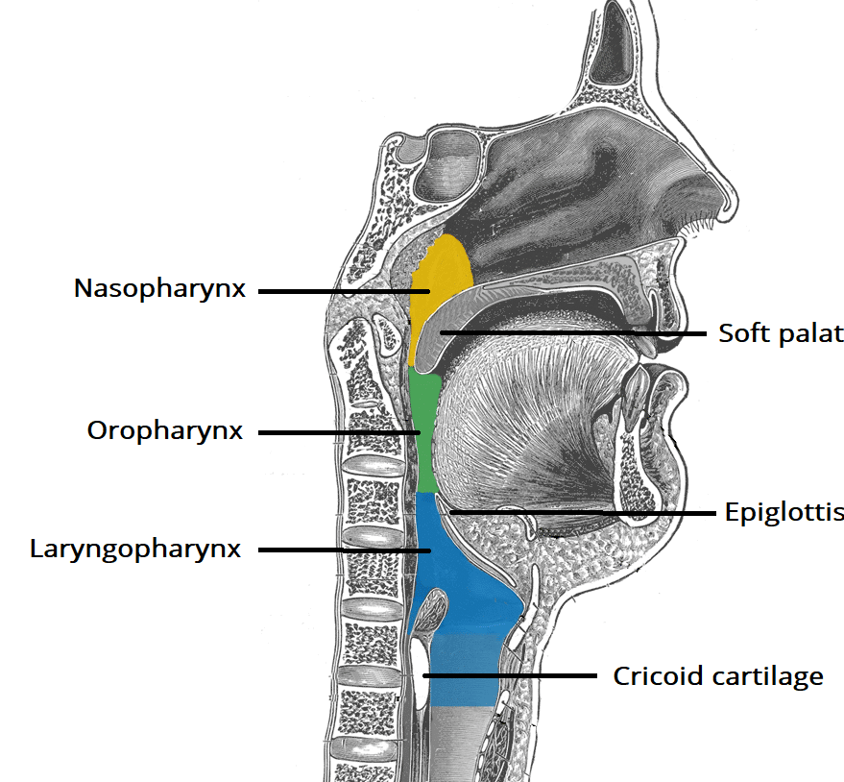
Oesophagus
- It is about 25 cm long and about 2 cm in diameter; it lies in the medial plane in the thorax, infront of the vertebral column and behind the trachea and the heart.
- It is continuous with the pharynx above, and just below the diaphragm it joins the stomach. It passes between muscle fibres of the diaphragm behind the central tendon at the level of the 10th thoracic vertebrae.
- Immediately the oesophagus has passed through the diaphragm it curves upwards, before opening into the stomach.
- This sharp angle is believed to be one of the factors that prevents the regurgitation (backflow) of gastric contents into the oesophagus.
- The upper and lower ends of the oesophagus are closed by sphincters. The upper oesophageal sphincter prevents the passage of air into the oesophagus during inspiration, and the aspiration of oesophageal contents.
- The lower oesophageal (cardiac) sphincter and prevents the reflux of acid gastric contents into the oesophagus.
- There is no thickening of the circular muscle in this area and this sphincter is therefore ‘Physiological”, i.e. this region can act as a sphincter without the presence of the anatomical features.
- When intra-abdominal pressure is raised, e.g. during inspiration and defaecation, the tone of the lower oesophageal sphincter increases. There is an added pinching effect by the contracting muscle fibres of the diaphragm.
STRUCTURE
There are four layers of tissue. As the oesophagus is almost entirely in the thorax, the outer covering the adventitia, consists of elastic fibrous tissue that attaches the oesophagus to the surrounding structures. The proximal third is lined by stratified squamous epithelium for protection during swallowing, and the distal third by Columnar epithelium. The middle third is lined by a mixture of the two.
Blood Supply
Arterial Supply
The thoracic region is supplied mainly by the paired oesophageal arteries, branches from the thoracic aorta. The abdominal region is supplied by branches from the inferior phrenic arteries and the left gastric branch of the coeliac artery.
Venous drainage
From the thoracic region venous drainage is into the azygous and hemizygous veins. The abdominal part drains into the left gastric vein. There is a venous Plexus at the distal end that links the upward and downward venous drainage, i.e. the general and portal circulations.
Functions of the Mouth, Pharynx and oesophagus
- Formation of a bolus
When food is taken into the mouth, it is chewed (masticated) by the teeth and moved around the mouth by the tongue and muscles of the cheeks. It is mixed with saliva and formed into a soft mass, or bolus, ready for swallowing. The length of time that food remains in the mouth largely depends on the consistency of the food.
- Swallowing (deglutition)
Swallowing occurs in three stages after chewing is complete and the bolus had been formed. It is initiated voluntarily but completed by a reflex (involuntary) action.
- Oral Stage
With the mouth closed, the voluntary muscles of the tongue and cheeks push the bolus backwards into the pharynx.

- Pharyngeal Stage
The muscles of the Pharynx are stimulated by a reflex action initiated in the walls of the oropharynx and coordinated by the swallowing centre in the medulla. Involuntary Contraction of these muscles propels the bolus down into the oesophagus. All other routes that the bolus could take are closed. The soft palate rises up and closes off the nasopharynx; the tongue and the Pharyngeal folds blocks the way back into the mouth; and the larynx is lifted up and forwards so that its opening is occluded by the overhanging epiglottis, preventing entry into the airway (trachea).

- Oesophageal Stage
The presence of the bolus in the pharynx stimulates a wave of peristalsis that propels the bolus through the oesophagus to the stomach. Peristaltic wave pass along the oesophagus only after swallowing begins. Otherwise the walls are relaxed. Ahead of Peristaltic wave, the lower oesophageal sphincter guarding the entrance to the stomach relaxes to allow the descending bolus to pass into the stomach. Usually Constriction of the lower oesophageal sphincter prevents reflux of gastric acid into the oesophagus.

