HUMAN ANATOMY AND PHYSIOLOGY-II (Theory)
Subject code: BP201T
Class – 10
PANCREAS
- The pancreas is a pale grey gland weighing about 60 grams. It is about 12 to 15 cm long and is situated in the epigastric and left hypochondriac regions of the abdominal cavity. It consists of a broad head, a body and a narrow tail. The head lies in the curve of the duodenum, the body behind the stomach and the tail lies in front of the left kidney and just reaches the spleen. The abdominal aorta and the inferior vena cava lie behind the gland. The pancreas is both an exocrine and endocrine gland.
The exocrine pancreas
This consists of a large number of lobules made up of small acini, the walls of which consist of secretory cells. Each lobule is drained by a tiny duct and these unite eventually to form the pancreatic duct, which extends the whole length of the gland and opens into the duodenum. Just before entering the duodenum the pancreatic duct joins the common bile duct to form the hepatopancreatic ampulla. The duodenal opening of the ampulla is controlled by the hepatopancreatic sphincter (of Oddi) at the duodenal papilla.
The function of the exocrine pancreas is to produce pancreatic juice containing enzymes that digest carbohydrates, proteins and fats. As in the alimentary tract, parasympathetic stimulation increases the secretion of pancreatic juice and sympathetic stimulation depresses it.
Endocrine pancreas
Distributed throughout the gland are groups of specialised cells called the pancreatic islets (of Langerhans). The islets have no ducts so the hormones diffuse directly into the blood. The endocrine pancreas secretes the hormones insulin and glucagon, which are principally concerned with control of blood glucose levels.
Blood supply
The splenic and mesenteric arteries supply the pancreas, and venous drainage is by veins of the same names that join other veins to form the portal vein.

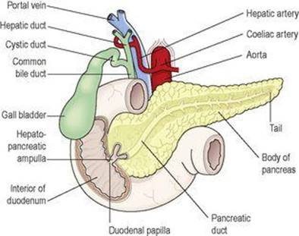
Pancreas in relation to the duodenum and biliary tract

LIVER
The liver is the largest gland in the body, weighing between 1 and 2.3 kg. It is situated in the upper part of the abdominal cavity occupying the greater part of the right hypochondriac region, part of the epigastric region and extending into the left hypochondriac region. Its upper and anterior surfaces are smooth and curved to fit the under surface of the diaphragm; its posterior surface is irregular in outline.
Organs associated with the liver
Superiorly and anteriorly – diaphragm and anterior abdominal wall
Inferiorly – stomach, bile ducts, duodenum, hepatic flexure of the colon, right kidney and adrenal gland
Posteriorly – oesophagus, inferior vena cava, aorta, gall bladder, vertebral column and diaphragm
Laterally – lower ribs and diaphragm.
The liver is enclosed in a thin inelastic capsule and incompletely covered by a layer of peritoneum. Folds of peritoneum form supporting ligaments attaching the liver to the inferior surface of the diaphragm. It is held in position partly by these ligaments and partly by the pressure of the organs in the abdominal cavity. The liver has four lobes. The two most obvious are the large right lobe and the smaller, wedge-shaped, left lobe. The other two, the caudate and quadrate lobes, are areas on the posterior surface.
The portal fissure
This is the name given to the region on the posterior surface of the liver where various structures enter and leave the gland. The portal vein enters, carrying blood from the stomach, spleen, pancreas and the small and large intestines. The hepatic artery enters, carrying arterial blood. It is a branch from the coeliac artery, which is a branch from the abdominal aorta. Nerve fibres, sympathetic and parasympathetic, enter here. The right and left hepatic ducts leave, carrying bile from the liver to the gall bladder. Lymph vessels leave the liver, draining some lymph to abdominal and some to thoracic nodes.
Blood supply
The hepatic artery and the portal vein take blood to the liver. Venous return is by a variable number of hepatic veins that leave the posterior surface and immediately enter the inferior vena cava just below the diaphragm.
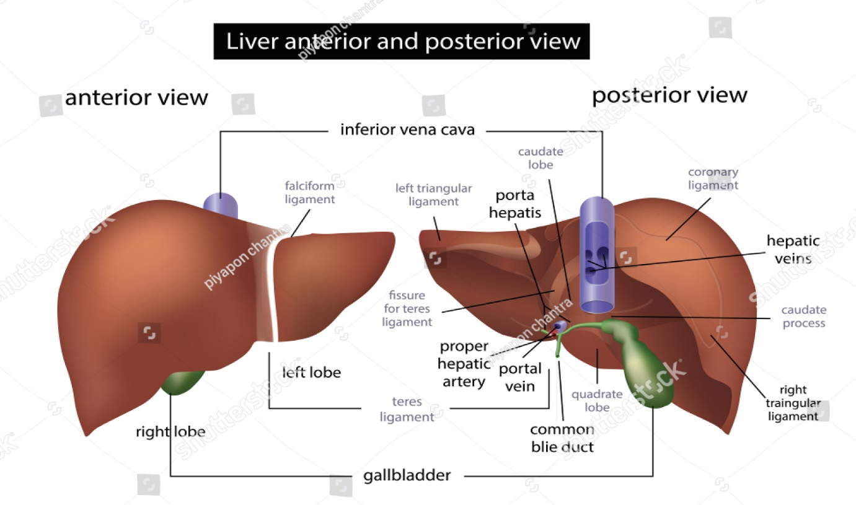
Structure
The lobes of the liver are made up of tiny functional units, called lobules, which are just visible to the naked eye. Liver lobules are hexagonal in outline and are formed by cubical-shaped cells, the hepatocytes, arranged in pairs of columns radiating from a central vein. Between two pairs of columns of cells are sinusoids (blood vessels with incomplete walls) containing a mixture of blood from the tiny branches of the portal vein and hepatic artery. This arrangement allows the arterial blood and portal venous blood (with a high concentration of nutrients) to mix and come into close contact with the liver cells. Amongst the cells lining the sinusoids are hepatic macrophages (Kupffer cells) whose function is to ingest and destroy worn out blood cells and any foreign particles present in the blood flowing through the liver.
Blood drains from the sinusoids into central or centrilobular veins. These then join with veins from other lobules, forming larger veins, until eventually they become the hepatic veins, which leave the liver and empty into the inferior vena cava. One of the functions of the liver is to secrete bile. It is seen that bile canaliculi run between the columns of liver cells. This means that each column of hepatocytes has a blood sinusoid on one side and a bile canaliculus on the other. The canaliculi join up to form larger bile canals until eventually they form the right and left hepatic ducts, which drain bile from the liver.
Lymphoid tissue and a system of lymph vessels are also present in each lobule.
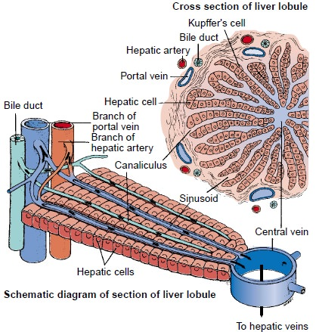
Functions of the liver
The liver is an extremely active organ. Those functions already described are only mentioned here.
Carbohydrate metabolism
The liver has an important role in maintaining plasma glucose levels. After a meal when levels rise, glucose is converted to glycogen for storage under the influence of the hormone insulin. Later, when glucose levels fall, the hormone glucagon stimulates conversion of glycogen into glucose again, keeping levels within the normal range.
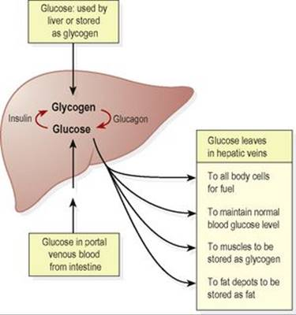

Fat metabolism
Stored fat can be converted to a form in which it can be used by the tissues to provide energy.
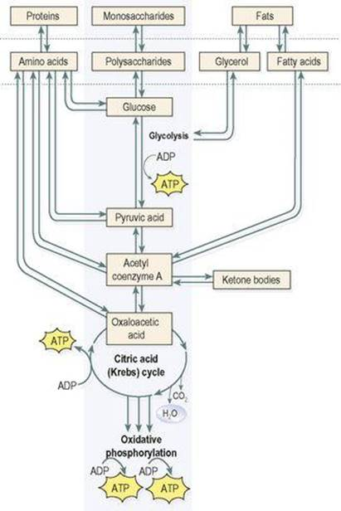
Protein metabolism
Deamination of amino acids
This process: removes the nitrogenous portion from the amino acids not required for the formation of new protein; urea is formed from this nitrogenous portion which is excreted in urine.Breaks down nucleic acids to form uric acid, which is excreted in the urine.
Transamination
Removes the nitrogenous portion of amino acids and attaches it to other carbohydrate molecules forming new non-essential amino acids.

Synthesis of plasma proteins and most blood clotting factors from amino acids.

Breakdown of erythrocytes and defence against microbes
This is carried out by phagocytic hepatic macrophages (Kupffer cells) in the sinusoids (breakdown of red blood cells also takes place in the spleen and bone marrow).
Detoxification of drugs and toxic substances
These include ethanol (alcohol) and toxins produced by, e.g., microbes. Some drugs are extensively inactivated by the liver and are not very effective when given by mouth (orally), e.g. glyceryl trinitrate. This is because after absorption from the alimentary tract, they travel in the blood to the liver where they are largely metabolised so that levels in the blood leaving the liver are inadequate to achieve therapeutic effects. This is known as ‘first pass metabolism’.
Inactivation of hormones
These include insulin, glucagon, cortisol, aldosterone, thyroid and sex hormones.
Production of heat
The liver uses a considerable amount of energy, has a high metabolic rate and produces a great deal of heat. It is the main heat-producing organ of the body.
Secretion of bile
The hepatocytes synthesise the constituents of bile from the mixed arterial and venous blood in the sinusoids. These include bile salts, bile pigments and cholesterol.
Storage
Stored substances include: glycogen, fat-soluble vitamins: A, D, E, K iron, copper some water-soluble vitamins, e.g. vitamin B12.
Composition of bile
Between 500 and 1000 ml of bile are secreted by the liver daily. Bile consists of: water ,mineral salts, mucus, bile pigments, mainly bilirubin ,bile salts, which are derived from the primary bile acids, cholic acid and chenodeoxycholic acid and cholesterol.
The bile acids, cholic and chenodeoxycholic acid, are synthesised by hepatocytes from cholesterol, then secreted into bile as sodium or potassium salts. In the small intestine they emulsify fats, aiding their digestion. In the terminal ileum most of the bile salts are reabsorbed and return to the liver in the portal vein. This enterohepatic circulation, or recycling of bile salts, ensures that large amounts of bile salts enter the small intestine daily from a relatively small bile acid pool.
Bilirubin is one of the products of haemolysis of erythrocytes by hepatic macrophages (Kupffer cells) in the liver and by other macrophages in the spleen and bone marrow. Bilirubin is insoluble in water and is carried in the blood bound to albumin. In hepatocytes it is conjugated (combined) with glucuronic acid and becomes water-soluble enough to be excreted in bile. Bacteria in the intestine change the form of bilirubin and most is excreted as stercobilin in the faeces. A small amount is reabsorbed and excreted in urine as urobilinogen. Jaundice is yellow pigmentation of the tissues, seen in the skin and conjunctiva, caused by excess blood bilirubin.

