HUMAN ANATOMY AND PHYSIOLOGY-II (Theory)
Subject code: BP201T
Class – 07

SMALL INTESTINE
- The small intestine is continuous with the stomach at the pyloric sphincter. The small intestine is a little over 5 metres long and leads into the large intestine at the ileocecal valve.
- It lies in the abdominal cavity surrounded by the large intestine. In the small intestine the chemical digestion of food is completed and absorption of most nutrients takes place.
- The small intestine comprises three continuous parts.
- The duodenum is about 25 cm long and curves around the head of the pancreas.
- Secretions from the gall bladder and pancreas merge in a common structure – the hepatopancreatic ampulla – and enter the duodenum at the duodenal papilla.
- The duodenal papilla is guarded by a ring of smooth muscle, the hepatopancreatic sphincter (of Oddi).

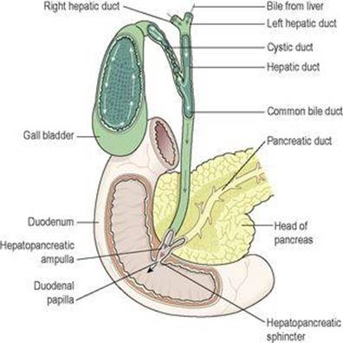

Flow of Bile from the liver to the duodenum
- The jejunum is the middle section of the small intestine and is about 2 metres long.
- The ileum, or terminal section, is about 3 metres long and ends at the ileocaecal valve, which controls the flow of material from the ileum to the caecum, the first part of the large intestine, and prevents regurgitation.

Structure of the small intestine
- The walls of the small intestine are composed of the four layers of tissue. Some modifications of the peritoneum and mucosa (mucous membrane lining) are described below.
Peritoneum
A double layer of peritoneum called the mesentery attaches the jejunum and ileum to the posterior abdominal wall. The attachment is quite short in comparison with the length of the small intestine, therefore it is fan shaped. The large blood vessels and nerves lie on the posterior abdominal wall and the branches to the small intestine pass between the two layers of the mesentery.
Mucosa
The surface area of the small intestine mucosa is greatly increased by permanent circular folds, villi and microvilli. The permanent circular folds, unlike the rugae of the stomach, are not smoothed out when the small intestine is distended. They promote mixing of chyme as it passes along.
The villi are tiny finger-like projections of the mucosal layer into the intestinal lumen, about 0.5 to 1 mm long. Their walls consist of columnar epithelial cells, or enterocytes, with tiny microvilli (1 μm long) on their free border. Goblet cells that secrete mucus are interspersed between the enterocytes. These epithelial cells enclose a network of blood and lymph capillaries. The lymph capillaries are called lacteals because absorbed fat gives the lymph a milky appearance. Absorption and some final stages of digestion of nutrients take place in the enterocytes before entering the blood and lymph capillaries.
The intestinal glands are simple tubular glands situated below the surface between the villi. The cells of the glands migrate upwards to form the walls of the villi replacing those at the tips as they are rubbed off by the intestinal contents. The entire epithelium is replaced every 3 to 5 days. During migration, the cells form digestive enzymes that lodge in the microvilli and, together with intestinal juice, complete the chemical digestion of carbohydrates, protein and fats.
Numerous lymph nodes are found in the mucosa at irregular intervals throughout the length of the small intestine. The smaller ones are known as solitary lymphatic follicles, and about 20 or 30 larger nodes situated towards the distal end of the ileum are called aggregated lymphatic follicles (Peyer’s patches, These lymphatic tissues, packed with defensive cells, are strategically placed to neutralise ingested antigens.
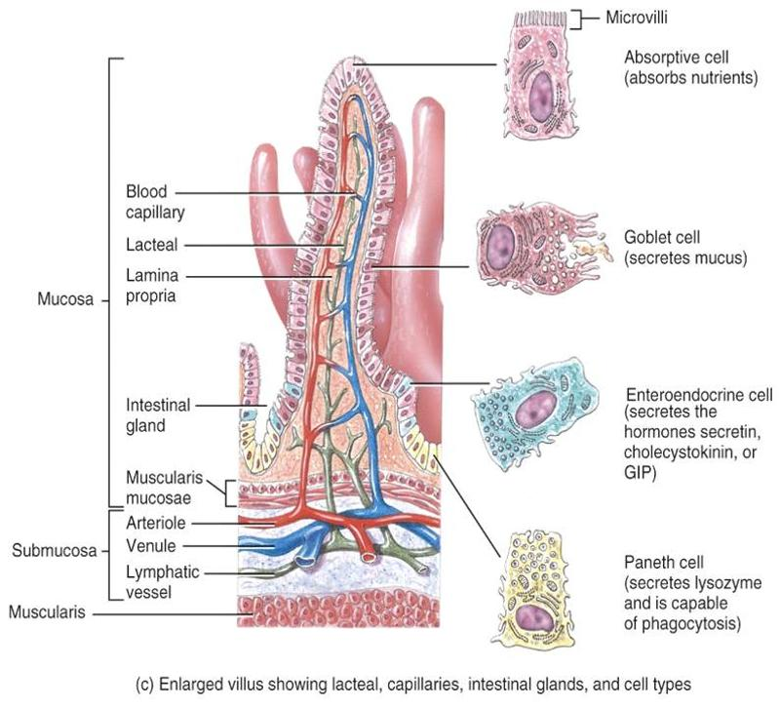
Blood supply
The superior mesenteric artery supplies the whole of the small intestine, and venous drainage is by the superior mesenteric vein that joins other veins to form the portal vein. The portal vein contains a high concentration of absorbed nutrients and this blood passes through the liver before entering the hepatic veins and, ultimately, into the inferior vena cava.
Intestinal juice
About 1500 ml of intestinal juice are secreted daily by the glands of the small intestine. It consists of: water, mucus and mineral salts. The pH of intestinal juice is usually between 7.8 and 8.0.
Functions of the small intestine
The functions are: onward movement of its contents by peristalsis, which is increased by parasympathetic stimulation secretion of intestinal juice, also increased by parasympathetic stimulation.
Completion of chemical digestion of carbohydrates, protein and fats in the enterocytes of the villi
Protection against infection by microbes that have survived the antimicrobial action of the hydrochloric acid in the stomach, by the solitary lymph follicles and aggregated lymph follicles.
Secretion of the hormones cholecystokinin (CCK) and secretin absorption of nutrients.

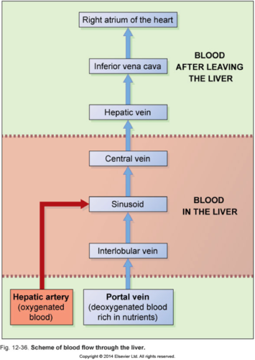
Blood flow through the liver

